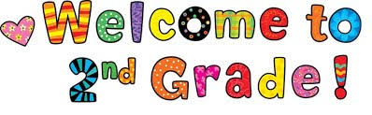
Grade 2 Supply List
2025-2026

- Spill proof water bottle
- Pencil box with coloring supplies
- Healthy snacks for daily snack time
- Optional: headphones for chromebooks
*Students are welcome to bring in an extra set of clothes and sneakers to leave in their cubby.