Grade 3 and 4 Supply List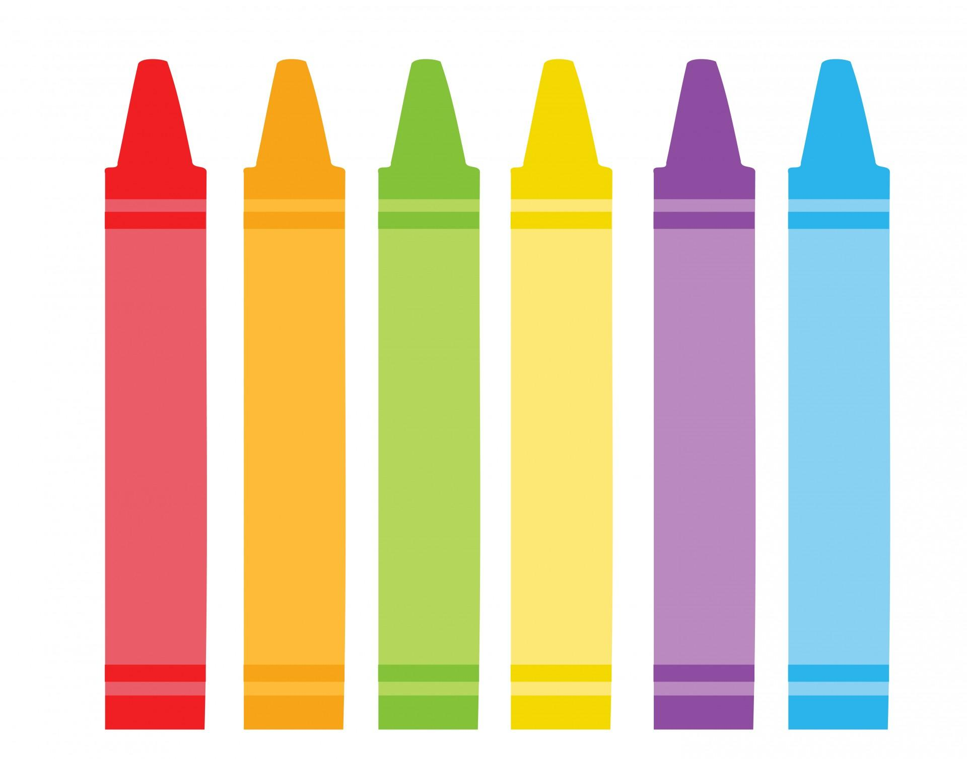

2 Pack of Pencils- Sharpened
Headphones (NO wireless)
Post-it Notes
1 Homework Folder
Soft sided pencil case
Water Bottle (WATER ONLY in the classroom)
Daily Healthy Snack

Please do not send:
Notebooks, folders, coloring supplies (These will all be provided)

Thank you! We can’t wait to see everyone on the first day of school!!

