Chromebooks at TUFSD
What to know!

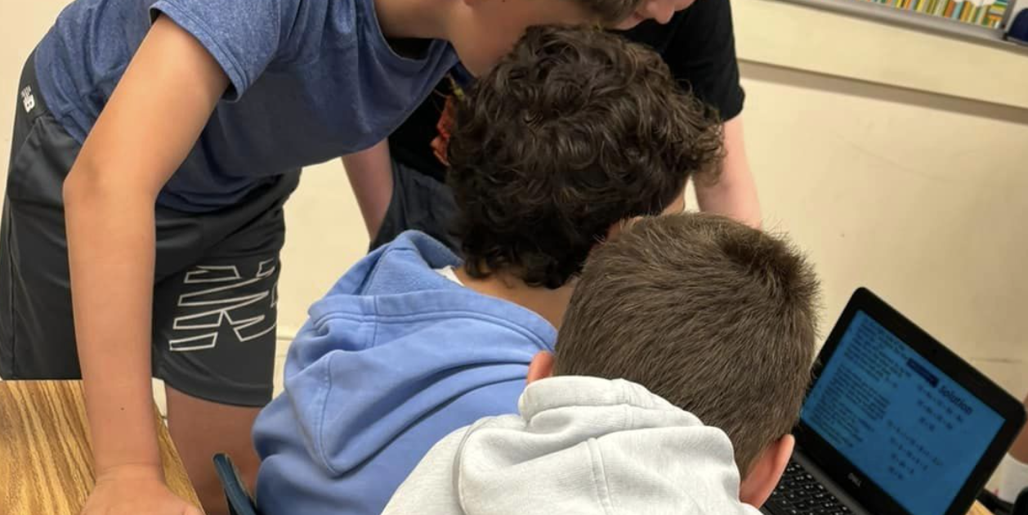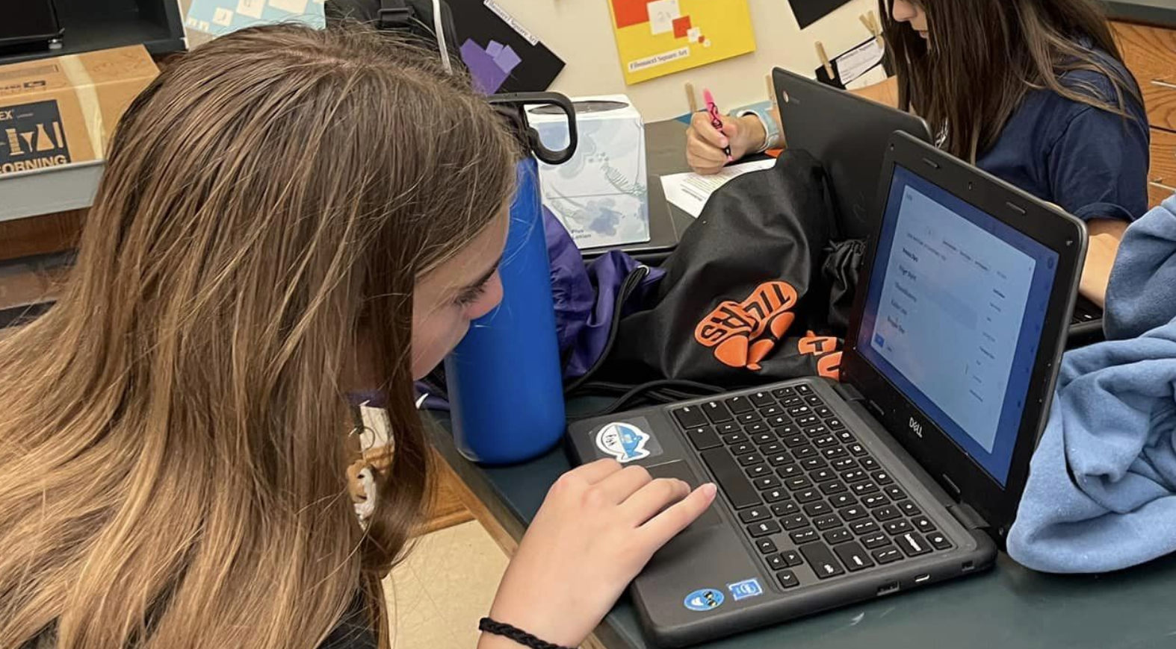
Chromebooks are distributed each fall and must be returned at the end of the school year or upon leaving the district.
Damage, Loss, and Theft:
- Immediate reporting is required for any damage, loss, or theft. Students can report damage and incidents to the circulation desk in the MS/HS library.
- Accidental damage fines range from $40 to $50, increasing with each incident. After two incidents, students may lose privileges and face disciplinary action. Intentional damage incurs high-level fines covering all replacement or repair costs.
- Loss of a Chromebook can cost as much as $249 (depending on the replacement cost at the time).
- Theft must be reported to the administration and the Eastchester Police Department at no cost to the student.
General Care and Maintenance:
- Students are responsible for keeping Chromebooks in good working condition and charged daily.
- Parents may wish to carry personal insurance for theft, loss, or damage not covered by the district.
Policy Adherence:
- Students must follow all TUFSD policies, including the Responsible Use Policy.
- Unauthorized applications and changes to device settings are prohibited and monitored.

