LOS ANGELES UNIFIED SCHOOL DISTRICT
Grade Level

K

Arts Education Branch
DISCIPLINE: VISUAL ARTS
Grade Level Focus: Art is All Around Us
Where do you see art?

Module # 1 HOUSE of ELEMENTS BOOK
Enduring Understanding The Elements of Art Are All Around Us

Standard(s) Essential 4.1 Discuss their own works of art, using appropriate art vocabulary (e.g., color, shape/form, texture).
Supporting 1.3 Identify the elements of art (line, color, shape/form, texture, value, space) in the environment and in works of art, emphasizing line, color, and shape/form.
Spiral 3.3 Look at and discuss works of art from a variety of times and places.
Recommended 2.2 Demonstrate beginning skill in the use of tools and processes, such as the use of scissors, glue, and paper in creating a three-dimensional construction.
2.3 Make a collage with cut or torn paper shapes/forms.

Performance Task Choose one artwork from your portfolio. Share orally with the class the kinds of lines, shapes, or colors used in the artwork. Tell what the artwork is about and why you chose to talk about it.

Scoring Tool:
Student was able to explain use of an element of art.
Student explained the subject matter of the artwork

Essential Questions: What is art?
Where do we see the elements of art?

Knowledge | Skills
- Color, Shape and Line are elements of art.  - Painting, drawing, sculpture, collage and architecture are all examples of art.  - Works of art are created by people  - Shapes can be geometric and organic (free-form)  - Lines can be described and drawn in numerous ways.  - Vocabulary: line, shape, color, geometric, organic, (additional descriptive ‘line’words) | - Identify works of art created by artists and students  - Recognize and identify shapes, lines and colors in art and in the environment  - Identify primary and secondary colors  - Mix secondary colors with paints  - Use brush and paints  - Draw and/or cut out a variety of shapes.  - Use glue and/or glue sticks in creating a collage.

Connections: Math - geometric shapes.
Writing - Different types of lines are used when writing letters of the alphabet.
Extensions: Color Zoo by Lois Ehlert. Harold and the Purple Crayon by Crockett Johnson, White Rabbit's Color Book by Alan Baker
Differentiation:
(CRRE): Students bring in photographs or drawings of houses from their neighborhood
(SP ED)
(EL) Practice vocabulary for furniture and common household items with picture car

Sequence of instruction:
Grade K Module# 1 Lesson 1 of 3

Objective: Students explore line as an element of art and in the environment
Materials:
HOUSE BOOK: LINE
Opening  Phase | Student Engagement  (5 minutes) | •Ask students "What is art?"  •Chart answers (painting, drawing, making things with clay...etc.).  •Explain that art is made up of elements like lines, shapes, and colors. Elements can be thought of as the ingredients of art.  •Show a poster of Art Elements, acknowledging that there are more than just the three elements of line, shape and color, but that we'll concentrate on just those for a while.  •Title a chart "Line". Begin by discussing the properties and definition of a line. (A moving point; “taking a dot for a walk”)  •What makes a line?  •Draw lines in the air with students, drawing from prior student vocabulary knowledge when possible.  •Draw a variety of line types on the Line chart and label: straight, curved, broken, dotted, zigzag, wavy, loopy, “stair-step” are all good ones.  •Take student suggestions as well. Students will probably suggest shapes: explain that a line that meets itself becomes a shape, but yes, we can also make a line of shapes.
Exploring/Creating  Phase | Aesthetic Exploration  (5 - 10 minutes) | •Look around the classroom.  •Have students find lines in the classroom. Name the lines found.  •Look at images of art from different time periods and places; identify the types of lines in the artwork.  •Use images of houses with strong line elements of houses (Architecture unit on MOCA CAS disc is a possibility).  •Have students find various lines in these images.  •Explain that designing houses and buildings, or Architecture, is an art.  You can study different types of art, like painting, drawing, and architecture.  •Add architecture to the "What is Art" chart.  •Review list on "What is Art" chart. Ask students where they have seen art. Remind them that houses and buildings, or architecture is art too.
Exploring/Creating  Phase | Demonstration  (5 - 10 minutes) | •Introduce the project: We will be creating a “house book” to learn some elements of art. •“Elements” can be described as the ingredients that make art.  •Demonstrate cover page: Title: House Book, write name.  •Open to the first two - page spread. On the left side, teacher models creating a chart of lines. The word line is written at the top of the page.  •Students create their own “line inventory”. This can be done at the rug or at seats.  •Ask students: What kinds of things can you find inside a house?  •Model drawing these objects on the board.  •Discuss types of lines in the objects (curved, straight, vertical, horizontal, zig-zags in stairs, etc.)  •Model drawing on the right side page a room interior. Adding wallpaper and decorative pattern can utilize many types of lines.
Exploring/Creating  Phase | Creative Expression  (15 minutes) | •Students work at their seats, creating an interior of a house on their right side page.
Reflection  Phase | Reflection/Assessment  (10 minutes) | •Model talking about the use of line in teacher model.  •Have students stand in front of their drawings and practice using the vocabulary in a pair-share activity. “I like the way I used a ____ line in my ______.”  •Have students do a gallery walk; have students stop in front of an artwork and pick out a special way lines were used (ex: I like the way this student made a couch with curved lines.)

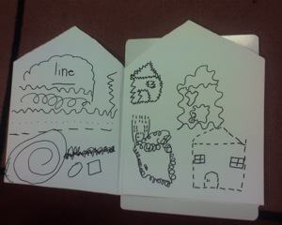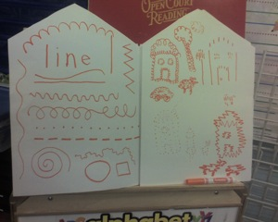

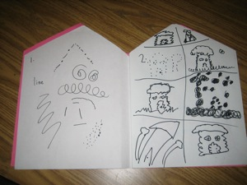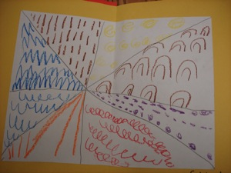

Sample Element of Line Pages

K Module#1 Lesson 2 of 3
Objectives: Student learns about different types of shapes in art and the environment; student creates a "shape page" in their house book.
Materials:

HOUSE BOOK: SHAPE
Opening  Phase | Student Engagement  (5 minutes) | •Re-read/discuss the "What is Art" chart with students, stressing that architecture, the design of houses and other buildings, is an art.  •Review the meaning of art elements (ingredients for making art). Identify line, shape and color on the Art Elements poster. Review "Line" chart from previous week.  •Title a chart "Shape".  •Begin by illustrating on the board how you can draw a line, but when you "close it up" it becomes a shape. A closed line is a shape.  •Draw shapes in the air, drawing from prior student vocabulary knowledge when possible. •Draw a variety of shapes on the "Shape" chart and label. If desired, Geometric and Organic may head two different sections of the shape poster.  •Discuss the idea of man - made vs. natural (curvy) for geometric and organic respectively.
Exploring/Creating  Phase | Aesthetic Exploration  (5- 10 minutes) | •Look around the classroom.  •Have students find shapes in the classroom.  •Name the shapes found.  •Look at images of art from different time periods and places; identify the types of shapes in the artwork.  •Share images of façades of different styles of homes, from different cultures and times (Victorian, California Bungalow, Tudor, Craftsman, African, Brownstone Apartment, Adobe, Contemporary, Chinese, Yurt, etc).  •Have students identify elements of the interior and exterior of a house: (roof, porch, stairs, windows, siding, etc.) and shapes and lines in the house images.
Exploring/Creating  Phase | Demonstration  (5 - 10 minutes) | •Open to next two - page spread of the house book.  •Write the word shape at the top, left hand page emphasizing that shape is the next art element we are studying and recording in our books.  •On the left side, teacher models creating a chart of shapes. Students create their own “shape inventory” on their left hand page. This can be done at the rug or at seats.  •Demonstrate drawing and cutting shapes (triangle, rectangle, circle) from three primary colors of construction paper. Have students cut as you demonstrate.  •Demonstrate how shapes can be collaged onto the right hand side to create parts of a house or things in or on the outside of a house.  •Demonstrate gluing and adding drawn shape and line elements.
Exploring/Creating  Phase | Creative Expression  (15 minutes) | •Students collage paper and draw details with lines and shapes to create an interior or exterior of a house on the right side page.
Reflection  Phase | Reflection/Assessment  (10 minutes) | •Clean - up.  •Model talking about the use of shape in teacher model.  •Have students do a “gallery walk” with a partner, and discuss shapes on house page. Share out to class.

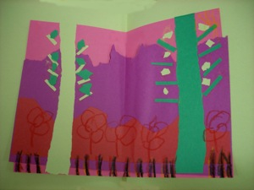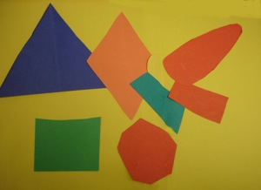

Sample Organic and Geometric Shape Pages
Grade K Module# 1 Lesson 3 of 3

Objective: Student learns about different types of colors in art and the environment; student creates a "color page" in their house book.
Materials:

HOUSE BOOK: COLOR
Opening  Phase | Student Engagement  (minutes) | •Re-read/discuss the "What is Art" chart with students, stressing that architecture, the design of houses and other buildings is an art.  •Review the meaning of art elements (ingredients for making art). Identify line, shape and color on the Art Elements poster. Review last week’s work: use of shape and vocabulary.  •Title a chart "Color Wheel".  •Draw an upright triangle so primary colors can be placed on its corners.  •Next transpose a down-turned triangle over it so secondary colors can be placed on its corners.  •Have students name some colors.  •Using crayons or markers, fill in the color wheel with the primary and secondary colors as students name them.  •Explain how to refer to the color wheel to mix one secondary from two primaries. "You can not make the primaries - you just have to have them. Then you can mix the secondary colors.  •What two primaries are on each side of green? Those are the two primaries that will make green."
Exploring/Creating  Phase | Aesthetic Exploration  (___minutes) | •Look around the classroom.  •Have students find colors in the classroom.  •Look at images of art from different time periods and places; identify the colors in the artwork.  •Share images of interiors and exteriors of homes from different cultures and times. Have students identify colors.
Exploring/Creating  Phase | Demonstration  (___minutes) | •Have students open house books to next two - page spread.  •Put a dot of primaries on both plate and left side page for each student in upright triangle configuration as with Color Wheel chart created in Student Engagement.  •On plate, demonstrate mixing secondary colors using one finger.  •Demonstrate cleaning finger between touching new colors. Students then mix secondary colors on left side page in books.  •On right side page, model finger painting different things found in and on a house using the colors mixed on the plate.
Exploring/Creating  Phase | Creative Expression  (___minutes) | •Guide students step by step at seats through demo, right side is independent finger painting using mixed colors from plate.
Reflection  Phase | Reflection/Assessment  (___minutes) | •Clean - up.  •Model talking about the use of color in teacher model. Have students do a “gallery walk” with a partner, and discuss colors on house page. Share out to class.

Performance Task: Choose one artwork from your portfolio. Share orally with the class the kinds of lines, shapes, or colors used in the artwork. Tell what the artwork is about and why you chose to talk about it.

Scoring Tool: Student was able to explain use of an element of art.
Student explained the subject matter of the artwork

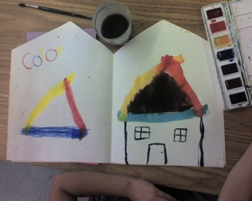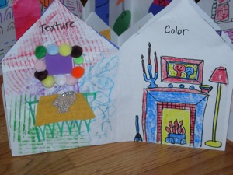

Sample Element of Color Pages

Additional Examples and Project Extensions

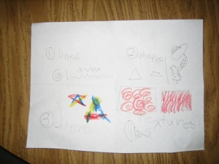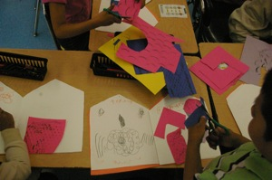

End of Unit Assessment Texture page with crayon rubbing collage

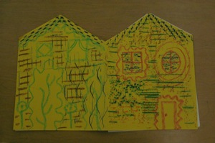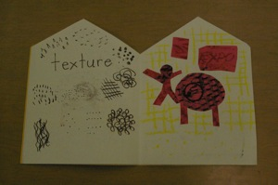

Cover Complete Texture page

