LOS ANGELES UNIFIED SCHOOL DISTRICT
Grade Level

K

Arts Education Branch
DISCIPLINE: VISUAL ARTS
Grade Level Focus: Art is All Around Us
Where do you see art?

Module # 3 Art We Can Use
Enduring Understanding People use art for many reasons

Standard(s) Essential 3.1 Describe functional and non-utilitarian art seen in daily life; works of art that are used versus those that are only viewed.
Supporting 4.3 Discuss how and why they made a specific work of art.
Recommended 2.1 Use lines, shapes/forms, and colors to make patterns.
5.2 Look at and draw something used every day (e.g., scissors, toothbrush, fork) and describe how the object is used.
Spiral 3.3 Look at and discuss works of art from a variety of times and places.

Performance Task Choose an artwork that you made that can be used. Tell how you made it and how it can be used.

Scoring Tool:
Explained the process used to make the artwork
Explained the function of the objective (how it can be used?)

Essential Questions: How do people use art?

Knowledge | Skills
- Art can have every day uses  - Beginning use of observation skills  - Vocabulary: use (utility) object, observe (observation) | - Proper use of media and tools: scissors, glue, crayons, pencils, markers  - Explain how an artwork is made (process of artmaking)  - Explain how an object can be used (function of object)  - Beginning use of observational skills to draw every day items

Connections:
Extensions: Have students make drawings of art objects they have at home that can be used.
Have students paint/draw pictures of people using various functional art objects.
Differentiation:
(CRRE): Share images of objects that are familiar to students.
(EL) Provide visuals for vocabulary words.

Sequence of instruction:

Grade K Module#3 Lesson 1 of 4
Objective: Students will identify art that is used in their daily life.
Materials: 12”x18” white drawing paper, pencils, crayons

ART WE CAN USE - Intro
Opening  Phase | Student Engagement  (5 minutes) | Ask students “How many of you have ever made a drawing or a painting?” After students respond, ask them if you can USE a drawing or painting (i.e. Can you wear it? Can you drive around in it? Can you live inside of it?) Explain that while some art is made for us to look at, think about, and enjoy, other art is made for us to use. This kind of art is called “utilitarian art”, meaning it has a purpose or function.
Exploring/Creating  Phase | Aesthetic Exploration  (10 minutes) | Look at examples of functional artworks (i.e. Lucy Lewis’ Jar with Zigzag Pattern). Find useful objects (such as your t-shirt, the sole of your shoe) in the classroom. Have students describe the things they see, making not of any special designs or patterns. Make a circle map (graphic organizer) to list all the students’ observations/ideas.
Exploring/Creating  Phase | Demonstration  (5 minutes) | Guide the students through the “quick draw” process. Model how to look for lines and shapes in the object. Don’t forget to add details (designs/patterns).
Exploring/Creating  Phase | Creative Expression  (25 minutes) | Have students draw six useful objects, add designs/patterns, and label them.
Reflection  Phase | Reflection/Assessment  (5 minutes) | Journal Reflection: Think of an object you use at home. Draw it in your journal. Label your object.

Grade K Module#3 Lesson 2 of 4
Objectives: Students will make a paper hat they can wear.
Materials: 12”x18” construction paper, construction paper crayons or markers (If your school has other fun materials like pom-poms, feathers, yarn, sequins, etc. you can add these on with glue for decorations.)

PAPER HATS
Opening  Phase | Student Engagement  (5 minutes) | Bring in several different hats to share with the students. Have students describe the hats (i.e. Which could you wear in cold weather? On a sunny day? To a fancy place?) Ask students to describe hats they have at home and tell where they wear them.
Exploring/Creating  Phase | Aesthetic Exploration  (10 minutes) | Look at different hats from around the world and from different time periods. Have students share their observations. Chart their ideas on a circle map. Read a book about hats (i.e. Old Hat New Hat by Stan & Jan Berenstain or Do you have a hat? By Eileen Spinelli).
Exploring/Creating  Phase | Demonstration  (5 minutes) | Explain that the students will make a paper hat today. Model folding and creasing paper. 1) Fold paper in half – hamburger/book/door style – so that paper is now 9”x12”. 2) Lightly fold paper in half again, just to make a crease showing where the middle point is. 3) Fold corners to middle. 4) Fold bottom pieces up (over folded corners on one side, and the other side just the opposite.) 5) If desired, tuck corners inside.  Show students how to decorate it using special designs or patterns.
Exploring/Creating  Phase | Creative Expression  (25 minutes) | MODEL WHILE CLASS FOLLOWS ALONG, STEP BY STEP. Fold paper to make your own hat. Decorate it with designs/patterns. Tell your partner how you made it and how it should be worn.
Reflection  Phase | Reflection/Assessment  (5 minutes) | Journal Reflection: Draw someone wearing your hat. Write a title for your drawing that tells us how the hat is being used.

Steps 1, 2, & 3 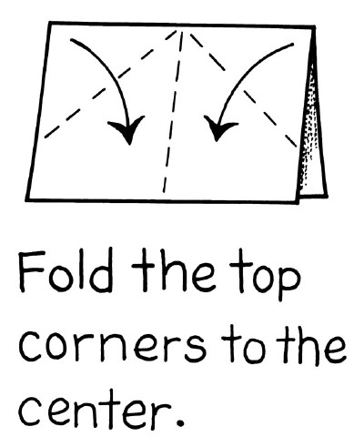 Step 4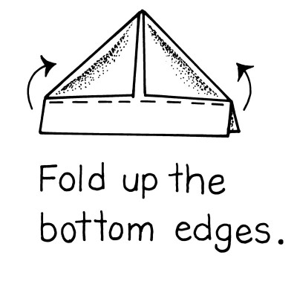 Step 5 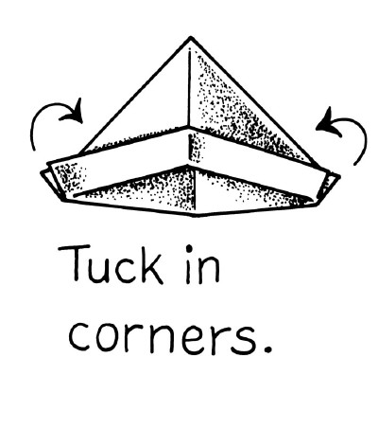

Grade K Module#3 Lesson 3 of 4
Objective: Students will make a clay tile/plate decorated with patterns.
Materials: clay – 1 tennis-ball-sized piece per student, damp sponges on plates for students to share, newspapers on desks, chipboard – 1 piece per student, carving tools (can be toothpicks, plastic utensils, old pencils, etc.)

CLAY PLATE
Opening  Phase | Student Engagement  (5 minutes) | Bring in some different objects made from clay – plates, bowls, cups, etc. Have students describe similarities and differences (form). Have students think about how each object can be used (function).
Exploring/Creating  Phase | Aesthetic Exploration  (10 minutes) | Look at art images of decorative objects from around the world made from clay with patterns/designs (e.g. containers, ceramic plates, clay tiles). Discuss how clay is used and where it comes from.  Pass around two or three balls of clay and let students explore and touch it. Review what a pattern is.  Explain that the students will be making a clay plate. What could it be used for?
Exploring/Creating  Phase | Demonstration  (5 minutes) | Model how to flatten out the ball of clay into a kind of “pancake” without making it too thin. Their plate can be round or square. Show students how to use tools to carve into the clay to make their patterns.
Exploring/Creating  Phase | Creative Expression  (25 minutes) | Make a clay tile. Use a stick to scratch patterns into clay. Tell your partner how you are going to use it.
Reflection  Phase | Reflection/Assessment  (5 minutes) | Journal Reflection: Draw a picture of how you can use your tile. Write a title for your drawing.

Grade K Module#3 Lesson 4 of 4
Objective: Students will decorate a place mat for a special celebration.
Materials: *If drawing: 12”x18” colored construction paper (1 per student), crayons/construction paper crayons, or markers
*If making a collage: 12”x18” colored construction paper (1 per student), scraps of construction paper, scissors, glue/glue sticks
*If using felt: 9”x12” felt pieces (1 per student), felt scraps, sharp kids scissors (for easy cutting), glue sticks or tacky glue

PLACE MATS
Opening  Phase | Student Engagement  (5 minutes) | Ask students to think about special celebrations they share with their families and friends. Chart ideas on a circle map.
Exploring/Creating  Phase | Aesthetic Exploration  (10 minutes) | Show images of people celebrating (i.e. Carmen Lomas Garza’s Lala and Tudi’s Birthday Party and Faith Ringgold’s The Church Picnic Story Quilt). Ask students “What are some things you see that tell you that these people are celebrating something?” Ask students if they ever use anything special when they celebrate different events (holidays, birthdays, etc.) Possible answers could be special clothing, food, decorations, party hats, etc. Add their ideas to the “celebrations” circle map.  Explain that sometimes when we have special celebrations that involve eating, we use special dishes (like those made in the prior lesson) and table settings (i.e. silverware and/or placemats). The students will make placemats for a special occasion of their choice.
Exploring/Creating  Phase | Demonstration  (5 minutes) | Before beginning to make your placemat, ask students to choose a special celebration. Their placemat should reflect the celebration in its imagery (i.e. appropriate symbols/pictures for the chosen event). Show students how to create a placemat using selected materials. If the selected celebration is a birthday, what are some symbols or pictures that are related to birthdays (cakes, presents, etc.)? Or a holiday? Model how to draw or cut simple shapes and lines to create their design.  *This lesson can be done as a drawing, collage, or with felt.
Exploring/Creating  Phase | Creative Expression  (25 minutes) | Students will make their placemat with selected materials, depicting imagery related to their selected celebration.
Reflection  Phase | Reflection/Assessment  (5 minutes) | Journal Reflection: Draw a picture of yourself using your placemat to eat a special meal. Write a title for your drawing.

