1. **POLICY OVERVIEW**
   1. This policy establishes uniform practices and procedures to be followed for authorizing ITD software projects.
   2. LAUSD’s Information Technology Division is responsible for implementation of this policy and will coordinate regular efforts to ensure compliance. Questions about this policy may be directed, via e-mail, to the ITD Project Management Office: [SMO-ITD-ProjectManagementOffice@lausd.onmicrosoft.com](mailto:SMO-ITD-ProjectManagementOffice@lausd.onmicrosoft.com)
   3. ITD is dedicated to maintaining a policy that is comprehensive, accurate, and current. If there are instances in which this policy omits or is unable to clarify scenarios for accurate implementation or if an employee believes that the policy may be incomplete or inaccurate, please email ITD PMO.
2. **PURPOSE**
   1. This policy is designed to enhance organizational efficiency and improve internal controls by defining policies that detail the requirements for securing approval of an ITD software project.
   2. Effective project request approval controls will be implemented to:
      1. Ensure projects are aligned with LAUSD initiatives and provide positive business value.
      2. Provide a mechanism for project and resource prioritization and a forum that identifies potential issues pro-actively.
      3. Ensure that all approved projects have been fully budgeted.
      4. Ensure that resources are available to undertake the project.
3. **SCOPE**
   1. This policy applies to all requests for project-related services submitted to ITD that meet the LAUSD Strategic Initiatives.
      1. This policy applies to requests that require new development (new application/system enhancements) and/or changes (modifications to existing applications/systems).
      2. This includes requests for development that add or change functions or peripheral output/processes such as reports and interfaces to or from these applications/systems **if the level of work effort exceeds 20 hours**.
      3. This policy does not address requests for services processed via a Helpdesk ticket or changes made to the ITD Infrastructure or Applications environment that are considered routine changes to support standard operations.
4. **ROLES AND RESPONSIBILITIES** 
   1. Business Sponsors
      1. Must understand this policy and the project lifecycle (See Figure 1).
      2. Should raise and/or approve ITD Requests with benefits that are:
         * + Aligned to district strategy.
           + Are in the best interest of the district.
           + Warrant the estimated costs and effort.

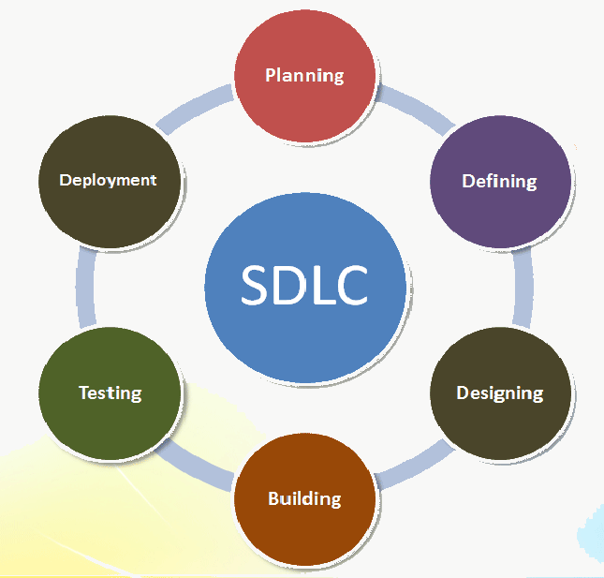

**Figure 1: Software Development Life Cycle (SDLC).**

* 1. ITD Project Management Office (PMO)
     1. Defines ITD Project Request approval policies and procedures to ensure ITD undertakes projects that warrant the estimated costs and effort.
     2. Serves as a primary point of contact for general ITD Project Request updates and guidance (request status, project approval updates, project compliance, and general support).
     3. Facilitates ITD Project Requests.
     4. Participates in charter approval process meetings in which new ITD project requests are reviewed and accepted or rejected.
     5. Reviews final project charter to ensure costs align to the initial cost estimates presented and approved by the ITD Project Charter Committee.
     6. Generates Project ID in the ITD Project Tracking application in Quickbase.
     7. Authorizes project to move into the “Planning” status in the ITD Project Tracking database.
     8. Facilitates the strategic initiative review and approval process (See Figure 2).
  2. ITD Project Manager
     1. Works with Business Sponsors to understand business requirements.
     2. Provides general guidance and support on all ITD requests including, but not limited to, providing suggestions for prioritization, scheduling, and preparing artifacts for project approval.
     3. Serves as the business–ITD liaison throughout the project lifecycle, providing updates, guidance and support (i.e., project status, prioritization, issue resolution, requirement updates, etc.).
     4. Coordinates all efforts associated with the ITD Request until approval is received.
     5. Ensures the overall requirements/needs of the Business Sponsor are fulfilled.

1. **POLICY**
   1. Project Initiative Requests
      1. All ITD Project Requests must have an appropriate Business Sponsor – a Department Head for business-initiated requests and an ITD Director for internal ITD-driven changes.
      2. A Project Request form is completed by Business Sponsor and submitted by the Sponsor to ITD PMO for preliminary review. Initial Requirements:
         1. Clear definition of business problem to be resolved or opportunity to be capitalized on.
         2. Description of business benefits, needs, risk avoided, mitigation plan, etc.
         3. High level scope statement: Timeline Range, Budget Range, Deliverables in scope, and Assumptions.
      3. ITD Requests must cycle through a multistep workflow process to ensure sufficient data is collected to assess scope, benefits, timelines, resource requirements, and cost.
      4. ITD Project Requests require project charter review and are to be approved by the ITD Project Charter Committee before detailed analysis and planning begins, before project work begins, including the procurement of external labor services, hardware, software, and generation of Project ID.

**Figure 2: ITD PMO Flow**

 **Figure 2: ITD PMO Flow**