Toolkit: Facilitator Guide


Timeframe: Approximately 30-45 minutes, depending on Q&A time, etc.
Audience: Parents, community members, and other stakeholders.

Preparation for Community Engagement about the “School Experience Survey for Parents” connections to the Strategic Plan

The “Big Ideas”
Los Angeles Unified School District released the 2022-2026 Strategic Plan, which was approved by the Board of Education on June 21, 2022. The Strategic Plan’s Pillar 3 (Engagement and Collaboration) identifies 3 Priorities that specifically require items and metrics from the SES Parent Survey to address 4 different Measures of Success.

This toolkit includes a PowerPoint presentation and a Facilitation Guide. Parents, families, and community partners who participate in this series will receive a quick introduction and overview about the 2022-2026 Strategic Plan and learn about 1) the importance of the SES; 2) how results are used; and 3) how the Parent Survey is directly connected to Pillar 3’s Priorities 3A, 3B, and 3D.

Principals are encouraged to invite stakeholders to download a copy of the plan so that they may understand the key components before learning about how their school plans to address each Measure of Success.

Participants’ Learning/ Performance Objectives
By participating in this community engagement effort, stakeholders will:
- Understand the importance of the SES and how results are used
- Learn about the key components of the 2022-2026 Strategic Plan
- Learn about the direct connections between the SES for Parents and the Strategic Plan
- Learn about the school’s plan to meet the district’s goals for each of the Pillar 3 Priorities that pertain to parents/families.

Preparing for Strategic Plan Community Engagement
- Review the 2022-2026 Strategic Plan facilitator guide
- Review the 2022-2026 Strategic Plan document and website at achieve.lausd.net/strategicplan
- Use the SES results dashboard to determine your Fall 2021 baselines for the four SES Parent Survey items/metrics, input the information in your Excel file “Progress Tracker” to determine your 2026 Goals. For assistance with how to use this tool, click HERE.
- Meet with your school team to review the Pillar 3 training slide deck and discuss ways to achieve each of the three Pillar 3 Priorities that pertain to parents/families.
- Add the information to slide 38 of this presentation:
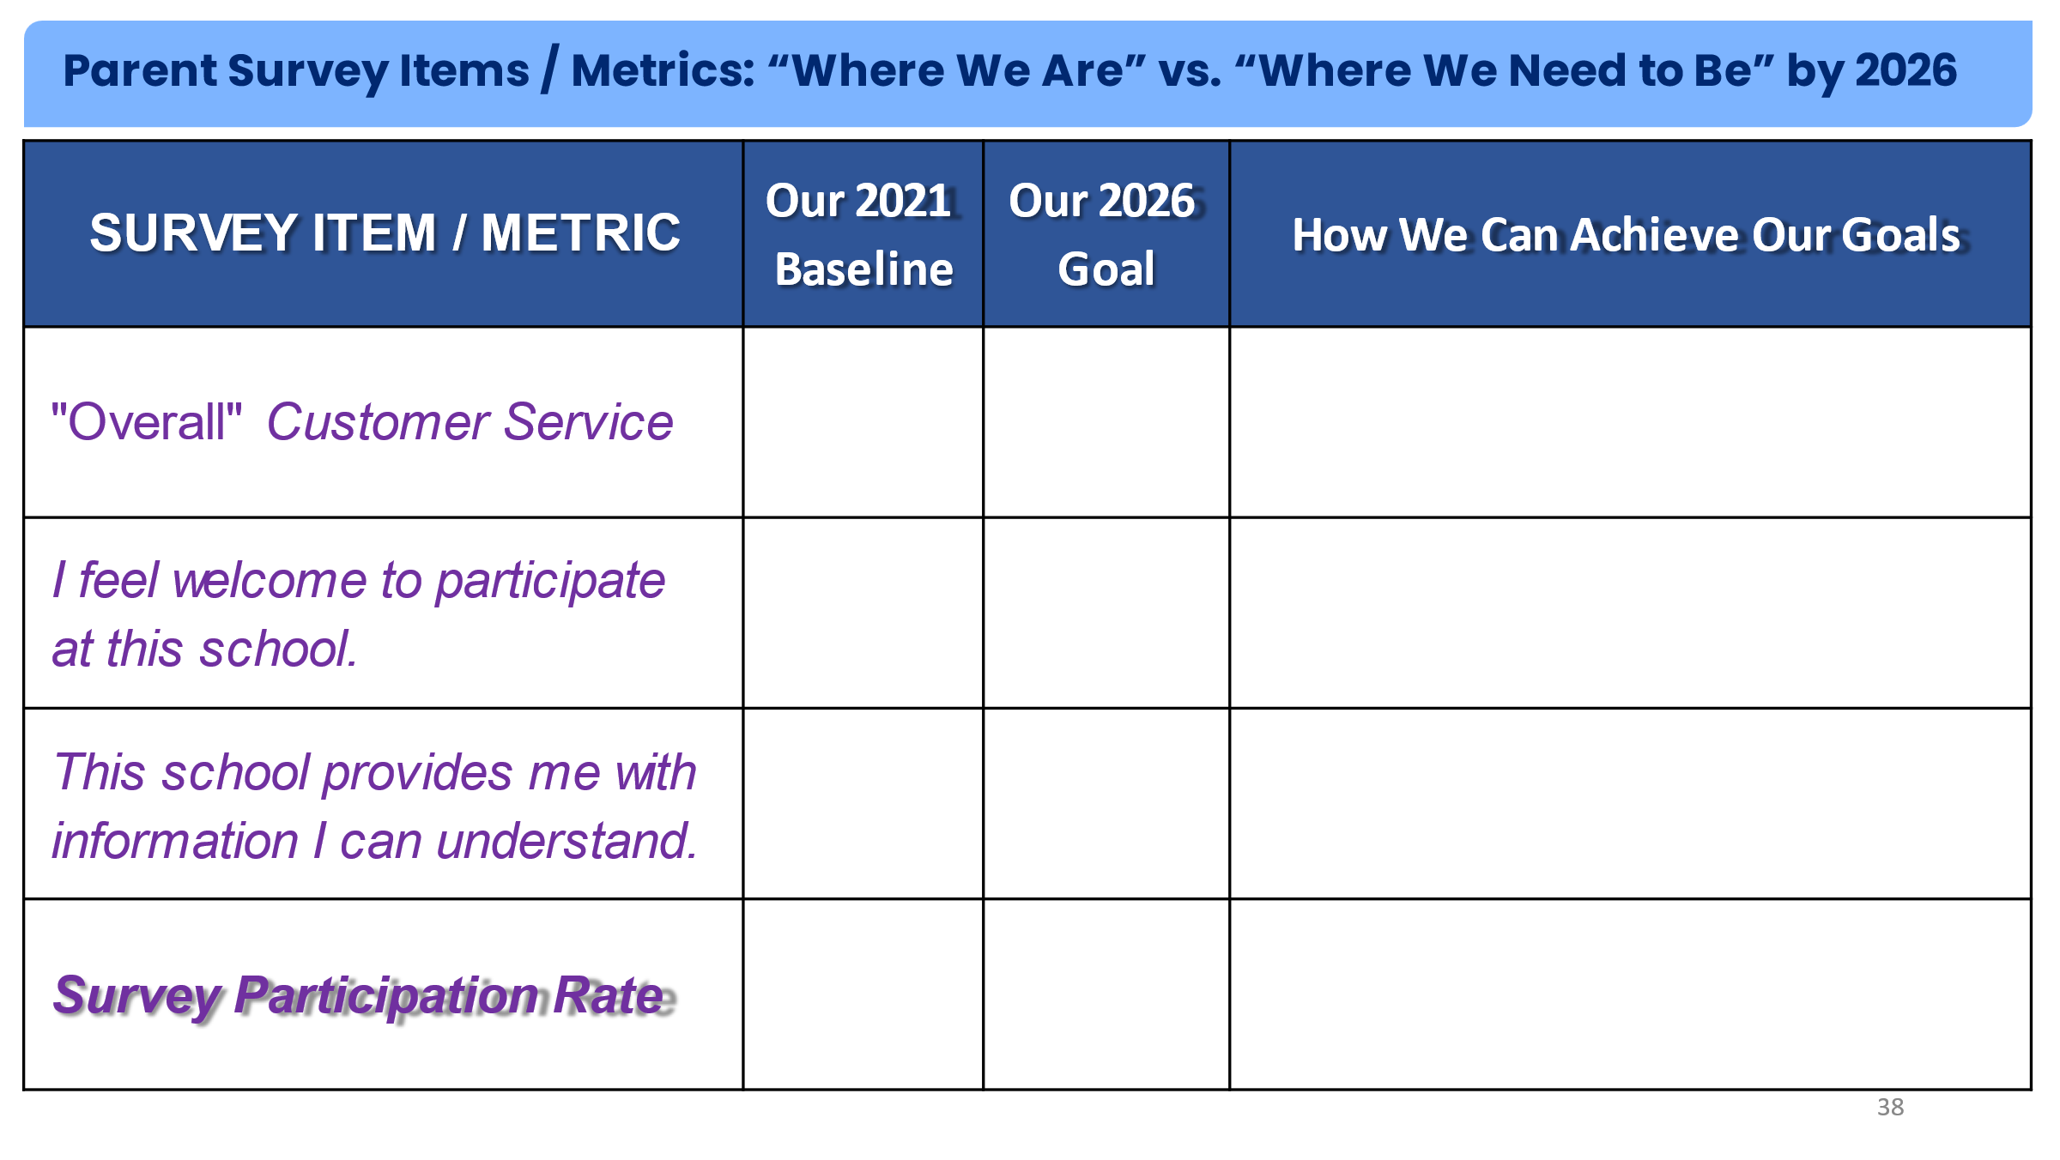
- Schedule meeting with families to present “Strategic Plan: Connection to the SES for Parents” slide deck and be prepared to discuss your school’s plans to achieve each goal.

Facilitator Guide
School Experience Survey for Parents:
Connections to the Strategic Plan
Slide | Slide View | Presenter’s Text
1 |  | ​[WELCOME SLIDE]  Thank you for joining us today. We are excited to provide an overview of the how the School Experience Survey for Parents is connected to the District’s Strategic Plan.  [ADD NAME OF LOCAL DISTRICT, COS, and/or SCHOOL PRESENTERS AND LOGO TO SLIDE]
2 | 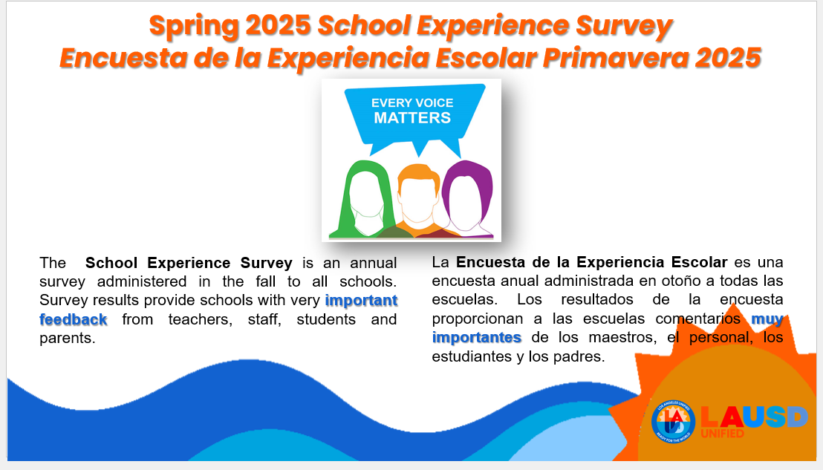 | Let’s begin with an overview about the importance of the annual SES.  [This slide establishes the importance of the SES.]
3 | 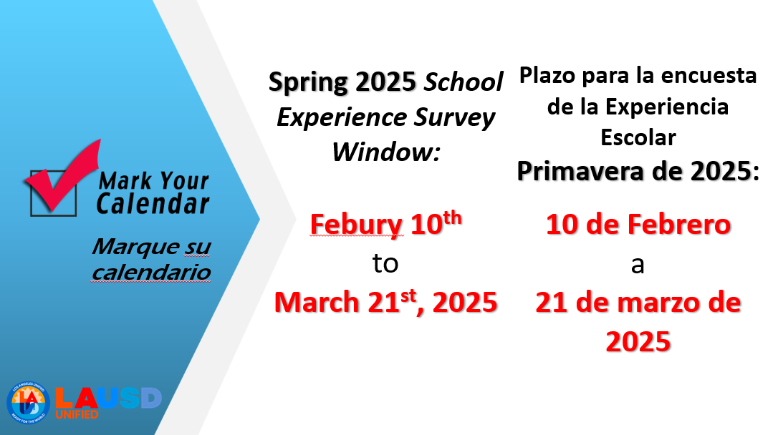 | [SES administration window reminder]  NOTE: SLIDES 3, 4, 5, 6, and 7 CAN BE OMITTED IF YOU DON’T WANT TO COVER THIS INFORMATION IN YOUR PRESENTATION.
4 | 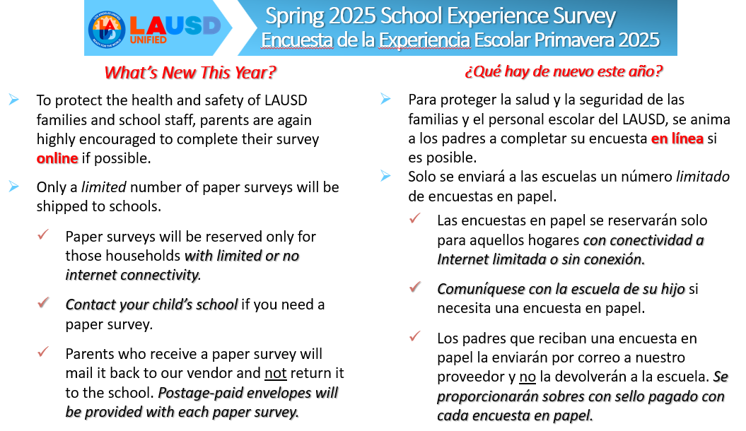 | [This slide explains what is new with the survey]  NOTE: SLIDES 3, 4, 5, 6, and 7 CAN BE OMITTED IF YOU DON’T WANT TO COVER THIS INFORMATION IN YOUR PRESENTATION.
5 | 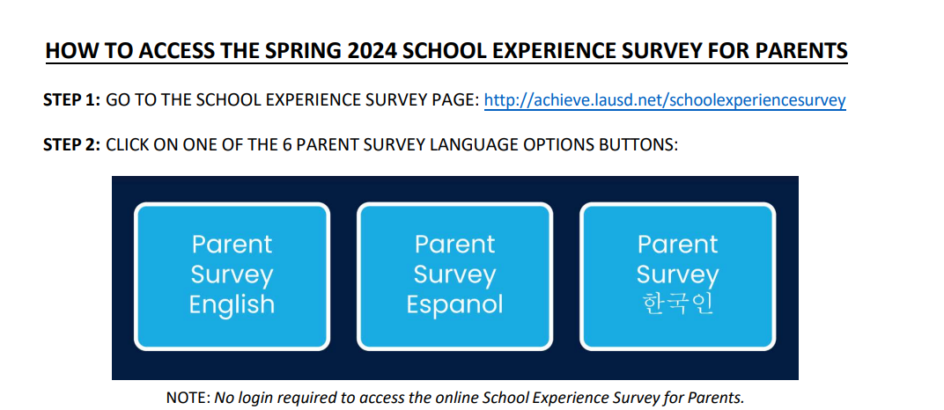 | [This slide explains where parents go to take the online survey and the steps to take to access the survey]  NOTE: SLIDES 3, 4, 5, 6, and 7 CAN BE OMITTED IF YOU DON’T WANT TO COVER THIS INFORMATION IN YOUR PRESENTATION.
6 | 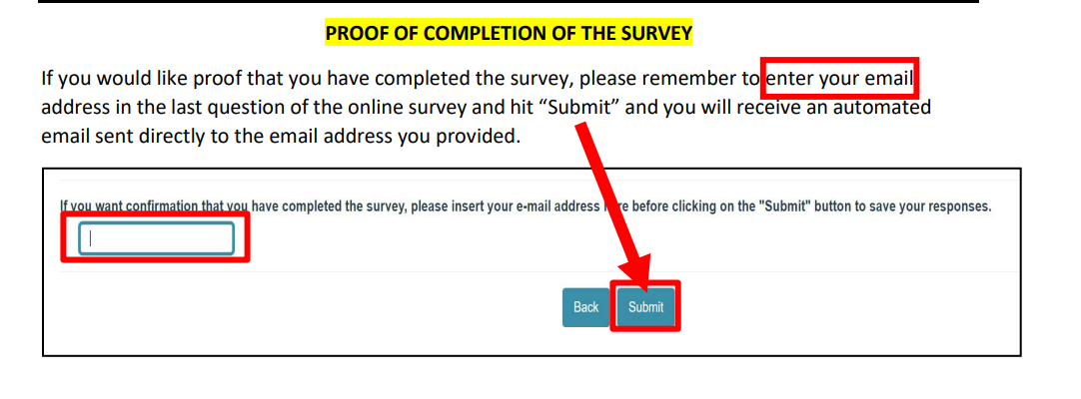 | [this slide explains how parents can obtain proof that they’ve completed the survey if they need it]  NOTE: SLIDES 3, 4, 5, 6, and 7 CAN BE OMITTED IF YOU DON’T WANT TO COVER THIS INFORMATION IN YOUR PRESENTATION.
7 | 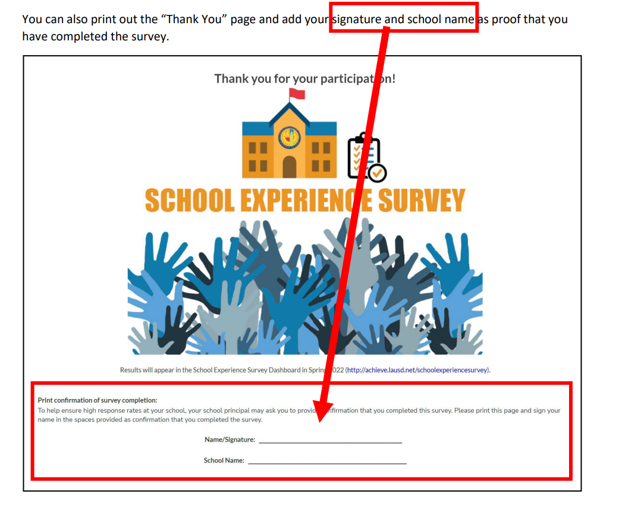 | [this slide explains another way parents can obtain proof that they’ve completed the survey if they need it]  NOTE: SLIDES 3, 4, 5, 6, and 7 CAN BE OMITTED IF YOU DON’T WANT TO COVER THIS INFORMATION IN YOUR PRESENTATION.
8 | 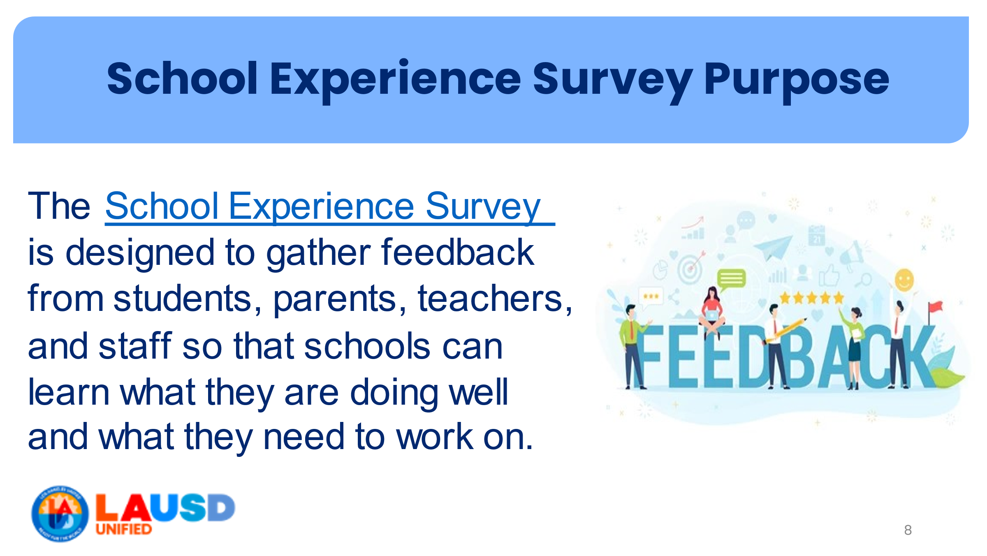 | [purpose of the SES. Read slide]
9 | 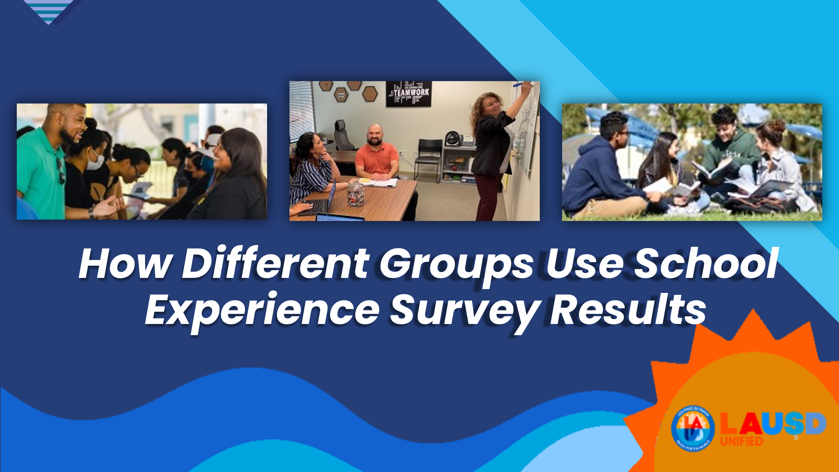 | [transition slide]  So, how do different groups use the SES results?
10 | 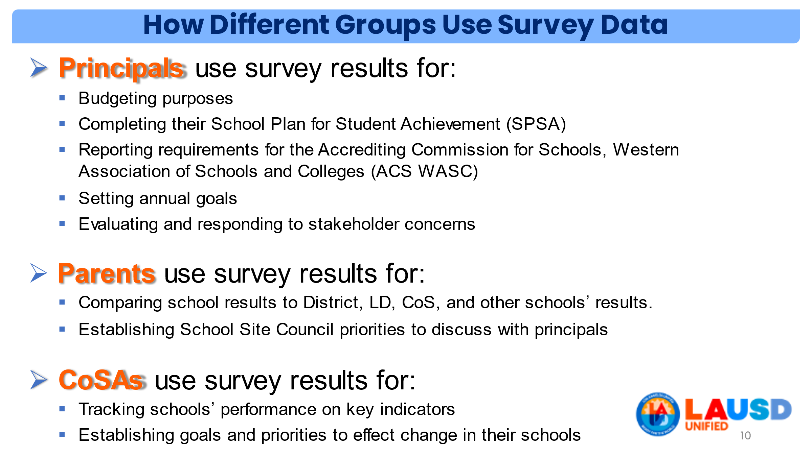 | Various groups have different needs so they often use SES results for lots of different purposes. [slide covers a few examples]
11 |  | [Transition slide]
12 | 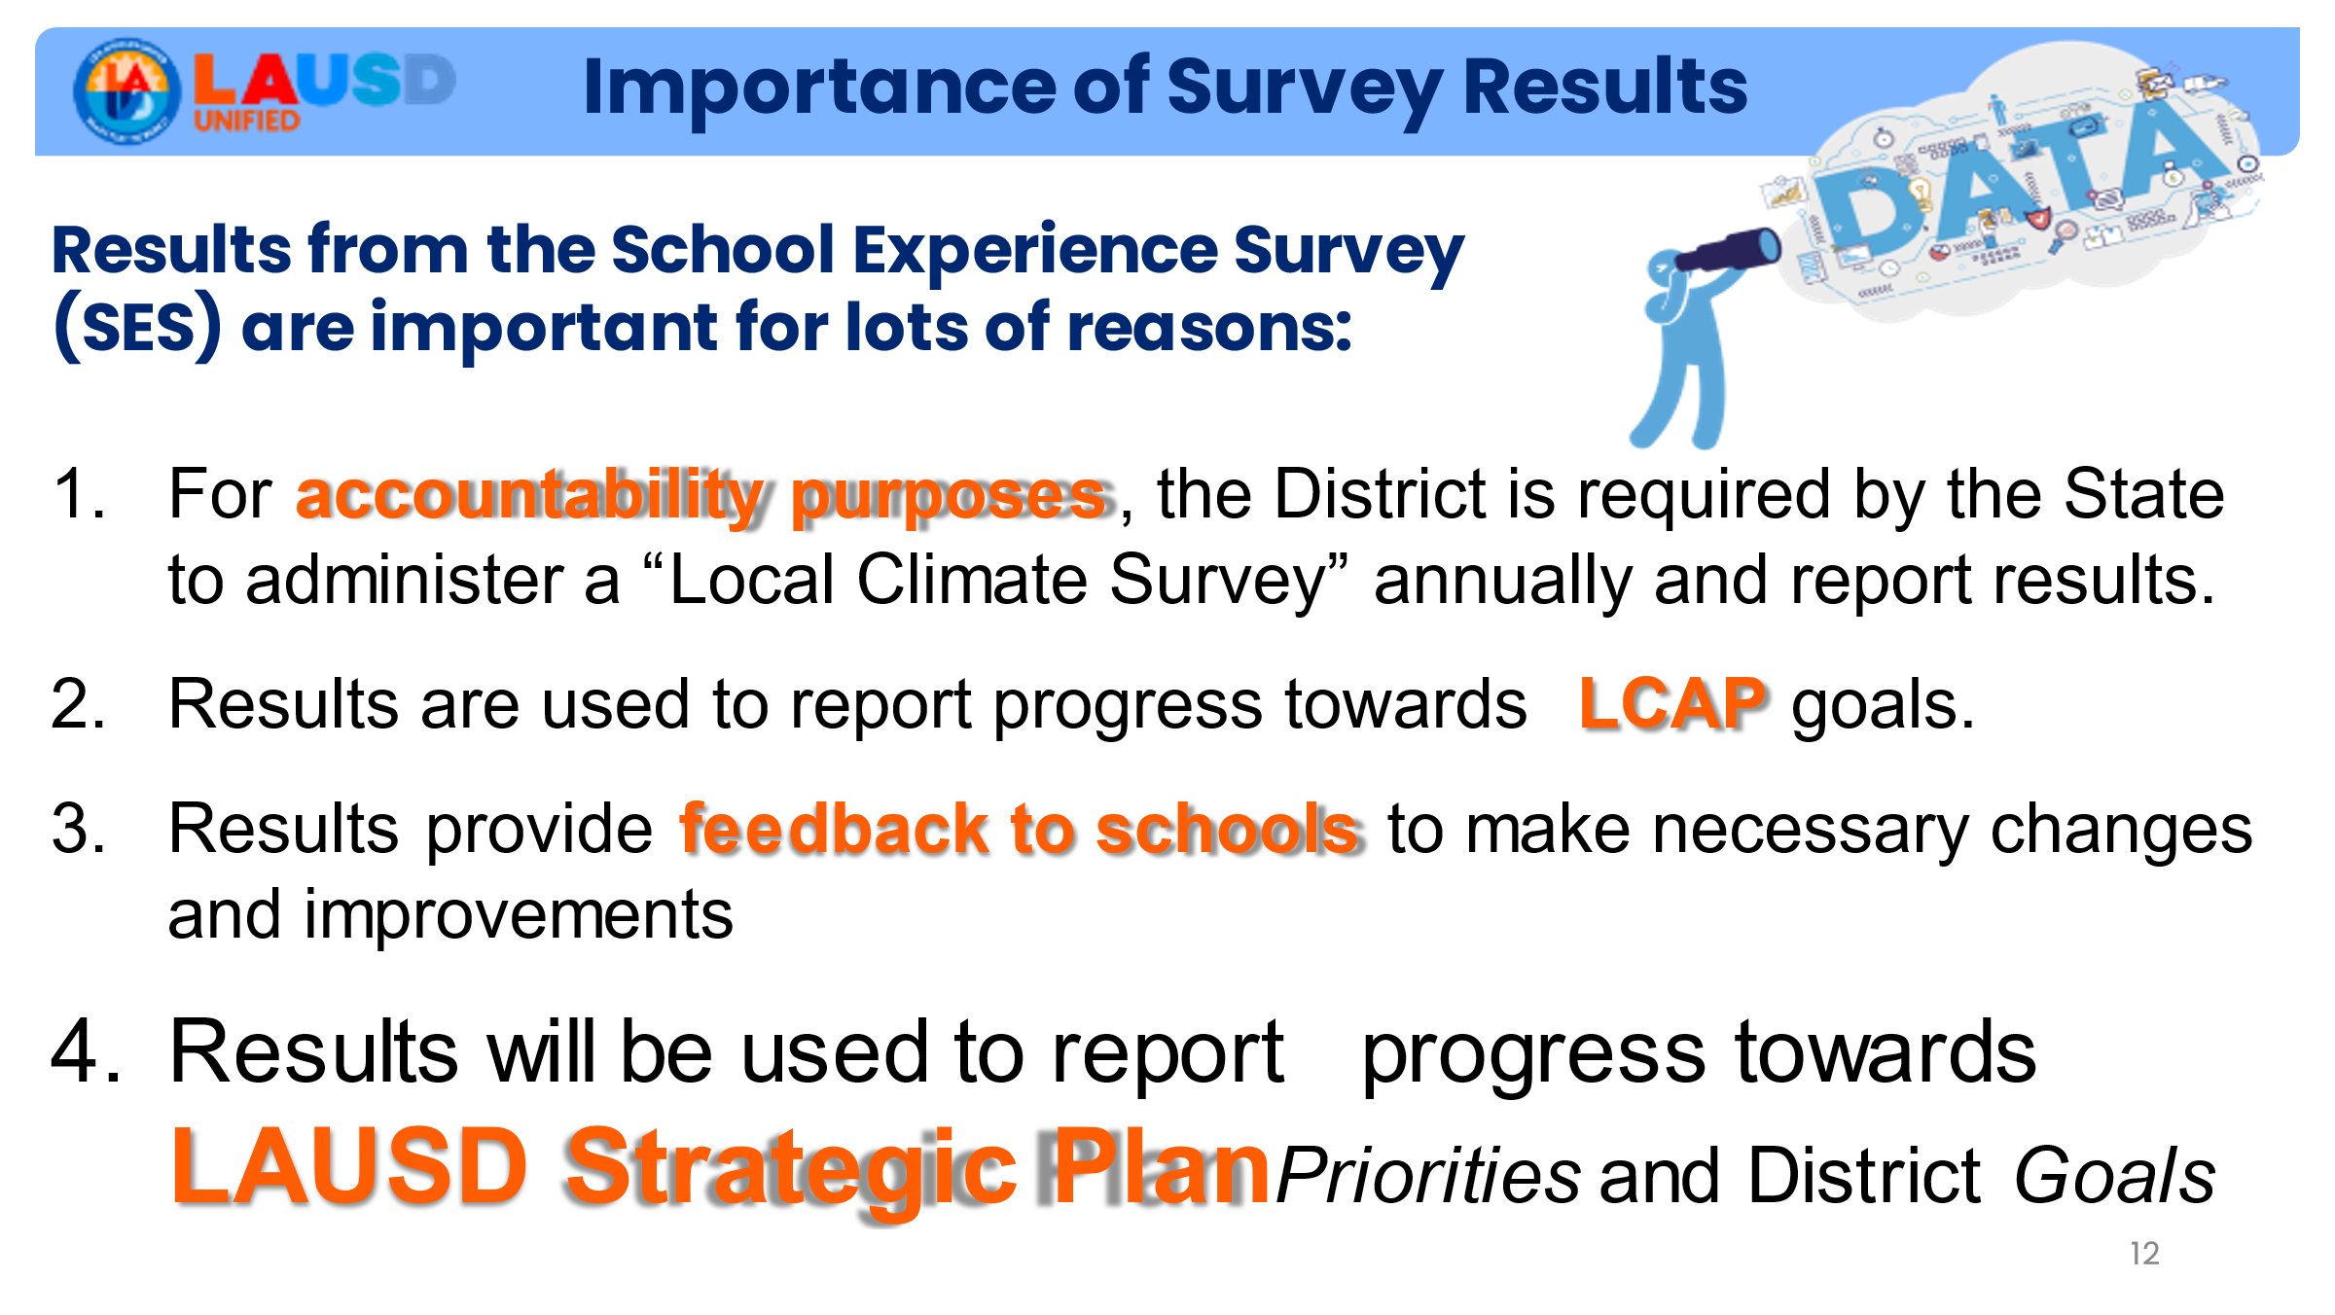 | Survey results are important for lots of reasons, including accountability purposes, tracking LCAP progress, providing feedback, and also for reporting progress towards Strategic Plan priorities and goals.
13 |  | [Transition slide]  Before we get into how the School Experience Survey for Parents is connected to the Strategic Plan, let’s first do a quick review.
14 | 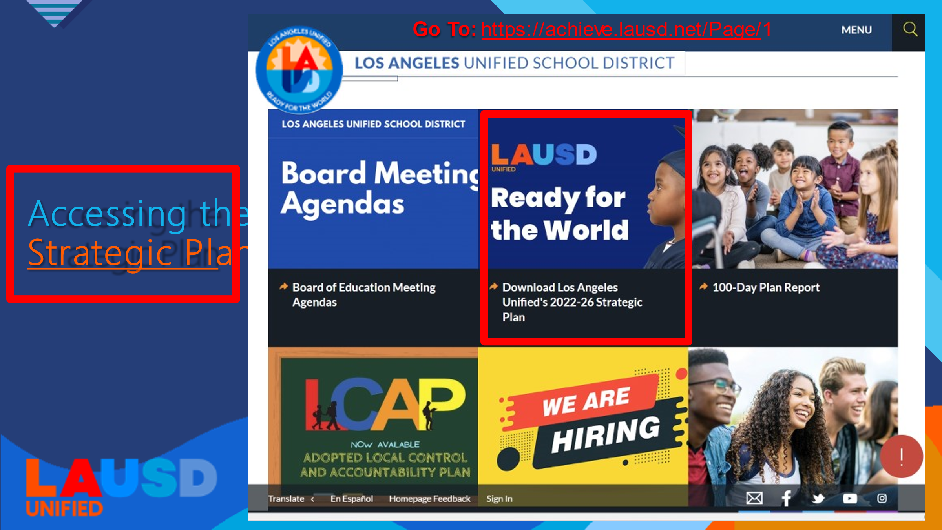 | First, I just want to point out that anyone can access a copy of the Strategic Plan online by going to the LAUSD homepage. There you’ll see a link that will take you directly to an interactive document with live links that help you to navigate easily to the sections you’re most interested in learning more about.
15 | 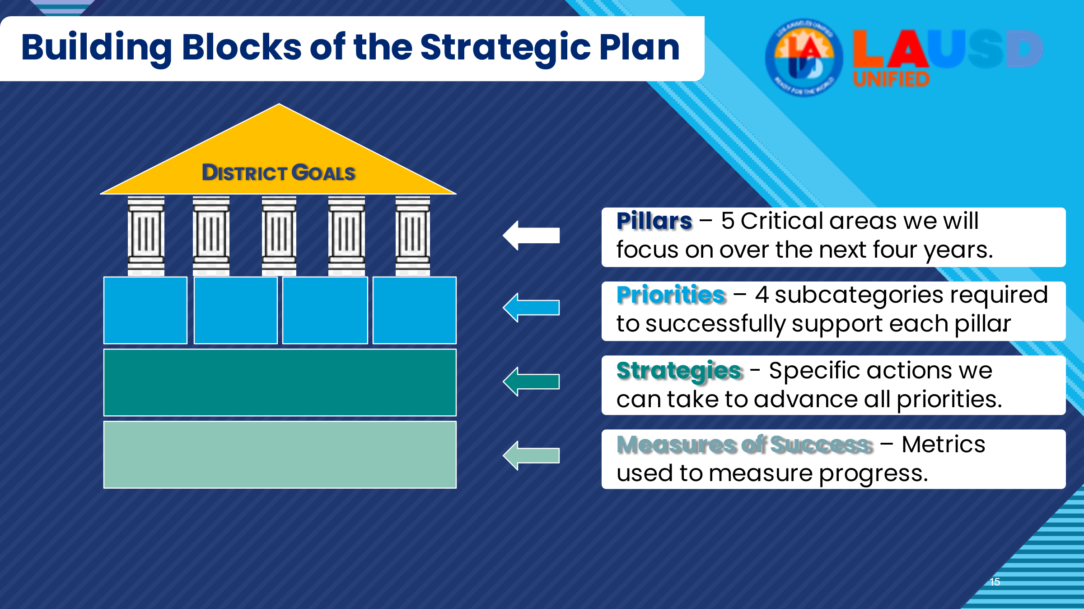 | - This graphic represents the architecture - or building blocks - of the Strategic Plan.  - These building blocks are the pillars, priorities, strategies, and measures of success.  - Note that the Pillars represent the 5 critical areas the district will focus on. Today we will focus only on Pillar 3 because it includes priorities that specifically relate to families and focuses on authentic engagement to leverage the power of our families, communities and educational partners.  - Along with the Strategies, which are specific actions we can take to advance Priorities, you’ll see Measures of Success-or metrics-for each priority. These allow us to monitor our progress toward our goals.  - These measures of success serve several purposes:  - In addition to helping us gauge the impact of our strategies on our students, it provides useful information on ways to optimize or further align our actions.  - Our measures of success also establish accountability so that we can all ensure that we are working in support of the same goals.
16 |  | [Transition slide]
17 | 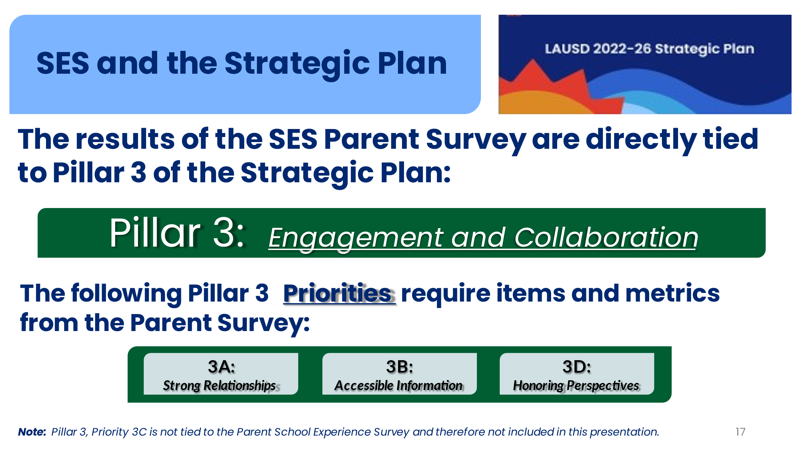 | - In the plan, there is a page for each priority. The Pillar 3 Priorities that are directly related to the School Experience Survey for Parents are 3A, 3B, and 3D.
18 | 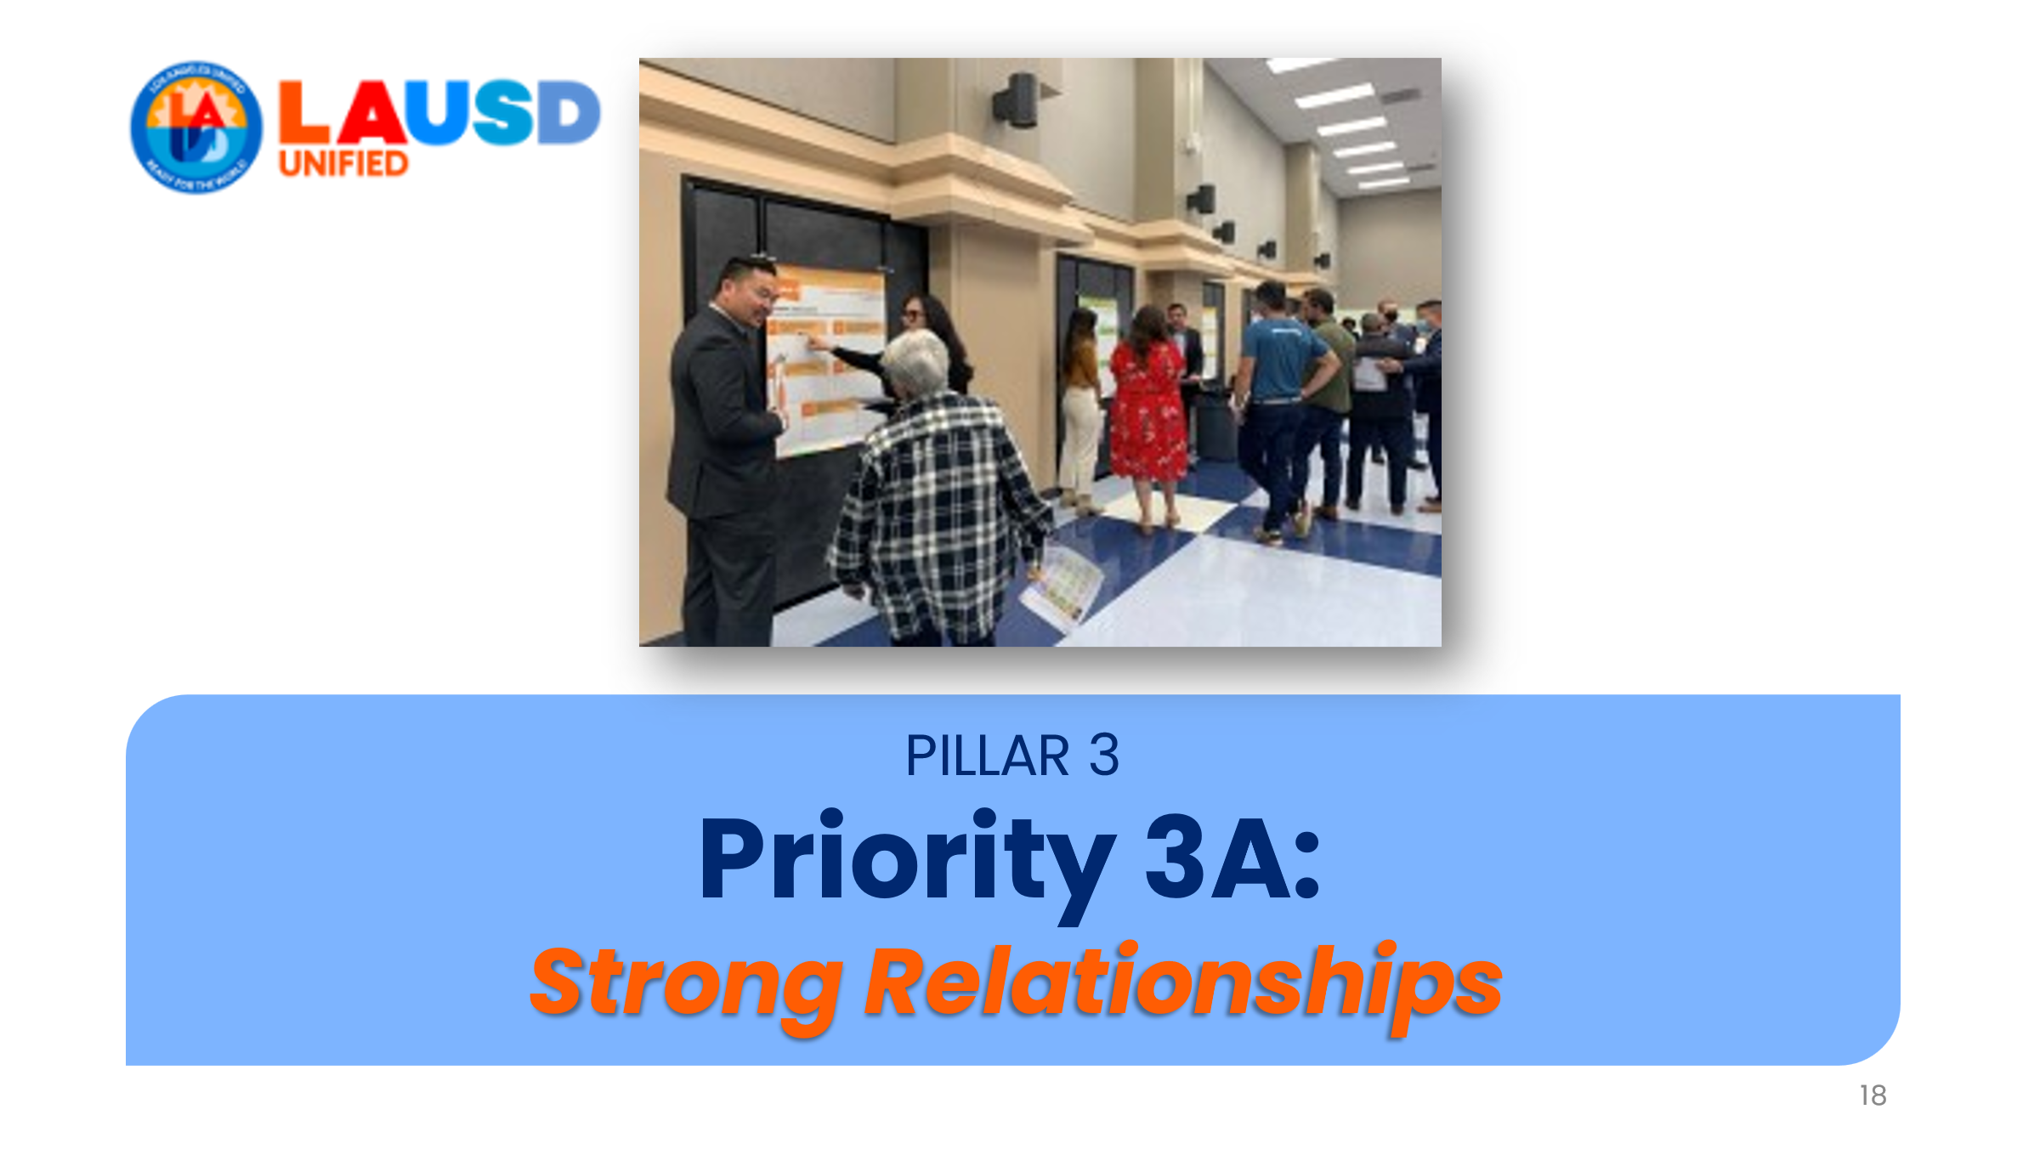 | [transition slide]
19 | 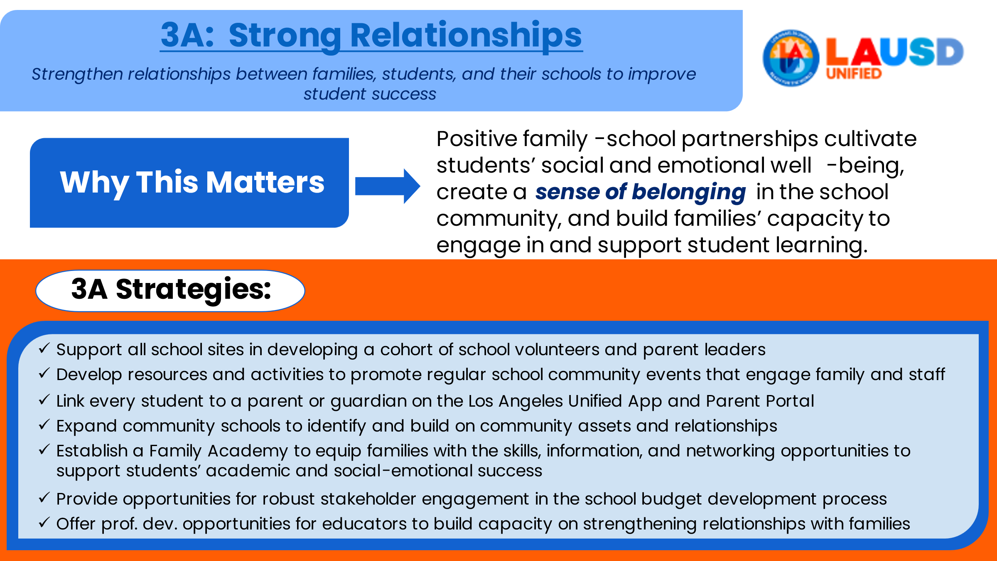 | - Today we will look at all 3 Priorities from Pillar 3 starting with the first priority, which is 3A ,“Strong Relationships.” This priority is important because of its focus on creating a sense of belonging in the school community.  - The Strategic Plan outlines the strategies for each priority that the district believes will be the most impactful ways to move the needle in each area.  - Note that these strategies, such as the ones listed here for Priority 3A, are actions that we can take to support implementation of the plan to meet our targets for each district goal.
20 | 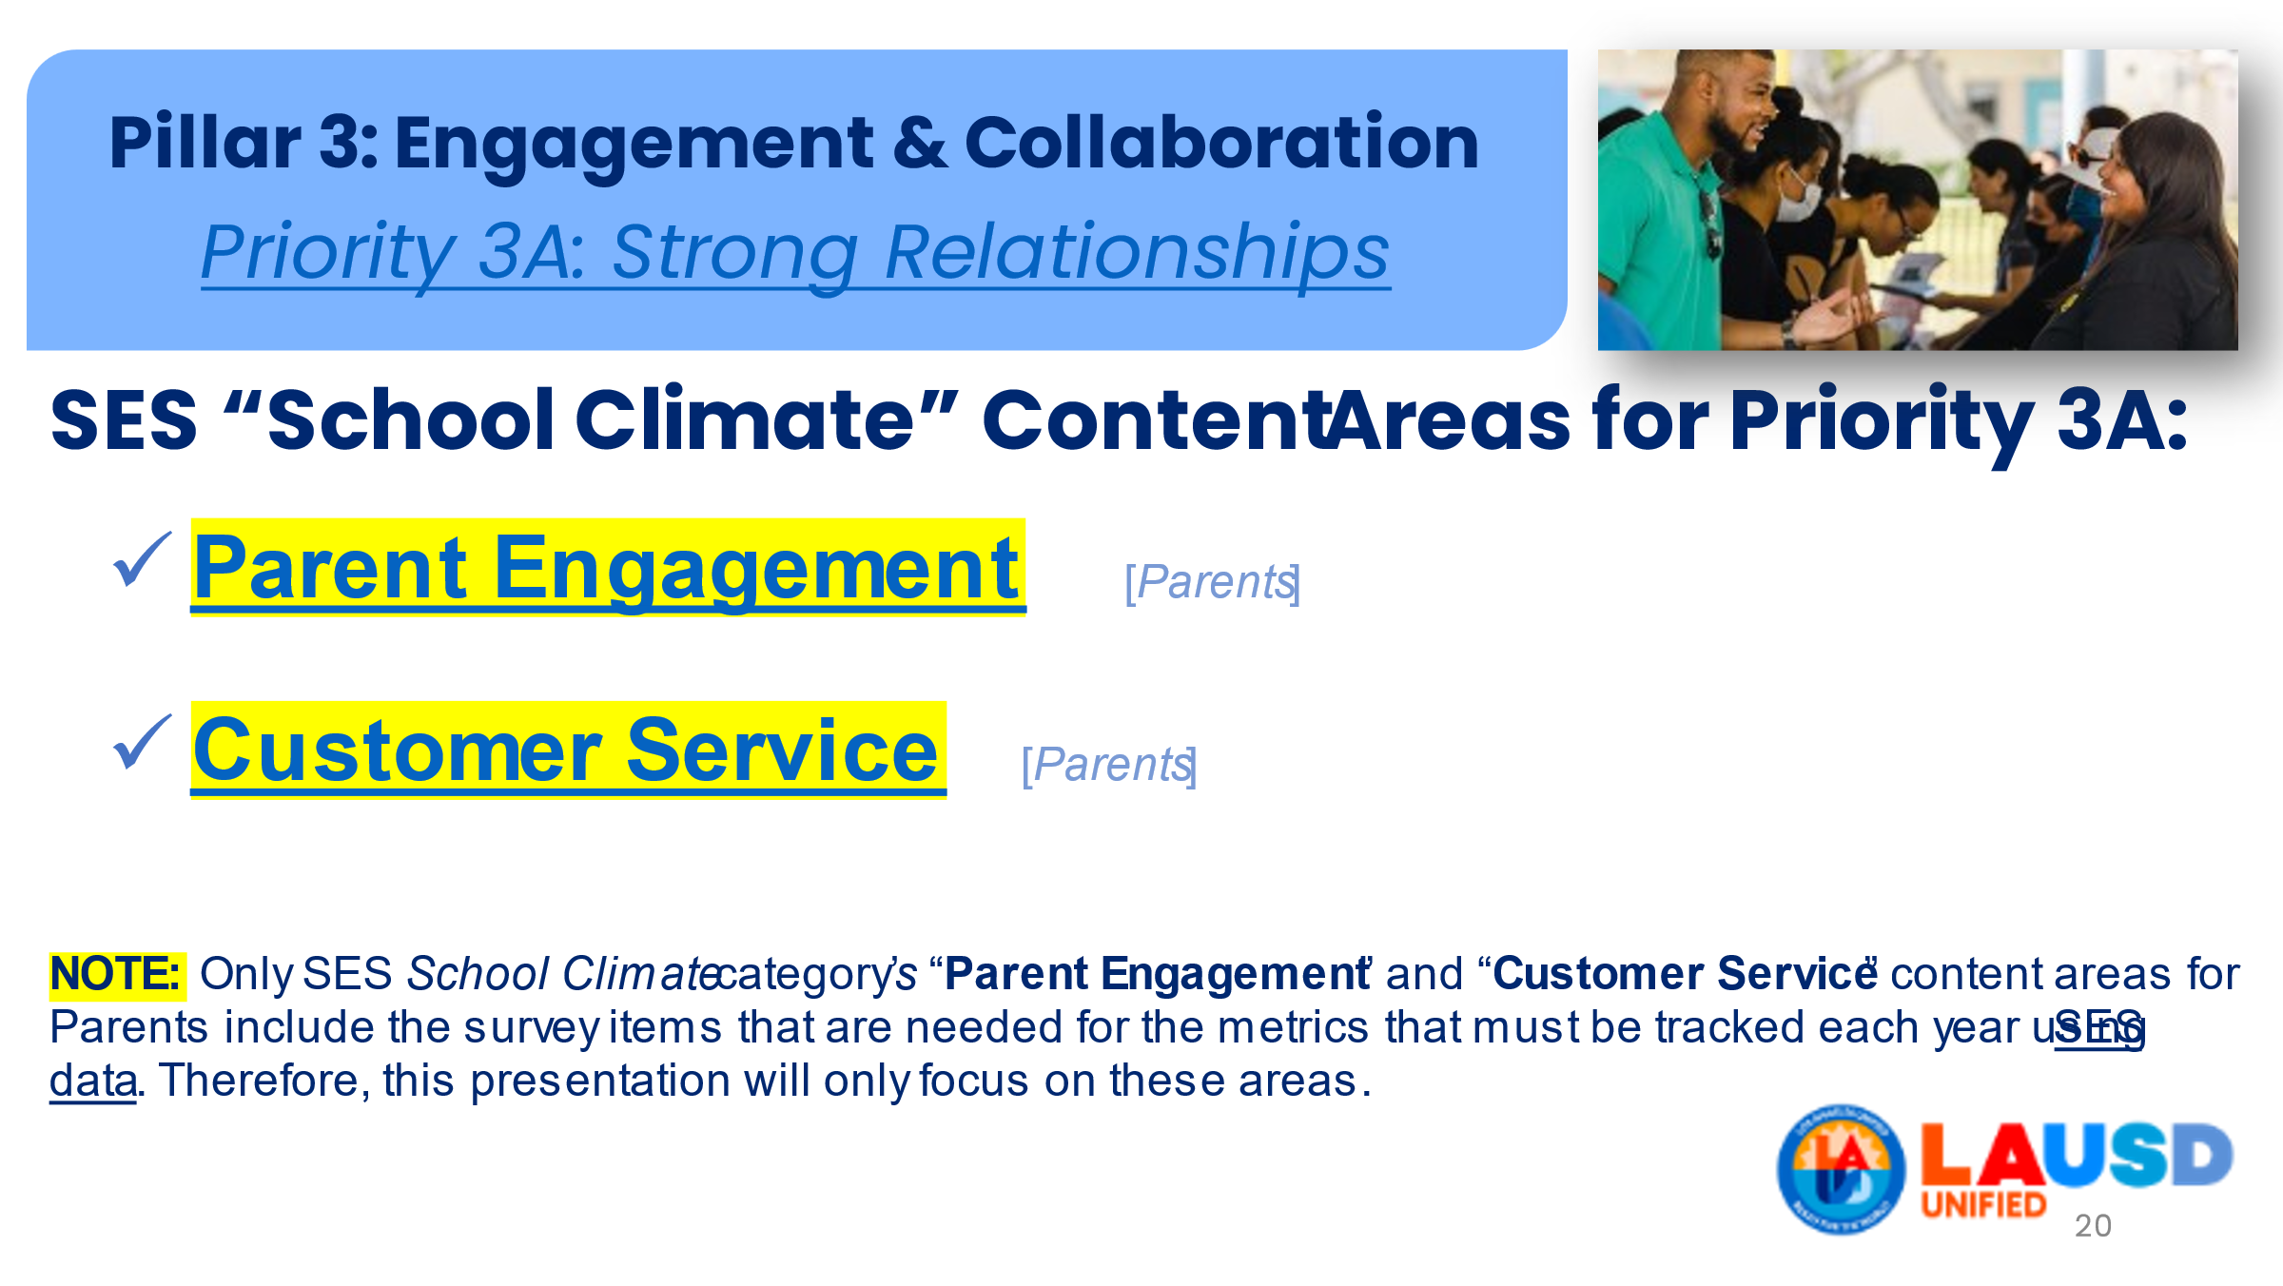 | The school experience survey for parents has specific content areas for groups of items that measure things like parent engagement and customer service. These survey content areas are where you will find the survey items and metrics needed for Priority 3A's Measures of Success.
21 | 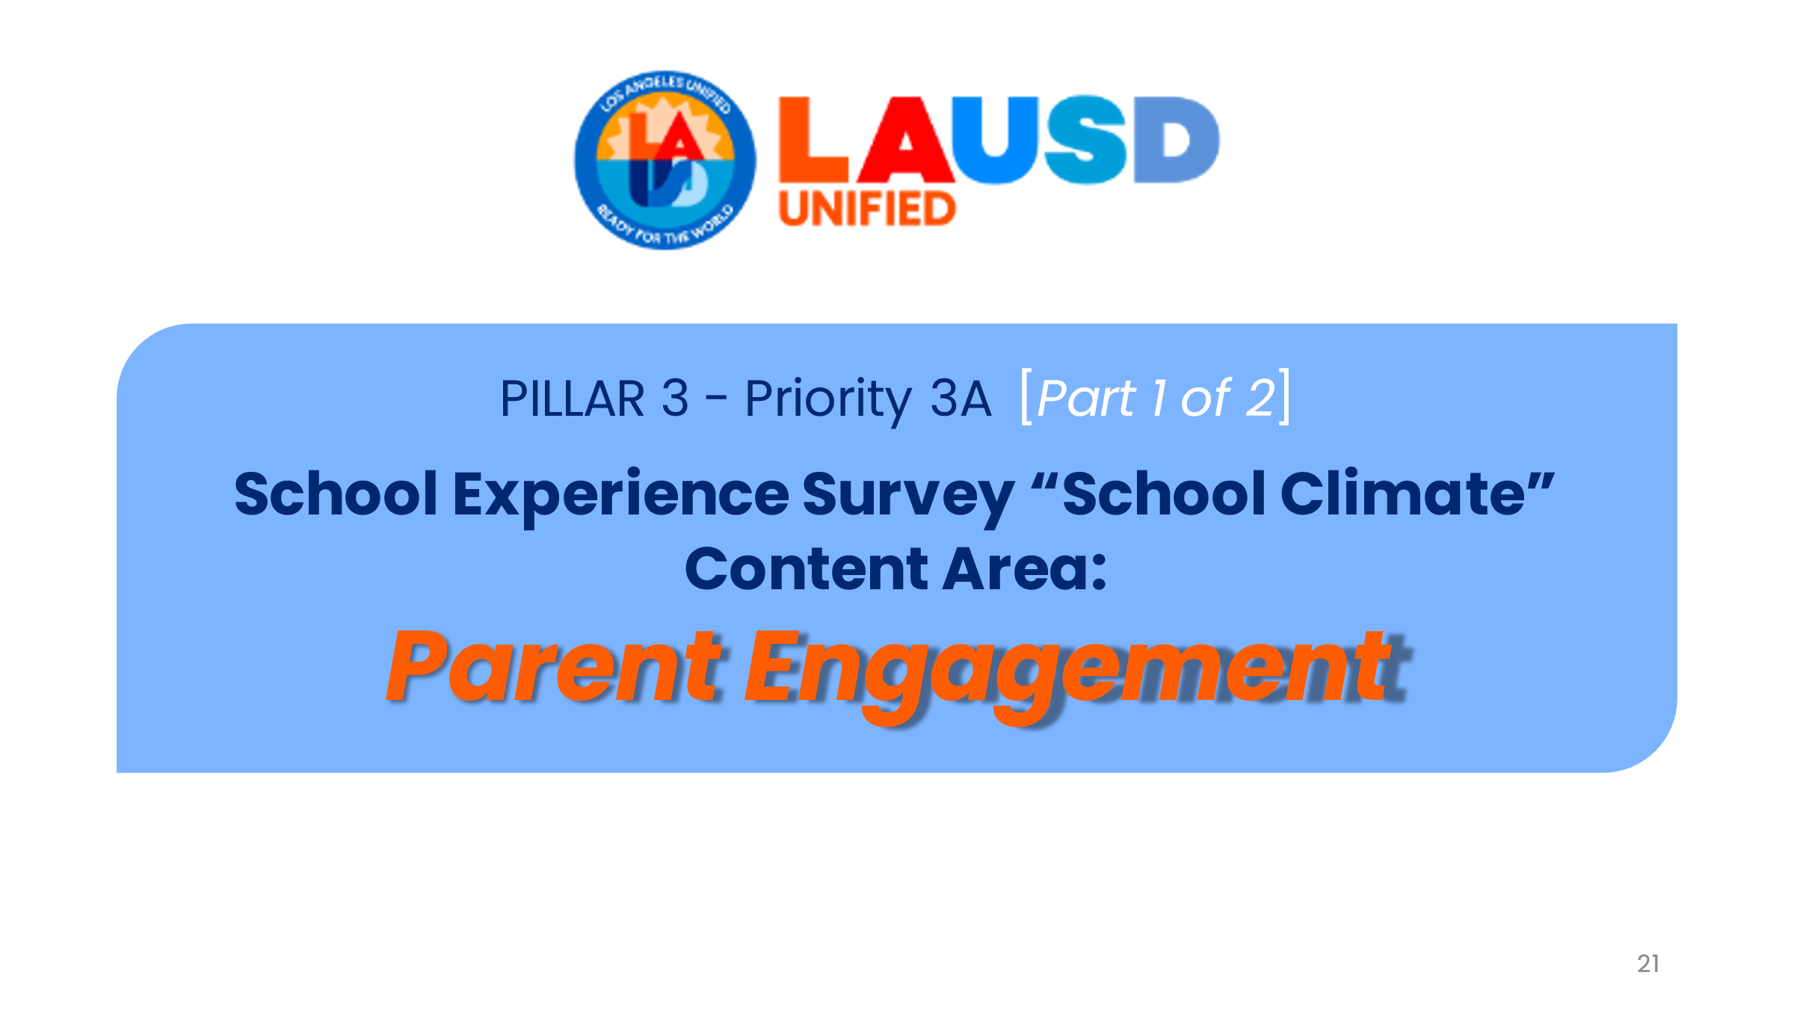 | Priority 3A actually has 2 measures of success, which we’ll cover in just a few minutes. For the first one, the SES content area, “Parent Engagement,” has one survey item that is required by the Strategic Plan to address Pillar 3, Priority 3A.  Note: to review all of the survey’s content areas and how it is organized for each group (parents, students, staff), see “SES categories and content areas” (pic below)  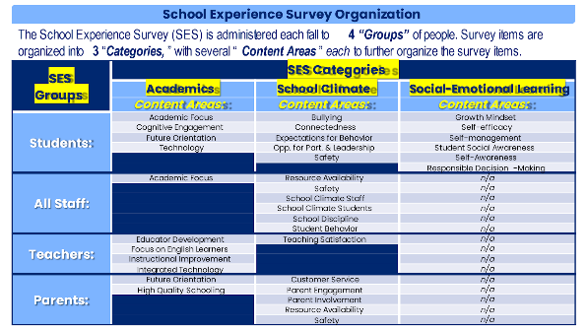
22 | 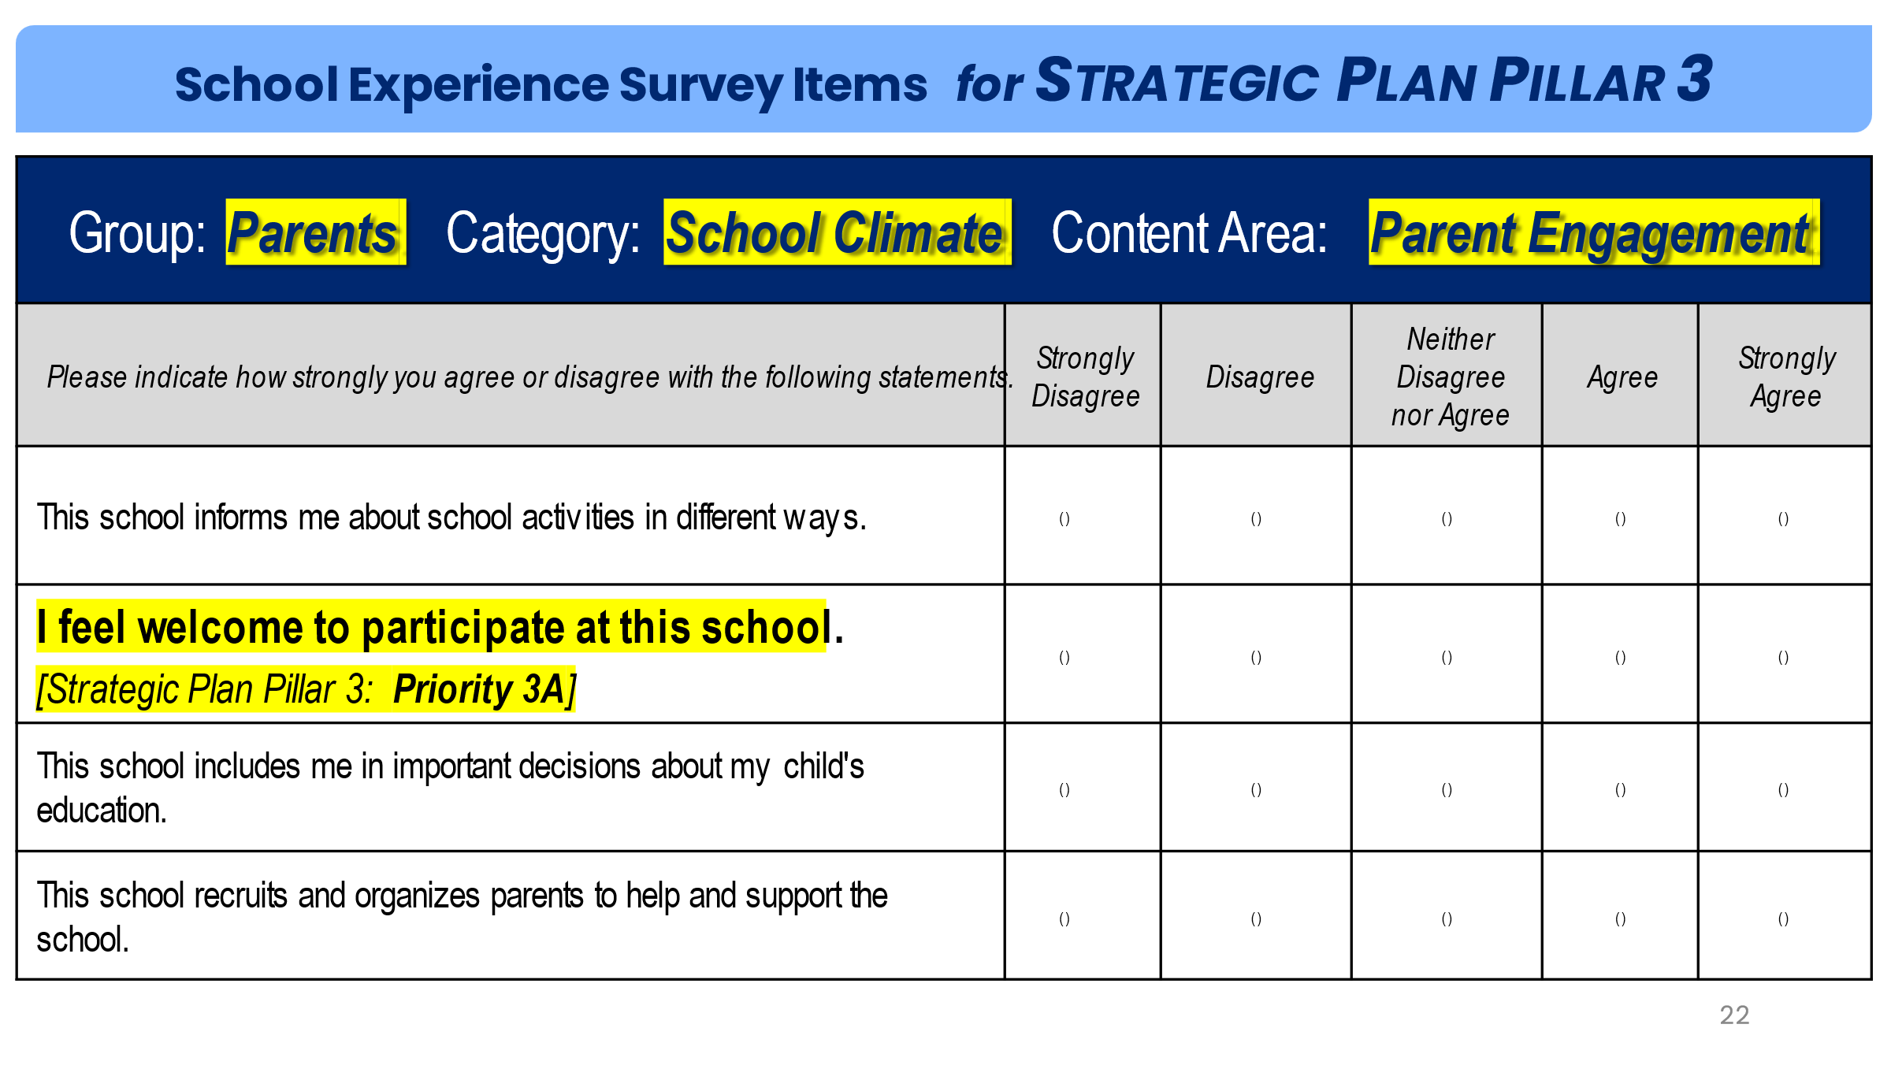 | As you can see here, these are all the items that are part of the SES school climate category’s “parent engagement” content area. However, only the highlighted item, “I feel welcome to participate at this school” is the one item that we are required to use to measure success towards the district goal for on Pillar 3’s Priority 3A outlined in the Plan.
23 | 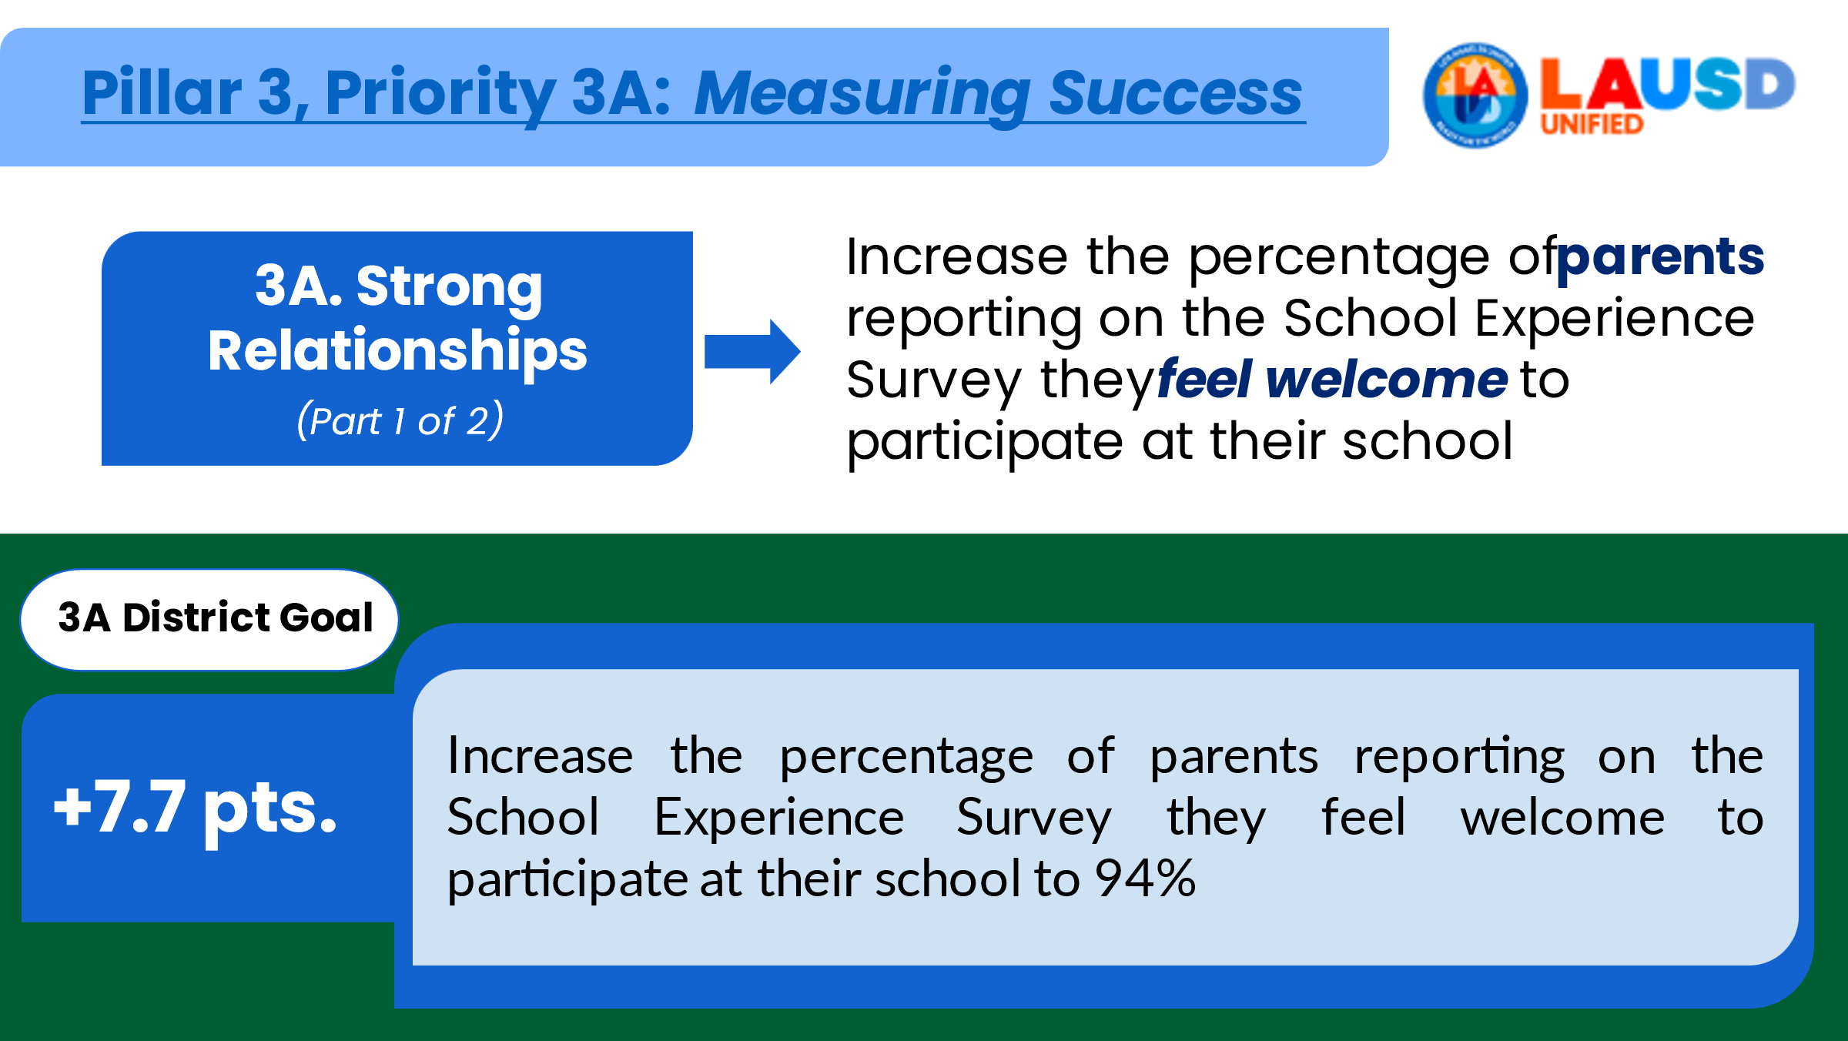 | This slide shows the measure of success for Priority 3A (part 1 of 2) and includes the district goal of a 7.7 percentage point increase by 2026. Note that the district goal of achieving 94% for this item only applies to the district.  Our school will be using the Fall 2021 Parent survey results to set our baseline or “starting point” for each goal, which means that by 2026, we will need to increase the percentage of parents feeling welcome to participate in our school by 7.7 percentage points. In just a few minutes I will explain what our baselines are for each district goal (including this one) and what our 2026 targets are. I will also discuss how our school plans to achieve each goal.
24 | 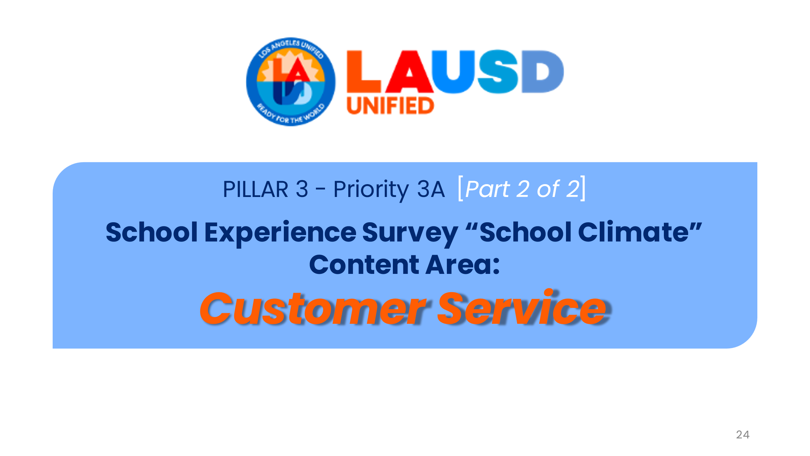 | Now we move onto part 2 of Priority 3A that is tied directly to the Customer Service items on the SES Parent Survey.
25 | 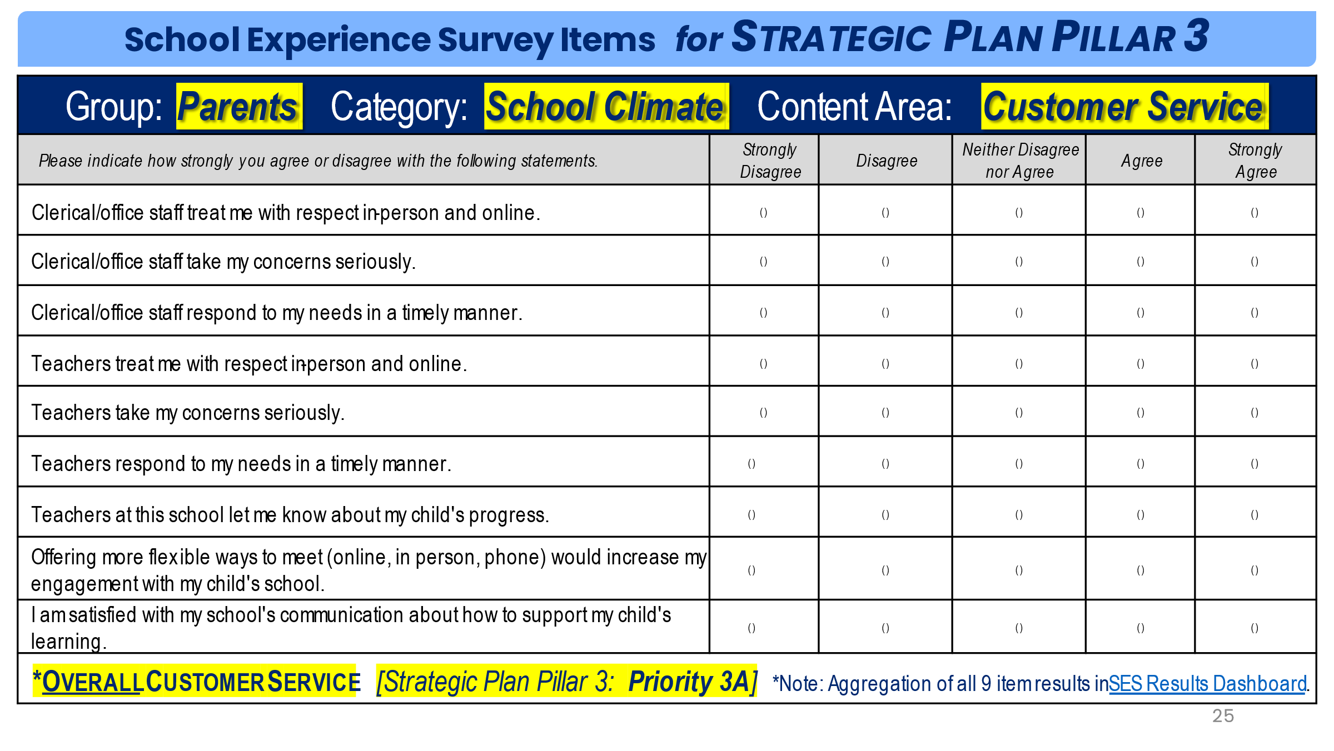 | Here you’ll see all of the Customer Service items that will contribute to our school’s “overall customer service” performance that will be tracked each year to meet our 2026 target. Note that all of these items’ results will be aggregated of combined to create a single percentage that will be used for the Pillar 3, Priority 3A Measure of Success.
26 | 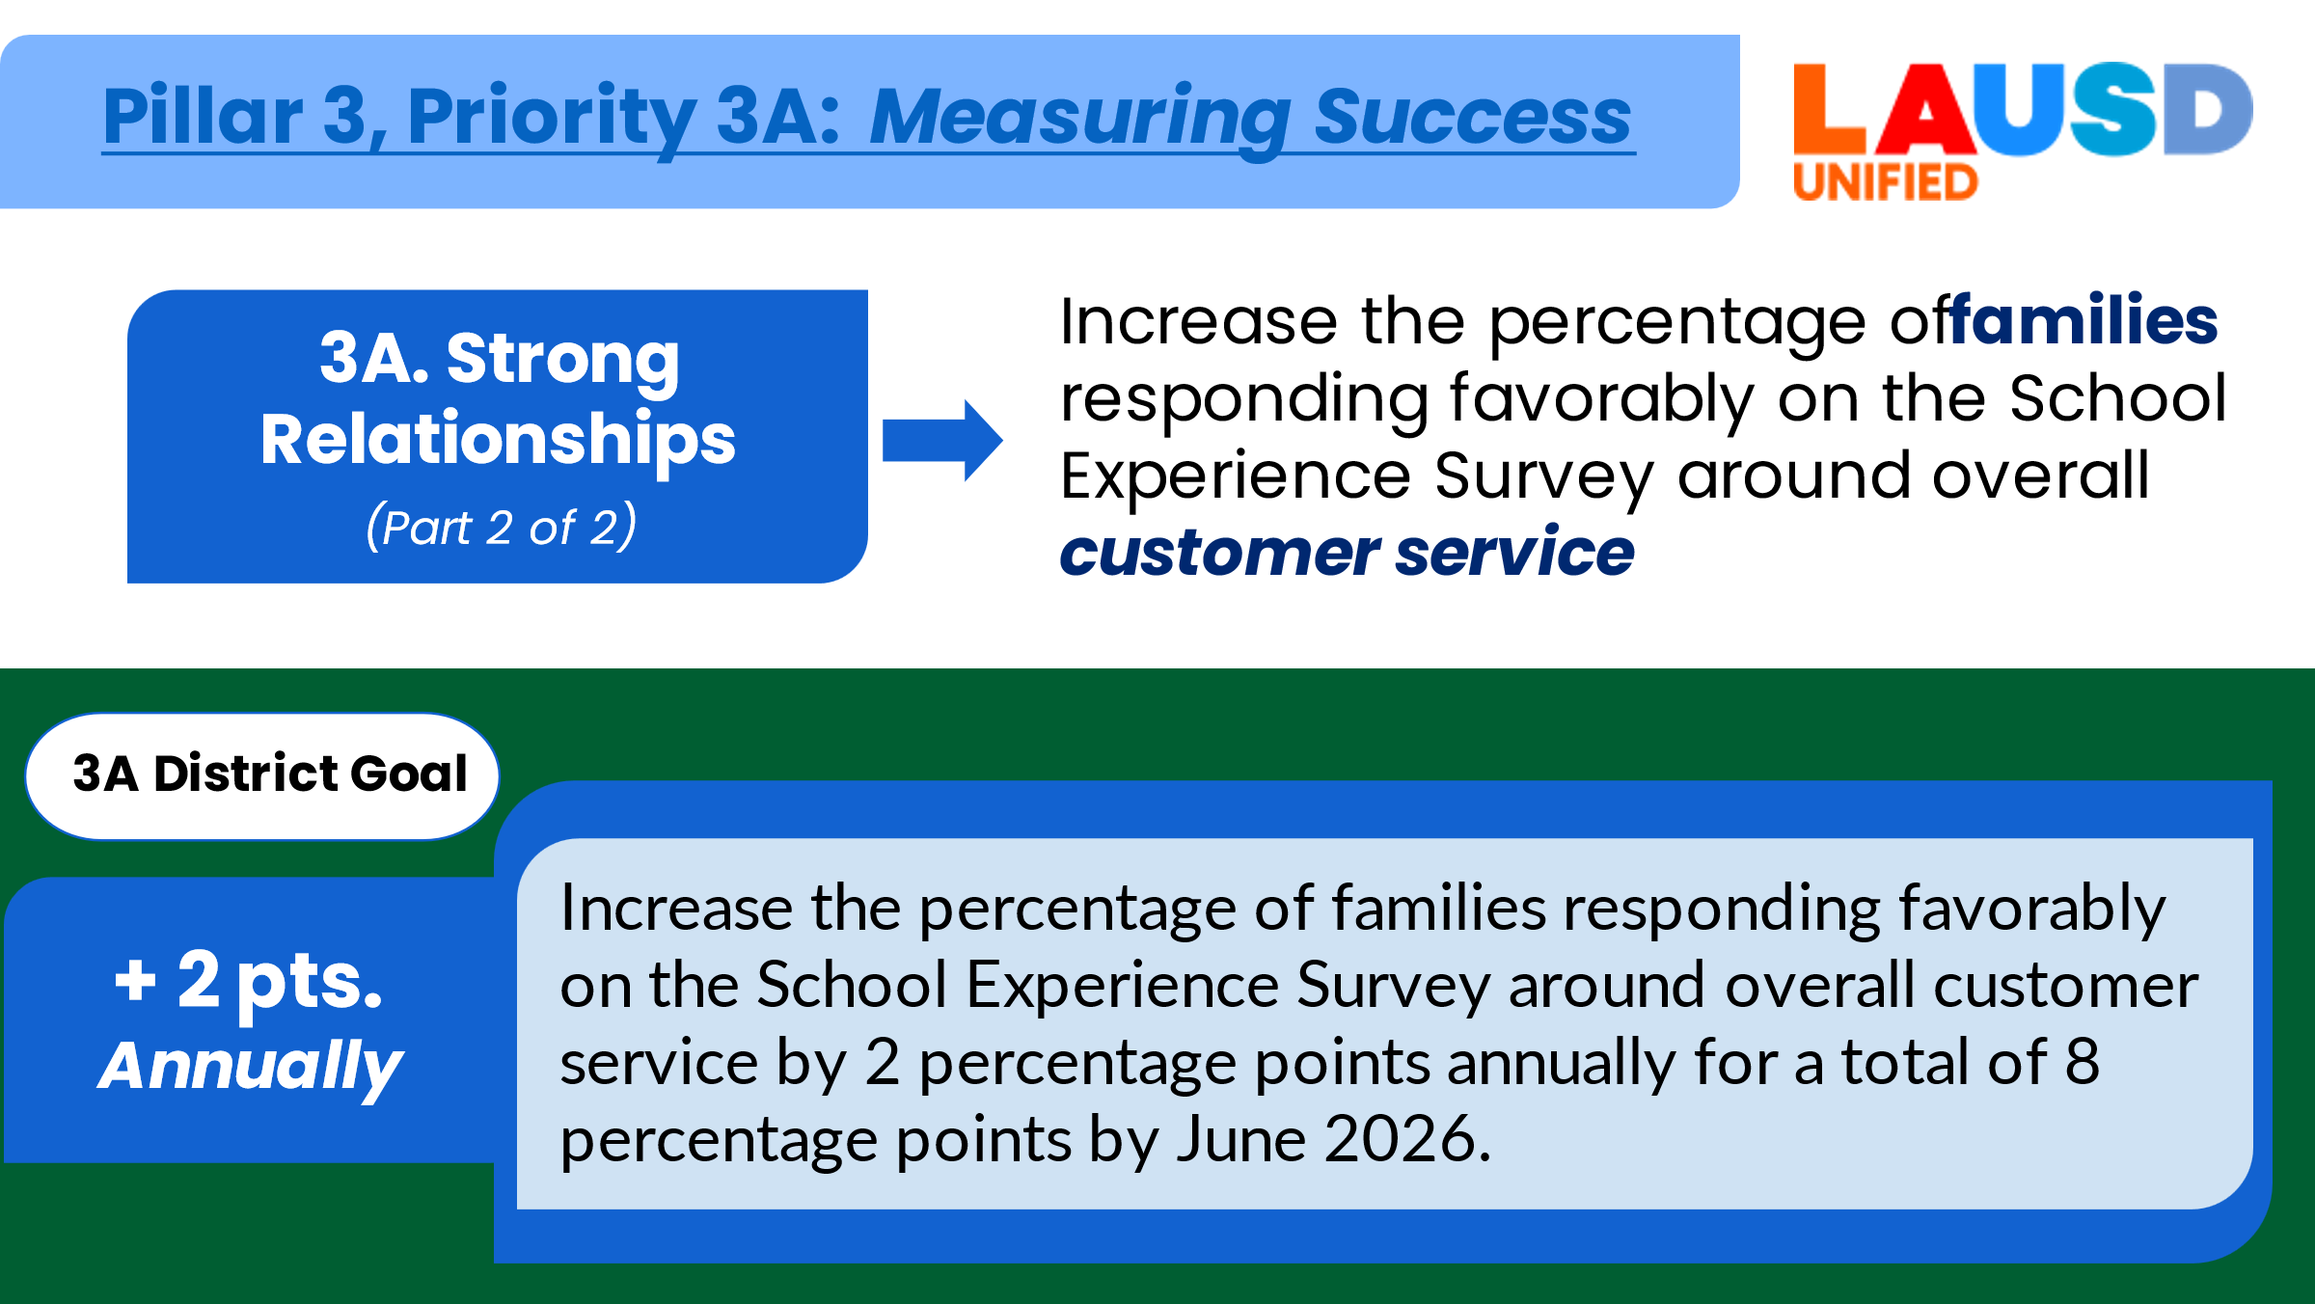 | This slide shows you how schools will measure success towards the district goal of increasing our customer service performance by 2 points each year (or a total of 8 points) until 2026.
27 | 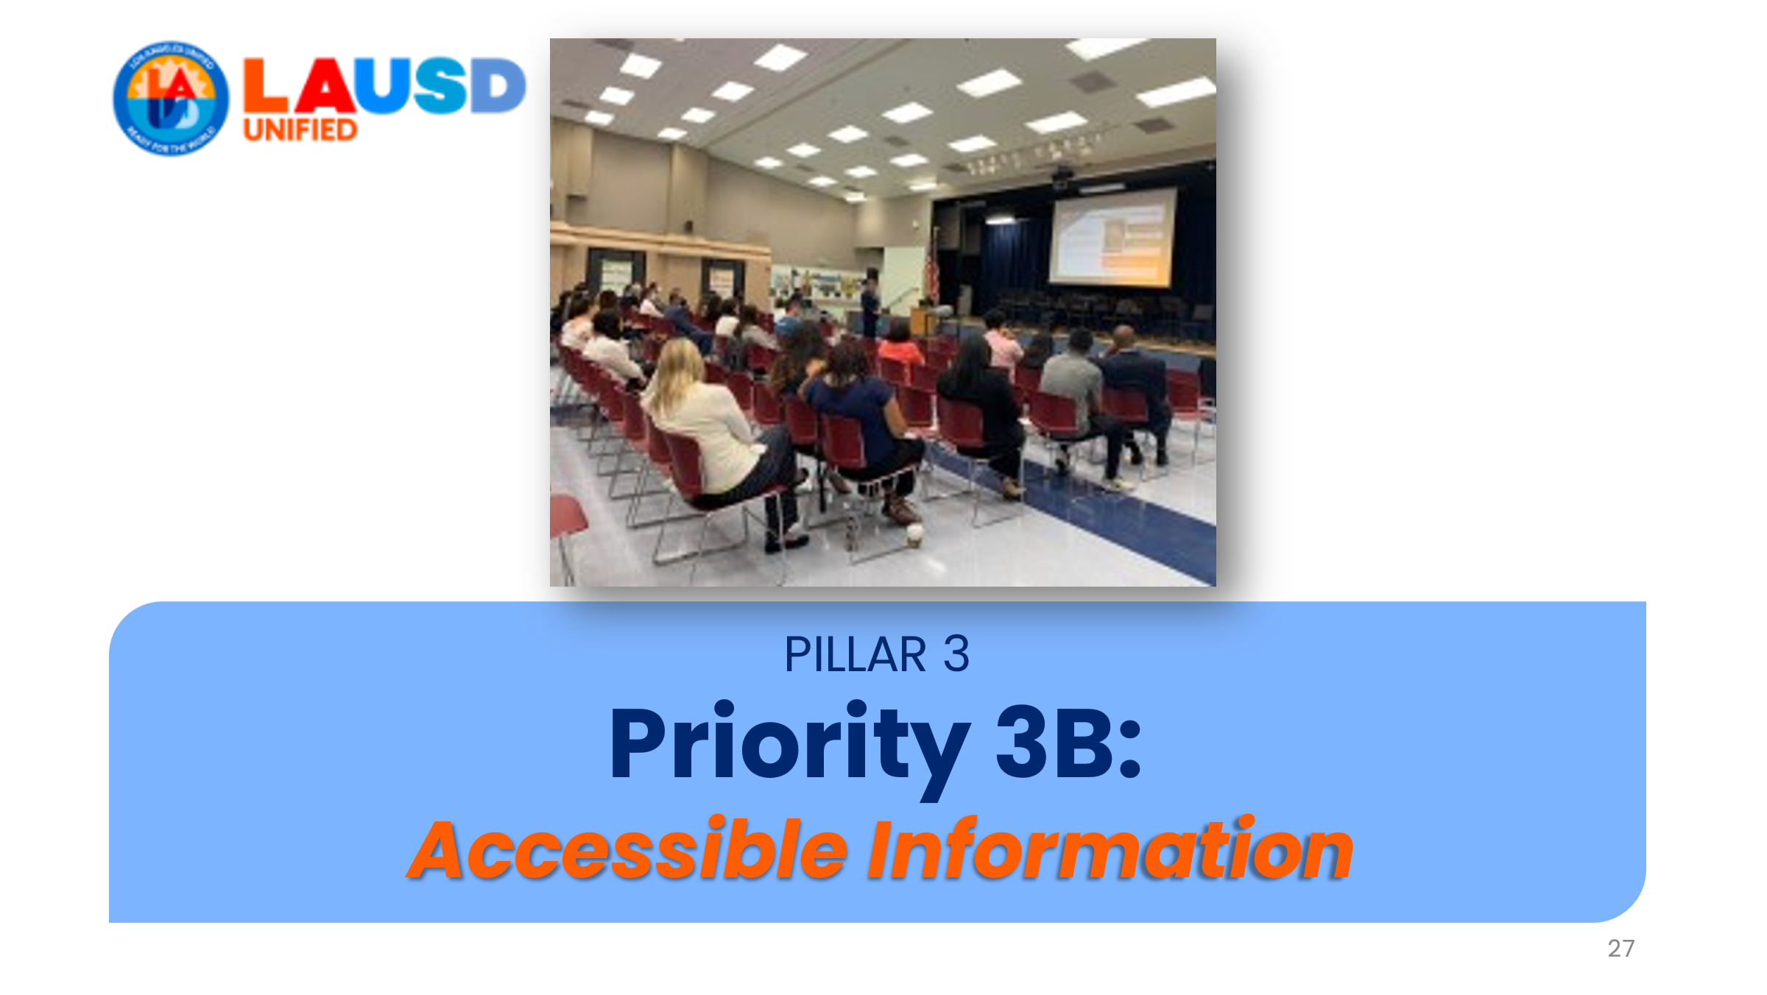 | Pillar 3’s Priority 3B is about ensuring schools provide clear, consistent, and accessible information to families and the school community.
28 | 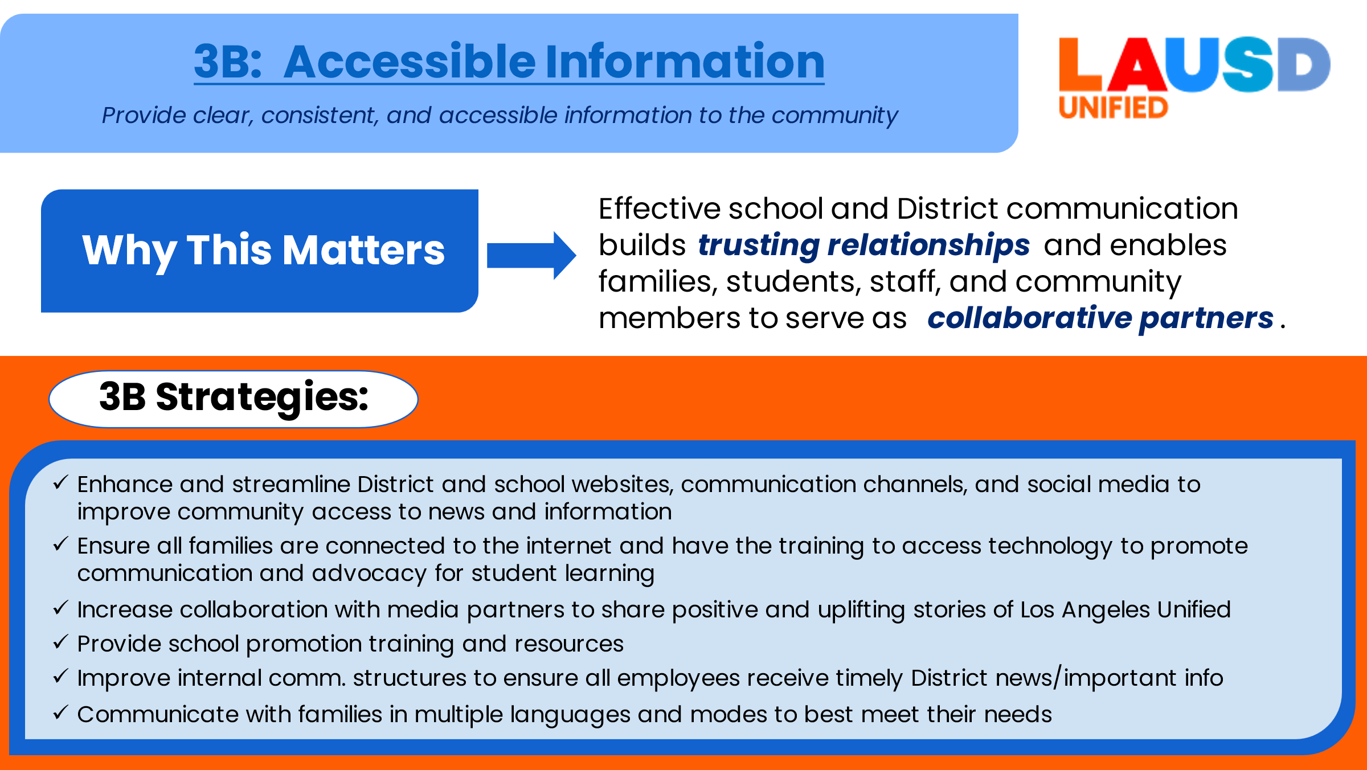 | Priority 3B matters because effective communication builds trusting relationships and enables all of us to work together to serve as collaborative partners in achieving our school’s goals. Note the various strategies called out in the Strategic Plan. As I mentioned previously, I will be discussing our school’s planned strategies to address each priority a little later in this presentation.
29 | 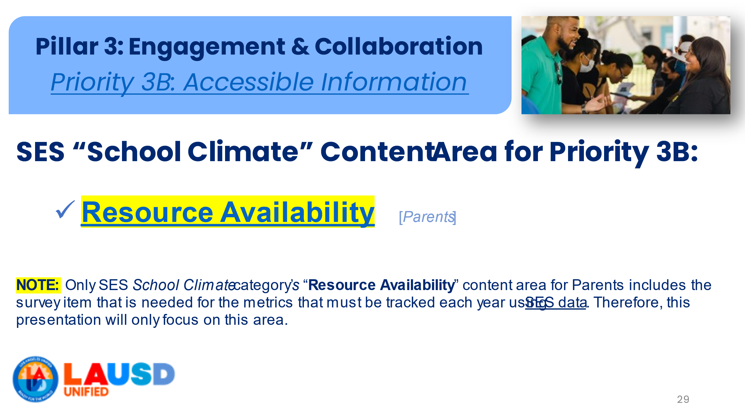 | The SES for Parents’ school climate content area, “resource availability” includes the one item needed to measure success towards the district goal for 3B.
30 | 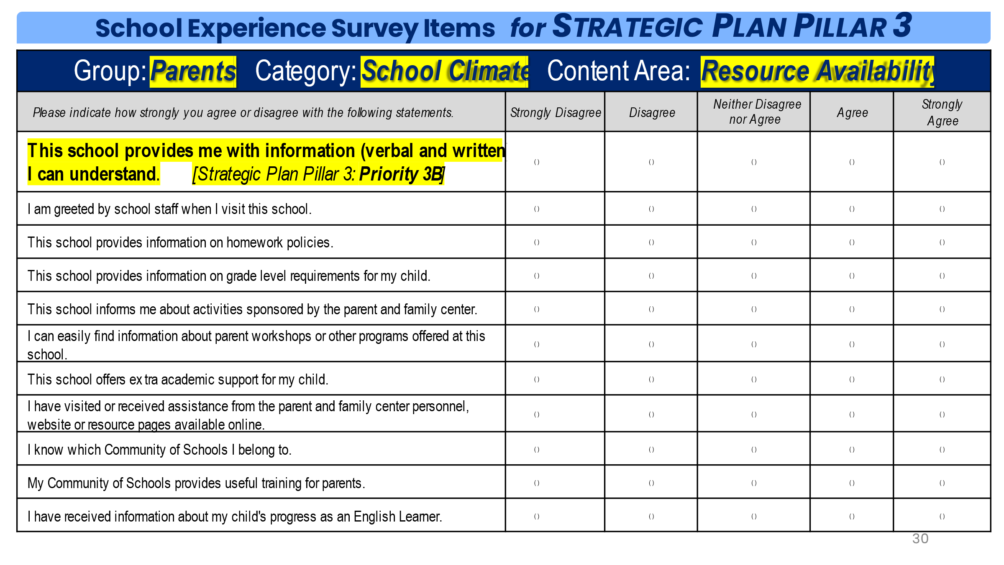 | As you can see here, these are all the items that are part of the SES school climate category’s “resource availability” content area. However, only the highlighted item, “This school provides me with information (verbal and written) I can understand” is the one item that we are required to use to measure success on Pillar 3’s Priority 3B.
31 | 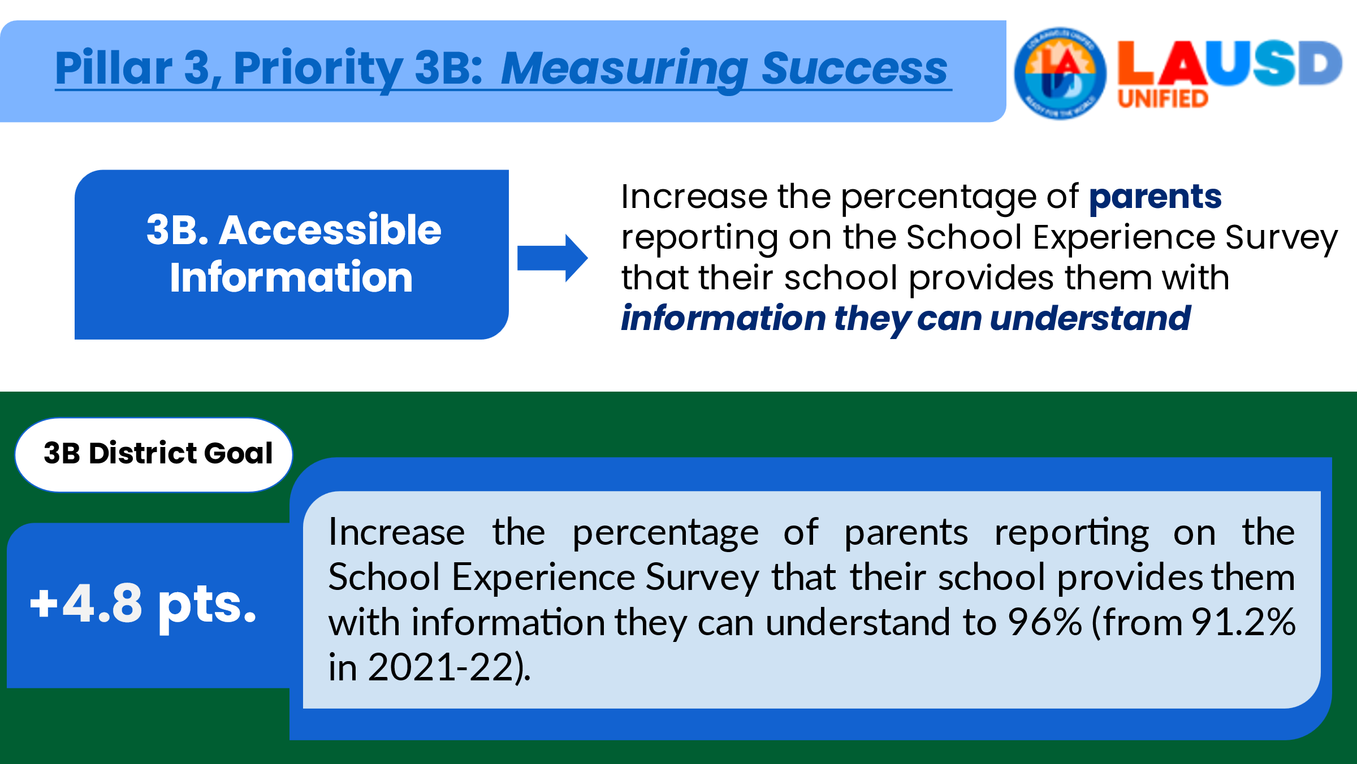 | This slide shows you how schools will measure success towards the district goal of increasing our “accessible information” performance by 4.8 points by 2026. Note that the district goal of achieving 96% for this item only applies to the district. Our school goal will be to increase 4.8 points from our 2021 baseline (which was not 91.2%). As I mentioned previously, I will go over each of our baselines and goals later in this presentation.
32 | 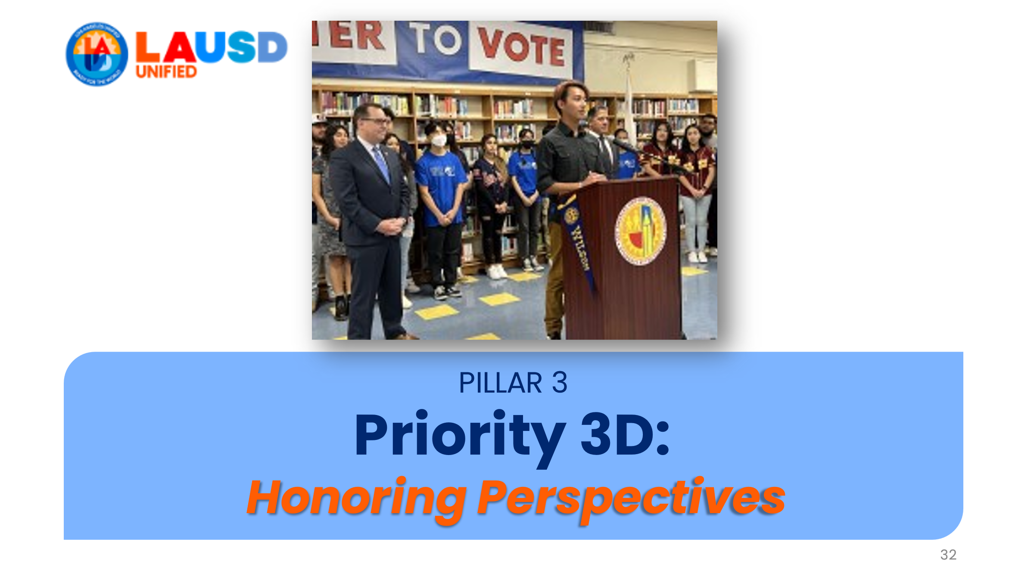 | Pillar 3’s Priority 3D is not just about honoring perspectives, but also about acting on the perspectives of students and everyone we serve.
33 | 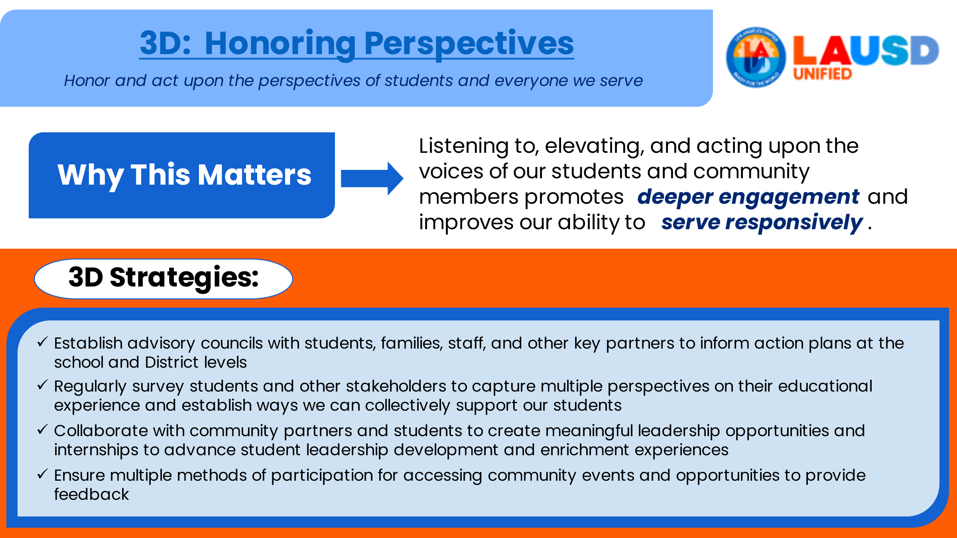 | Priority 3D matters because listening to, elevating, and acting upon the voices of everyone we serve promotes deeper engagement and improves our ability to serve responsibly. Note the various strategies called out in the Strategic Plan. As I mentioned earlier, I will be discussing our school’s planned strategies to address each priority a little later in this presentation.
34 | 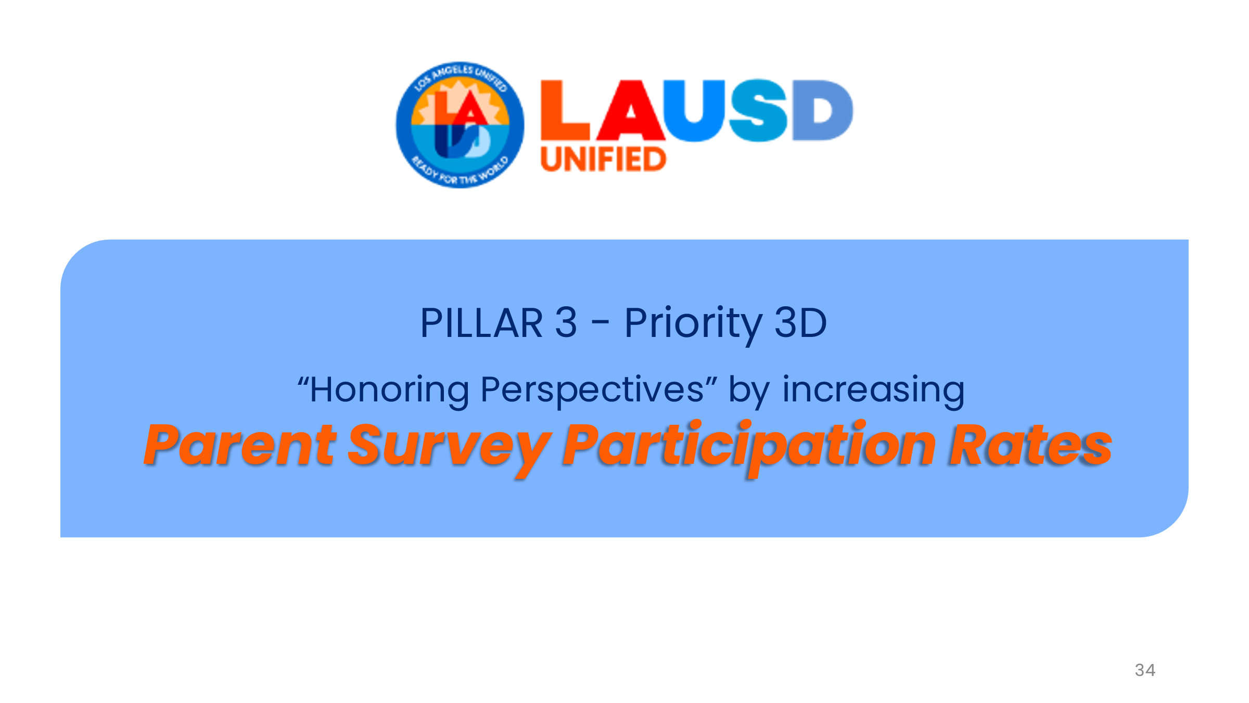 | To measure success towards the district goal for 3B, “Honoring Perspectives,” schools will be required to increase the percentage of parents participating in the School Experience Survey for Parents each year.
35 | 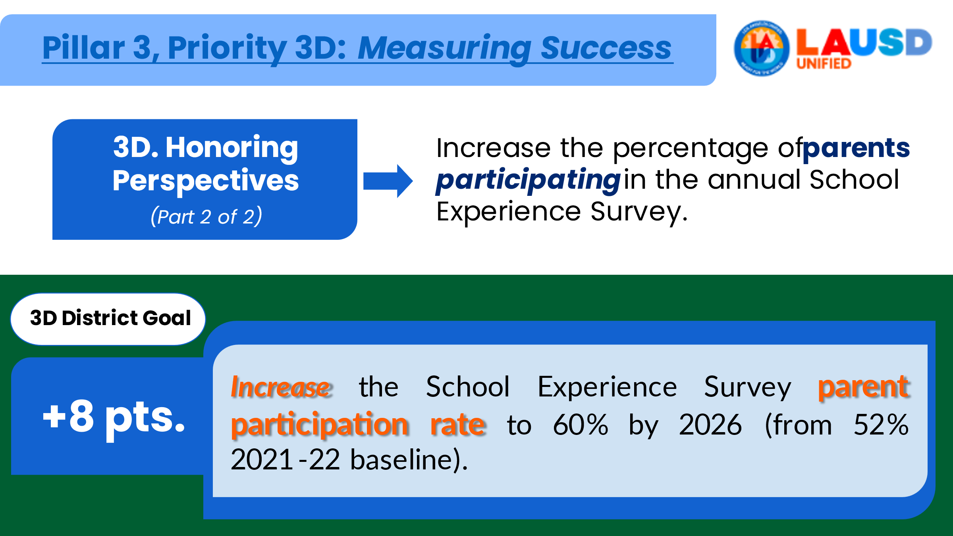 | This slide shows you how schools will measure success towards the district goal of increasing our parent survey participation rates by 8 points by 2026. Note that the district goal of achieving 60% for this item only applies to the district. Our school goal will be to increase 8 points from our 2021 baseline (which was not 52%). As I mentioned previously, I will go over each of our baselines and goals later in this presentation.
36 | 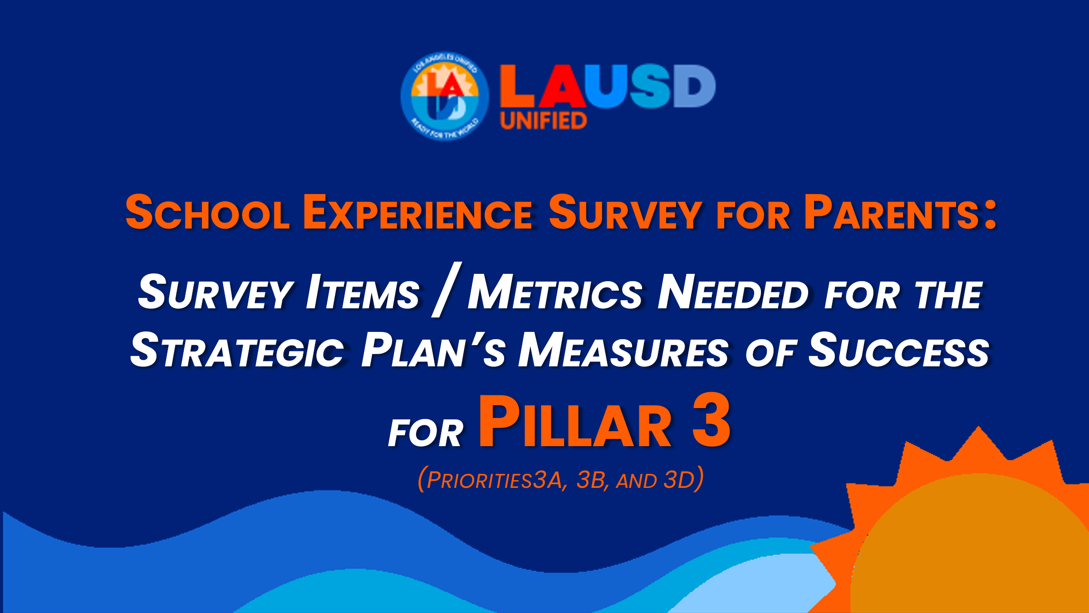 | [transition slide]  So, let’s recap what the four Pillar 3 Measures of Success are for our school.
37 | 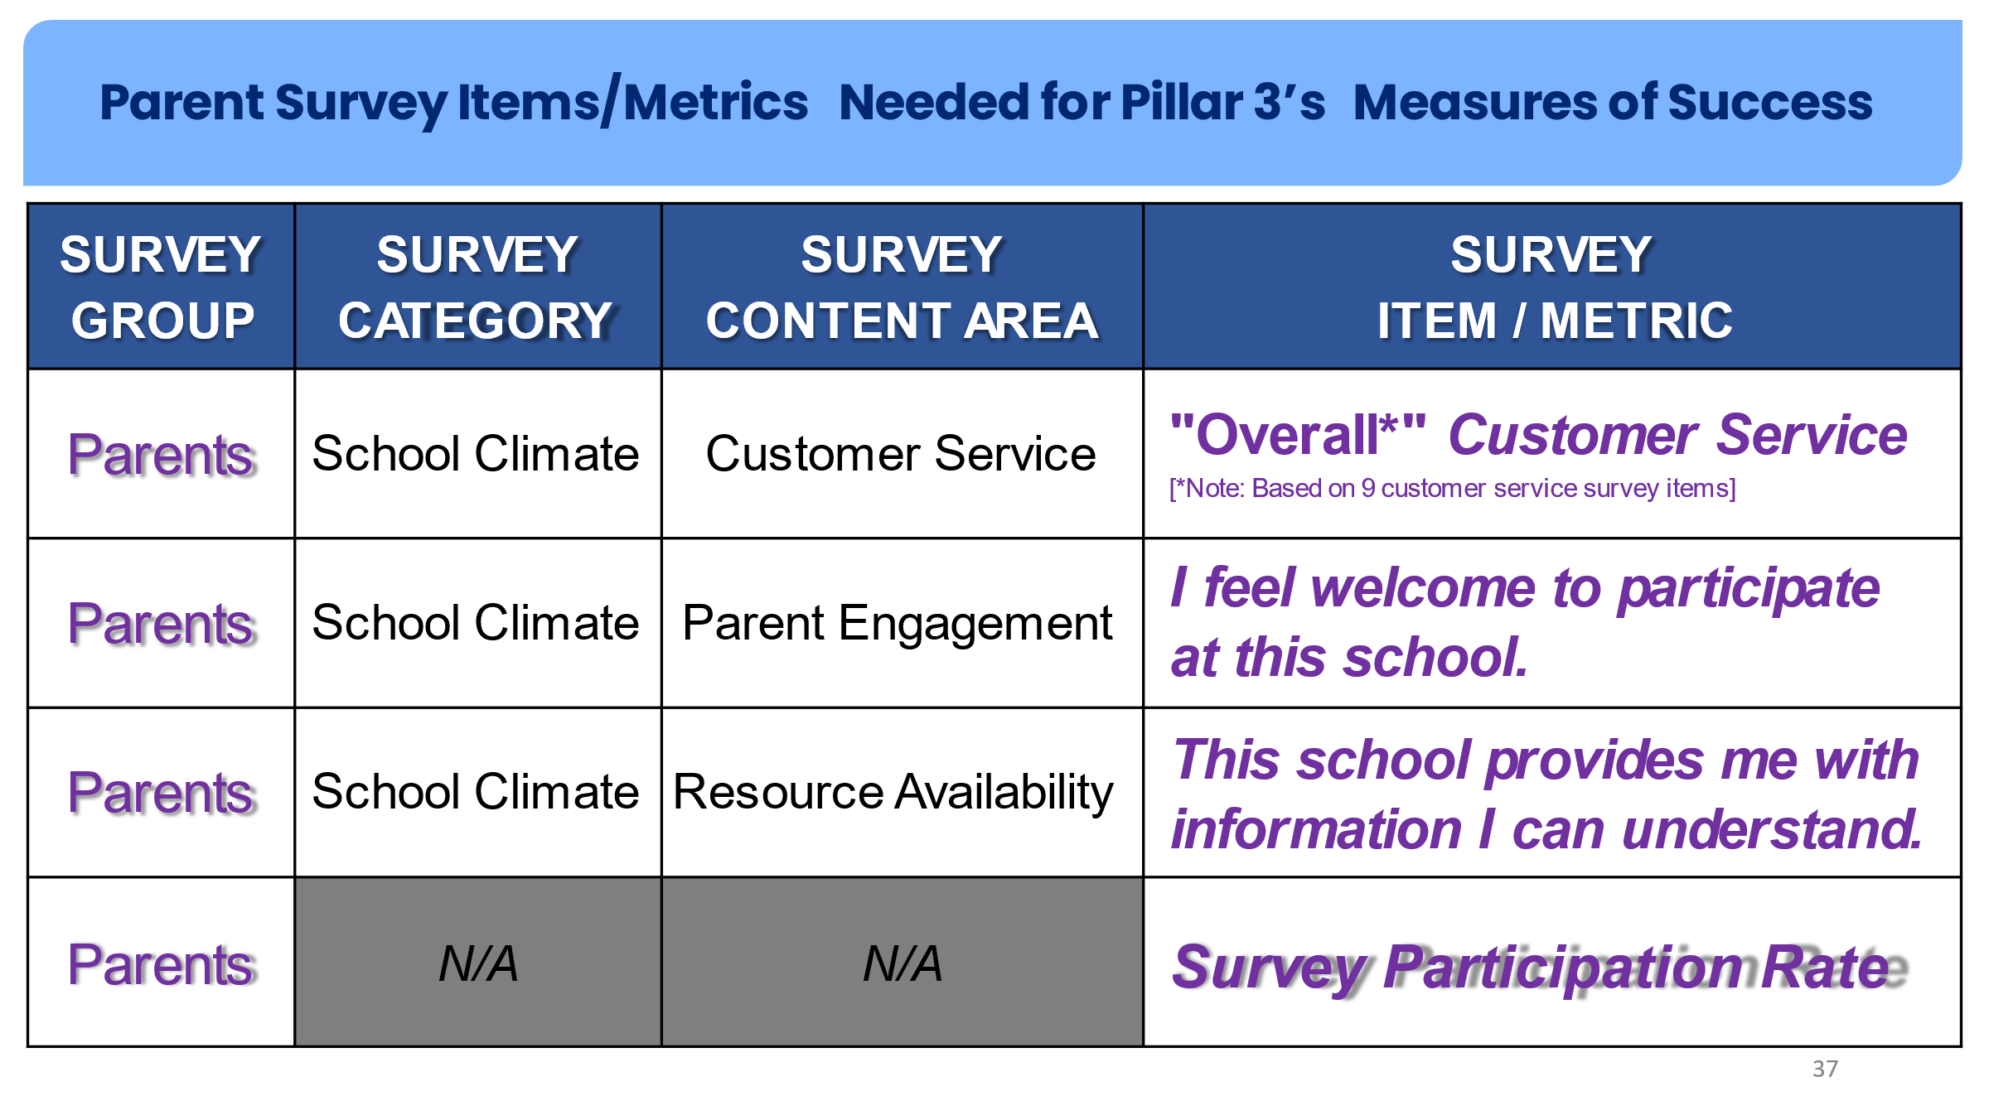 | On this slide you’ll see exactly what survey items/metrics from the Parent Survey that will be used to measure our school’s success towards our goals.  Note that the column headers are basically a “road map” to where to find the results for each item/metric in the School Experience Survey results dashboard.  (internal note: by road map, we mean the steps you would take in the dashboard to find the item/metric you are looking for: After selecting your school, you would then 1) select “parents” as the group you want to look at; 2) choose the survey category “school climate” and 3) look for the each of the 3 content areas listed in this table. Participation rates are found in the upper right of each page in the SES results dashboard.) for a demonstration on how to use the dashboard, refer to the training presentation, “how to access school results.”
38 |  | On this slide you’ll see our school’s baselines or “starting points” for each item/metric for the Parent Survey as well as our 2026 goal and our initial thoughts on how we plan to achieve each goal. [elaborate on how you met with your staff to brainstorm ways to address each goal and give details on each idea].  Note: You may want to solicit input from families on their suggestions for achieving each goal or tell them you will be setting up a separate meeting to get their input before finalizing your plan).
39 | 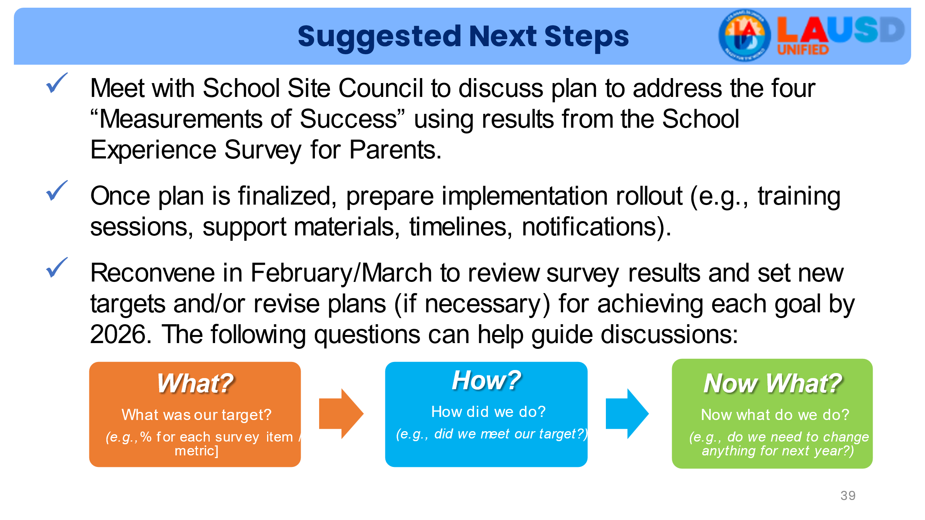 | This slide should be modified to include your planned next steps (which may or may not align with what is on this slide. These are just suggestions).
40 |  | [Transition slide]
41 | 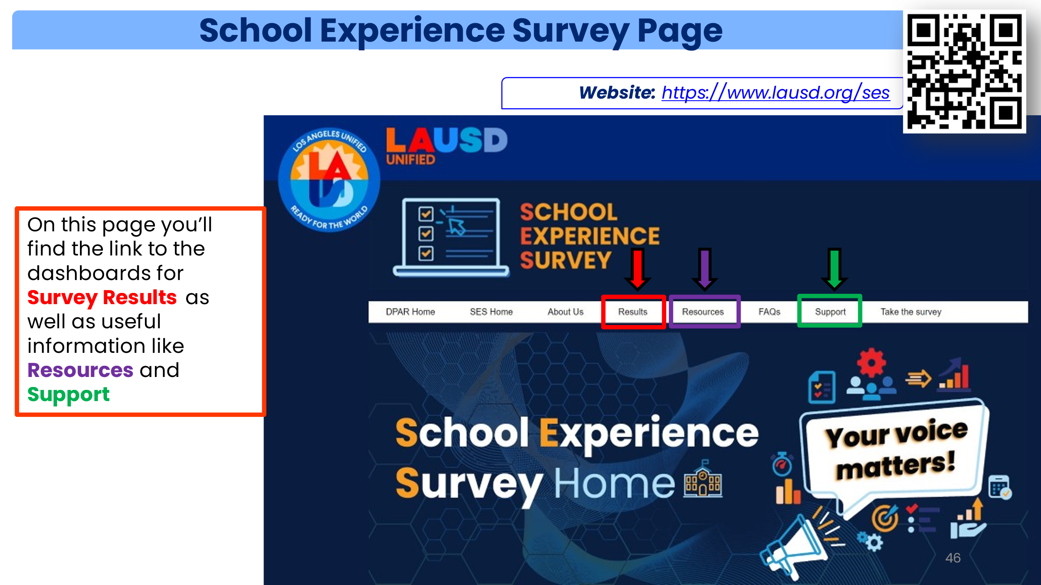 | If you haven’t already done so, I highly encourage each of you to visit the School Experience Survey web site. Here you will find the latest information like when the survey opens and closes, and you’ll also find links to the “Survey Results Dashboard,” survey questions, and lots of other great resources. Most importantly, this is the page where you will go to access the online Parent Survey. In case you need them, there are instructions available on how to access the online survey. You can access them by clicking on the “Resources” link under “SES Quick Links” on the SES page.  - “How to access the online parent survey” instructions [English]  - “How to access the online parent survey” instructions [Spanish]
42 |  | [remind parents to participated and that their voice matters]
43 |  | [thank you page]

