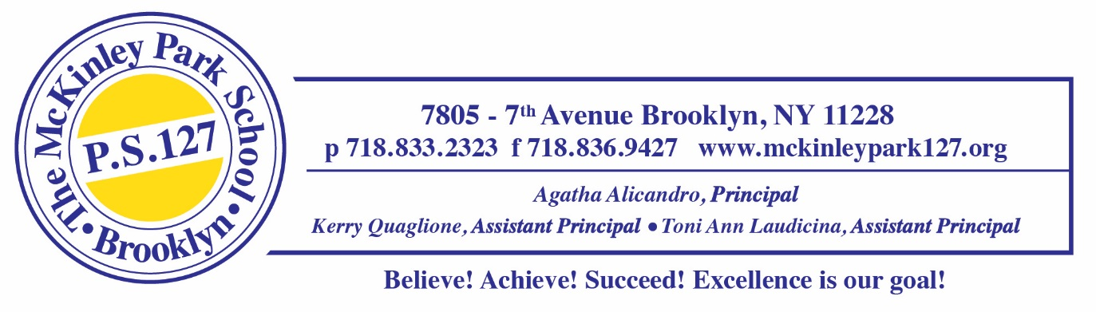
COUNSELING SUPPLY LIST 2025-2026
Mrs. Schiraldi
ROOM 433B

*please feel free to bring supplies a little at a time throughout the month of September

DISINFECTANT SPRAY

CONSTRUCTION PAPER

TISSUES

PAPER TOWELS

HAND SANITIZER

