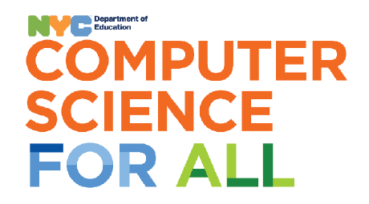
June 1, 2025
Dear Parents/Guardians of Computer Science Students:
Welcome to Computer Science! We are looking forward to a wonderful school year! In order to ensure a smooth transition back to school, I kindly ask each student to bring the supplies listed below during the 2nd or 3rd week of school. Please label supplies as “COMPUTER SCIENCE- Room 437”, so classroom teachers know where the supplies belong. Thank you for your cooperation and support!
Sincerely,
Mrs. Bonomolo
Computer Science
CS4All
__________________________________________________________________________________________

2024-2025 Computer Science Supply List 
Grades K-2:
- 1 package of Clorox/Lysol wipes
- 1 boxes of tissues
- 1 ream of copy paper 8 1/2 x 11
- 1 box of quart-sized/sandwich Ziploc bags
Grade 3 -5:
- 1 package of Baby Wipes
- 1 roll of paper towels
- 1 bottle of soap
- 1 box of gallon Ziploc bags

