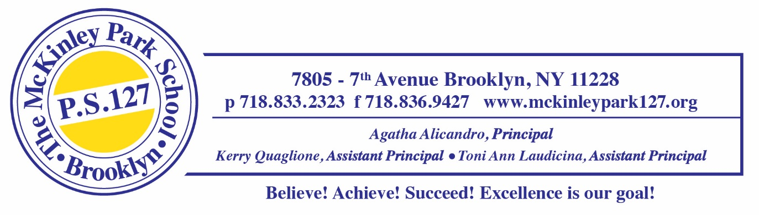
Counseling Supply List 2025-2026

Ms. Andre, School Counselor - Room 433C

DISINFECTING SPRAY

HAND SANITIZER

DISINFECTING WIPES

TISSUES

PAPER TOWELS

CONSTRUCTION PAPER

CRAYONS

MARKERS

