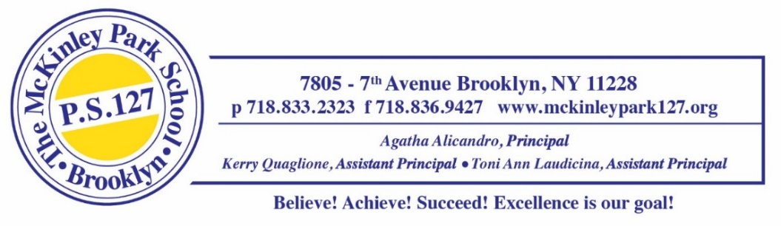
May 14, 2024
Dear Families,
We have some important news to share regarding the safety measures at our school. In line with our commitment to enhance security practices, all NYC Public Schools will have a Safer Access system installed during the 2023-25 school years.
The Safer Access system is designed to strengthen our existing safety and security practices as part of the overall visitor protocols at our school. What is Safer Access? The primary objective of the Safer Access system is to ensure that all doors remain locked outside of the morning-entry and afternoon-dismissal periods. When school doors are locked, visitors wishing to gain access to the building will ring the intercom at the main entrance door (or ADA-accessibility entrance if applicable) and identify themselves before access is granted into the school building. Safer Access allows our dedicated staff assigned to the main desk (School Safety Agents and/or school staff) to be able to see and speak with visitors before granting them access inside. Please be assured that all visitors to our school will continue to be treated with courtesy, professionalism, and respect while awaiting entry into our building.
In addition to enhancing safety, this system allows for easy access for first responders during an emergency. Once our Safer Access system is installed and operational, our school staff (including School Safety Agents) and students will receive training on using the system as well as how to support all visitors in accordance with our policy. We believe Safer Access will greatly contribute to maintaining a secure learning environment for our students and staff.
We look forward to the NYC Public Schools Safer Access system creating a safer environment for everyone. If you have any questions, please call (718-833-2323) or send an email to Parent Coordinator Donna Lubrano (dlubrano3@schools.nyc.gov).
Thank you for your continued support in keeping our school community safe.
Warm regards,
Agatha Alicandro Kerry Quaglione Toni Ann Laudicina
Agatha Alicandro Kerry Quaglione Toni Ann Laudicina
Principal Assistant Principal Assistant Principal

