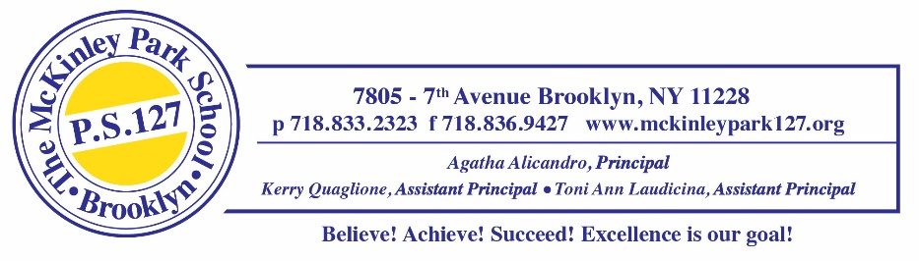
January 24, 2022
Dear Parents & Guardians,
While the rate of infection continues to increase in New York City, please be mindful of the attendance policies and procedures for our school. In this letter, there are a few reminders and explanations of our protocols.
All attendance issues should be reported to the Main Office by calling: 718-833-2323, or by contacting your child’s teacher through the Remind App. All Covid-19 positive cases must be reported immediately.
As of January 2022, there is a new practice in place in which an automated phone call will be made to your phone number on file any time your child is marked absent. This call will be made, even if you have already notified the office or teacher of the absence. If you have already contacted the school and then receive a call, you do not need to call us again.
Please note, there is no remote instruction option for this academic year. If a student is unable to attend in-person due to a documented COVID-19 related infection or quarantine, the student will receive asynchronous learning activities in combination with office hours. Your child’s teacher will provide daily assignments. The student must submit the completed assignments as outlined by the teacher to have the attendance adjusted to either REMOTE-PRESENT or REMOTE-ABSENT. Please note, this option is only available to students that are not permitted to enter the building due to their COVID-19 quarantine/isolation status.
All students are expected to attend school in-person unless they are sick. Our school is a safe and supportive environment and the classroom is a better place when your child is here. More time in school means your child will get the social-emotional and academic support they need to thrive, learn, and be happy.
Here are some basic things you should know about attendance in New York City schools:
- Schools must take attendance to show whether a student is in school or not; it’s the law.
- Schools mark a student as P for present or A for absent.
- There is no general remote learning option this year. If your child is learning remotely because they either have been asked to quarantine or are enrolled in medically necessary instruction, your child will be flagged as “learning remotely” in the DOE’s attendance system.
- While schools can mark an absence as “excused” for religious reasons, illness, or some other reasons, the excused absence is still an absence and must be part of the student’s record.
- You will receive an automated phone call if your child is marked absent or late. Do we have the correct information to contact you? Update your child’s account, NYCSA, with your current contact information.
For more information, please visit: https://www.schools.nyc.gov/school-life/school-environment/attendance
Please continue to complete the Daily Health Screening Questionnaire every day prior to entering the building. Your honest answers will let you know if your child is approved to enter the building each day.
Thank you for your help in keeping our school safe!
Sincerely,
Agatha Alicandro
Principal

