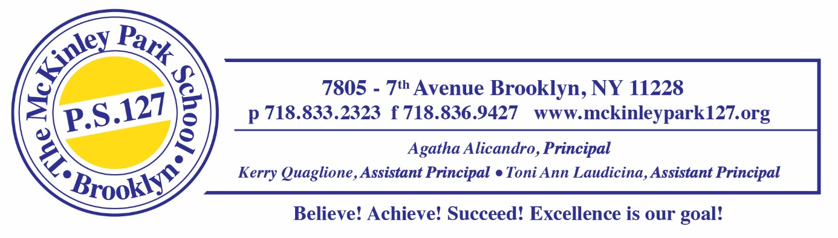
P.S. 127 has a school website: http://www.mckinleypark127.org/, a P.S. 127 Facebook page, and a P.S. 127 Instagram page. Our school website and our Facebook / Instagram pages keep families informed on things going on in our school community, and also highlight the many events that take place. Sometimes your child may participate in interviews, photography sessions, videos, PowerPoint Presentations, live broadcasts, media coverage, etc. as part of school programs or events. It is standard procedure for us to have your consent on file to allow your child to participate and be featured. Please sign the form below and have your child return it to his/her teacher.

Don’t forget to follow us on social media at:

Facebook Page Facebook.com/publicschool.127
p.s._127



PARENTAL CONSENT FORM
_______I hereby give permission for my child’s photograph, artwork, poetry or other work produced in conjunction with a school project, class or extracurricular activity, to be used in in interviews, photography sessions, videos, PowerPoint Presentations, live broadcasts, media coverage, etc. I give permission for this work to be put on the Department of Education’s World Wide Web (WWW) site, PS 127’s Instagram Page and our Facebook page in accordance with the policies set forth in the DOE’s World Wide Web Procedures and Guidelines.

_______ I do not give consent to the above.

I understand that the information to be posted does not include information from my child’s academic, guidance, permanent or cumulative record (i.e. grades or attendance records). I also understand that the information to be posted does not include other personal identifiable information such as my child’s address, phone number, or social security number.

Student’s Name: _____________________________________ Class __________________

Parent’s/ Guardian’s Signature: _____________________________________________

