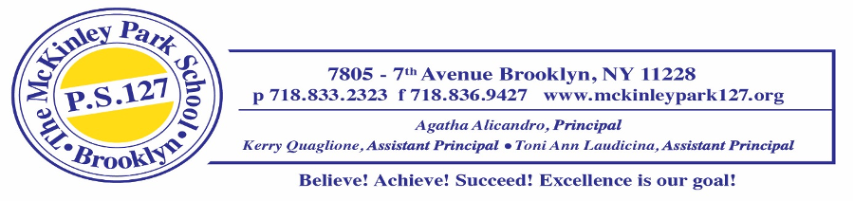
Third Grade Supply List 2025-2026
June 26, 2025
Dear Third Grade Parents and/or Guardians,
We’re excited to welcome our new third graders and look forward to a great year of learning. To start off strong, please have your child bring the required school supplies, labeled with their first and last name, before the first day.
Personal Supplies  Thursday, September 4, 2025 | Classroom Supplies  Friday, September 5, 2025
- 1 pair of inexpensive headphones (labeled with your child’s name)  - 1 package of 12 glue sticks  - 1 bottle of Elmer’s liquid glue  - 1 pair of safety scissors  - 1 box of crayons  - 1 package of colored pencils  - 1 package of markers  - 1 soft pencil case  - 1 package of expo markers  - 1 package of erasers  - 3 highlighters  - 3 packages of 4x4 post its  - 5 packages of sharpened pencils (no mechanical pencils)  5 Marble Notebooks- wide ruled  - Social Studies/ Science  - Math  - Writing  - Reading  - SEL  6 Folders  - Homework  - Social Studies/ Science  - Reading  - Writing  - Math  - SEL | - 2 boxes of gallon size Ziploc bags (boys only)  - 2 boxes of quart size Ziploc bags  (girls only)  - 2 rolls of paper towels  - 3 boxes of tissues  - 1 container of Lysol wipes  - 2 bottles of hand sanitizer  - 1 package of baby wipes  - 1 pack of multi-colored construction paper  - 3 rolls of scotch tape  - 1 package of white copy paper (staples brand)  - 1 pack of looseleaf paper
Your support is greatly appreciated! Please remember to replenish consumable supplies as needed throughout the year. From time to time, students may also be asked to bring in additional materials for special projects and assignments.
We’re looking forward to a fantastic year with your child in third grade.
Have a wonderful summer!
Sincerely,
The Third Grade Teacher Team

