5-308 Supply List for 2025-2026 School Year
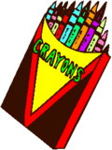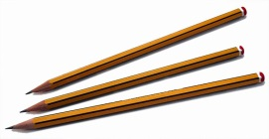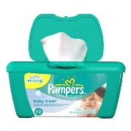
Please purchase the following supplies before the first day of school, however, do not send in the supplies on the first day of school. We will provide a schedule of which supplies need to be sent in on specific days. Thank you for your cooperation. We are looking forward to a new and exciting year.
Homeroom
- Crayola colored pencils and or markers
- 2 reams of white copy paper
- 1 roll of paper towels
- 1 box of tissues
- 1 pack of 5 dry erase markers (will be collected for the class set)
- 20 pre-sharpened pencils
- 1 pairs scissors
- 4 glue sticks (2 will be collected for class set)
- 1 Lysol wipes
- 1 pack of Baby wipes
- 1 pair of headphones (preferably in-ear headphones)
- 3 marble notebooks
- 2 folders- red Homework -blue Classwork
- 1 pack of multi-color Highlighters
- Pencil box to keep supplies

Please be sure to label all materials with your child’s name
**Please be advised I did not put a large number of items on the list because I will ask throughout the year for items we need for special projects. **
Thank you for your cooperation.

