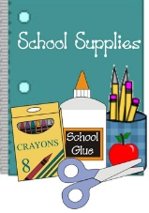 2025-2026 Class Supply List 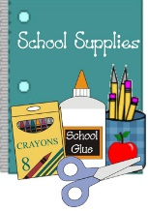

Dear Parents/Guardians:
I would like to take this opportunity to share a list of the supplies that your child will need for the next school year. In addition, I kindly ask that you replenish consumable items as needed throughout the year. Please note as well that, throughout the year, students may be asked to bring in additional supplies and materials.
Thank you very much for your cooperation. I wish you a happy and safe summer and look forward to meeting you in September!
Sincerely,
Mrs. Costello

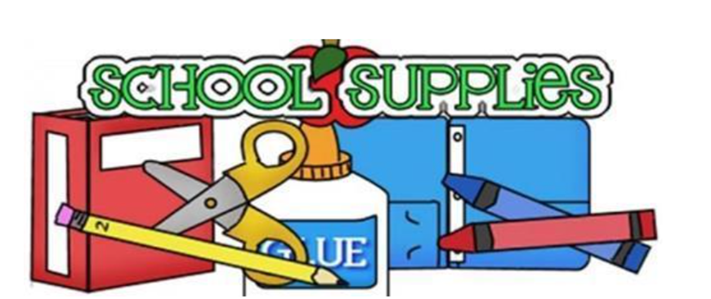
Below you will find the supplies that are assigned to a specific day. This will make it easier for the students to manage. Thank you for your cooperation.
Thursday:
- 1 backpack (NO WHEELS) with first and last name printed on the inside
- 1 pack of Expo dry erase markers and an eraser
- 6 marble notebooks (wide rule)
- 7 plastic 2-bottom pocket folders (solid colors: red, blue, yellow, green, orange, purple, and black)
*Please adhere to the requested colors. This is for organization purposes. *
- 1 soft pencil case
- 1 box of sharpened pencils
- 1 ream of copy paper 8 1/2 X 12

Friday:
- 1 box of 24 crayons
- 1 pair of safety scissors
- 4 large glue sticks
- 1 box of colored pencils
- 1 pack of construction paper

Monday:
- 3 packages of antibacterial wipes
- 2 packages of baby wipes
- 2 rolls of paper towels
- 1 hand sanitizers
- 2 boxes of tissue
- 1 box of gallon Ziploc gags
- 1 pair of headphones for device in a Ziploc Bag labeled with your child’s name

Approved: Toni Ann Laudicina

