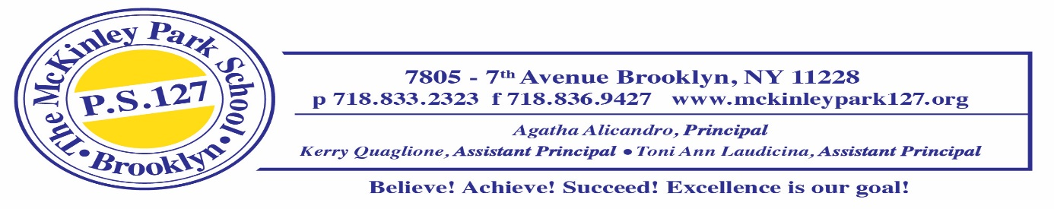
June 26, 2025
Dear Third Grade Parents and/or Guardians,
Welcome to third grade! We have very high expectations for our incoming third graders. To start the year off right, each student is expected to bring the following required supplies. Please label all school supplies with your child’s first and last name, prior to the first day of school.
Having your child prepared with the supplies below will be very helpful to us and will be greatly appreciated.
5 black and white marble notebooks(wide ruled) | 6 vinyl (thick plastic) folders (1 free choice, 1 red, 1 blue, 1 yellow, 1 green and 1 orange)
1 package of white copy paper (staples brand) | 1 package of Expo dry erase markers (black only)
Post-its 4x4 (lined) | 1 bottles Elmer’s liquid Glue
1 pair of headphones for iPads in a Ziploc bag labeled with your child’s name** | 1 box of Crayola crayons (16-24)
3 rolls of scotch tape | Highlighters
1 soft pencil case (no hard boxes-they will be sent home) filled with the following supplies
- 2 boxes of pre-sharpened pencils (no mechanical pencils)
- 4 Glue Sticks
- Pair of safety scissors

This year we will begin to collect supplies on different days the 1st week of school. Please follow the schedule below:

On Thursday, September 4, 2025
5 Marble Notebooks & 6 Vinyl Folders
Pencil case filled with supplies
Copy paper
Post-its
Package of Loose-leaf paper (wide ruled)
Pack of multi-colored construction paper
By Friday, September 12, 2025
1 roll of paper towels
1 box of gallon size Ziploc bags (girls only)
1 box of quart size Ziploc bags (boys only)
1 boxes of tissues
1 tub of Clorox wipes

In addition, please remember to replenish consumable items as needed throughout the year. During the course of the year students may be asked to bring in other supplies and materials for special projects and assignments.
We are looking forward to a wonderful year with your child in the third grade.
Have a great summer!
Sincerely,
The Third Grade Teacher Team

