5⁻³⁰⁶ Supply List for 2025-2026 School Year
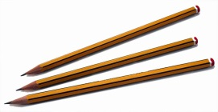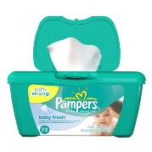
Please purchase the following supplies before the first day of school, however, do not send in the supplies on the first day of school. We will provide a schedule of which supplies need to be sent in on specific days. Thank you for your cooperation. We are looking forward to a new and exciting year.
Homeroom
- Crayola Crayons and markers
- 2 reams of white copy paper
- construction paper
- 1 roll of paper towels
- 3 box of tissues
- 1 pack of 5 dry erase markers
- 20 pre-sharpened pencils
- post-it notes (regular size)
- 1 pairs scissors
- 4 glue sticks(2 will be collected for class set)
- 1 pack of college ruled loose leaf
- 1 Elmer’s glue
- 1 Lysol wipes
- 1 box Gallon Zip lock bags
- 1 pair of headphones (preferably in-ear headphones)
- 3 marble notebooks
- 2 folders red Homework folder and blue classwork
- 1 pack of multi-color Highlighters
- Pencil box to keep supplies

*Please be sure to label all materials with your child’s name

Please do not bring in all supplies at once. Follow the following schedule:
Day 1: Notebooks, folders, markers, pencils, crayons, scissors, highlighters, headphones and glue
Day 2: Construction paper and copy paper
Day 3: Paper towels and tissues, dry erase markers, post-its
Day 4: Ziplock bags, Lysol wipes, and index cards

**Please be advised I did not put a large number of items on the list because I will ask throughout the year for items we need for special projects. **

