5th Grade Supply List for 2025-2026 School Year
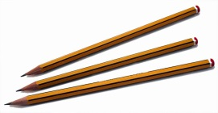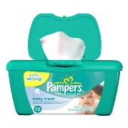
Please purchase the following supplies before the first day of school, however, do not send in the supplies on the first day of school. We will provide a schedule of which supplies need to be sent in on specific days. Thank you for your cooperation. We are looking forward to a new and exciting year.
Homeroom
- Crayola Crayons and markers
- 2 reams of white copy paper
- 1 roll of paper towels
- 1 box of tissues
- 2 packs of 5 dry erase markers (1 pack will be collected for the class set)
- 20 pre-sharpened pencils
- post-it notes (regular size)
- 1 pairs scissors(1 will be collected for the class set)
- 2 glue sticks (1 will be collected for class set)
- 1 Elmer’s glue
- 1 Lysol wipes
- 1 box Gallon Zip lock bags
- 1 pair of headphones (preferably in-ear headphones)
- 3 marble notebooks
- 5 folders- red, yellow, green, blue, and orange
- 1 pack of multi-color Highlighters
- Pencil box to keep supplies
*Please be sure to label all materials with your child’s name
Please do not bring in all supplies at once. Follow the following schedule:
Day 1: Notebooks, folders, markers, pencils, crayons, scissors, highlighters, headphones and glue
Day 2: copy paper
Day 3: Paper towels and tissues, dry erase markers, post-its
Day 4: Ziplock bags, and Lysol wipes

