# | Slide View | Presenter’s Text | Notes
1 |  | Today we are going to discuss the value of partnering with our students’ families.
2 | 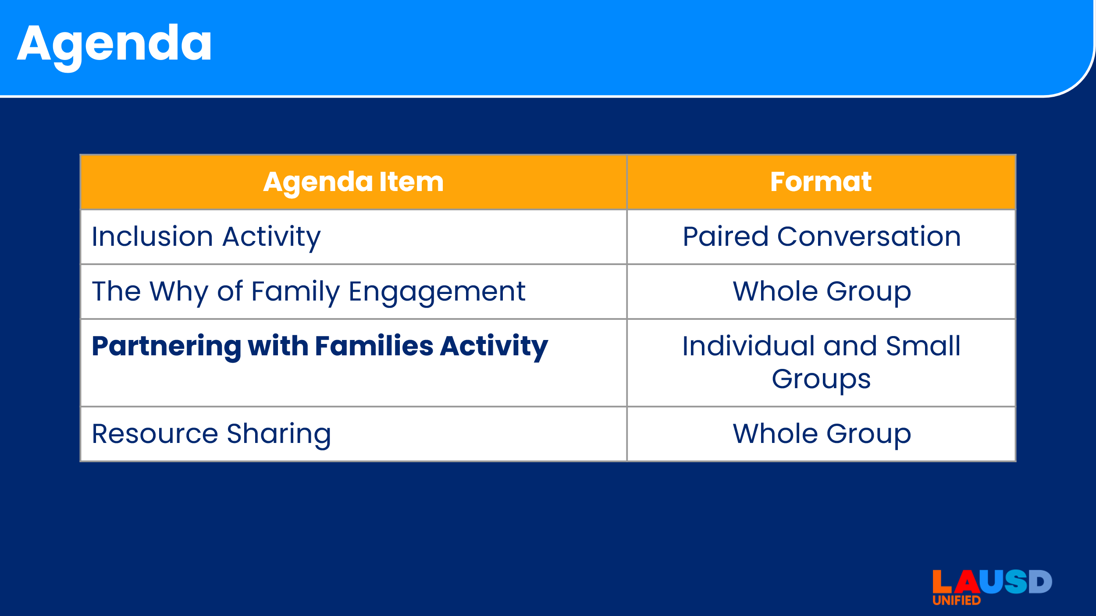 | This is what our time of learning will look like:  [share the agenda items and presentation format] | <1 minute
3 | 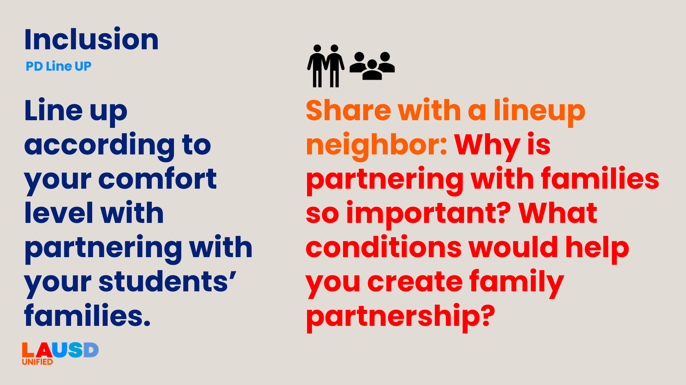  [Note: This slide has an animation] | Since the topic today will be all about working with our families, our inclusion will help us to see where we stand in our comfort with working with families.  Around the room, you will see three signs with a statement relating to comfort-levels in working with families. Please stand up and move to the statement that most aligns with your level of comfort.  [click to advance animation for prompt to appear]  Take 5 minutes to share with a neighbor:  Why is partnering with families so important? What conditions would help you create family partnership? | 7 minutes  Print out or write on separate sheets:  I am comfortable partnering with families.  I am somewhat comfortable with partnering with families.  I am uncomfortable partnering with families.  Place around the room.
4 | 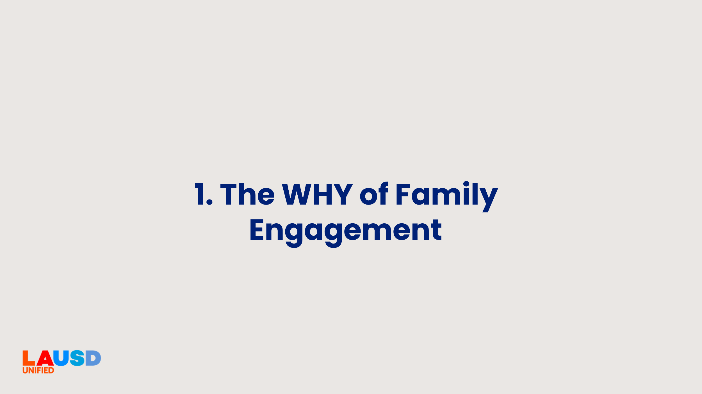 | Thank you for returning to your seats.  In your conversations you talked about why family engagement is important. I’ll review some additional reasons in the next few slides. | <1 minute
5 | 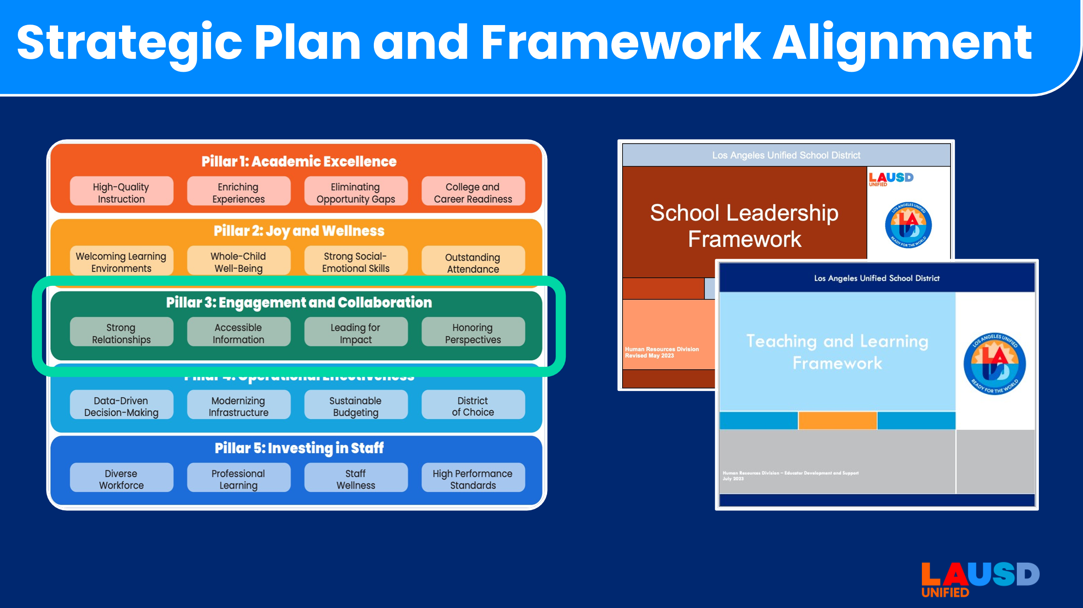 | Family engagement is integrated into almost every part of our Strategic Plan. While it’s not called out specifically in Pillars 1 and 2, we frequently engage with families around their students’ academic success and wellness. Pillar 3: Engagement and Collaboration directly speaks to Strong Relationships with our families, Accessible Information refers to providing information in timely manner in a way that parents can understand, and Honoring Perspectives speaks to the importance of parent input in decision-making.  Family engagement is also one of the domains within which we evaluate successful practice for administrators and educators in LAUSD. This is evident in the School Leadership Framework and the Teaching and Learning Framework.  In 2024, the revised California Standards for the Teaching Profession also highlight enhanced family and community engagement practices, with an emphasis on two-way communication to develop positive and reciprocal family and community connections. | 2 minutes
6 | 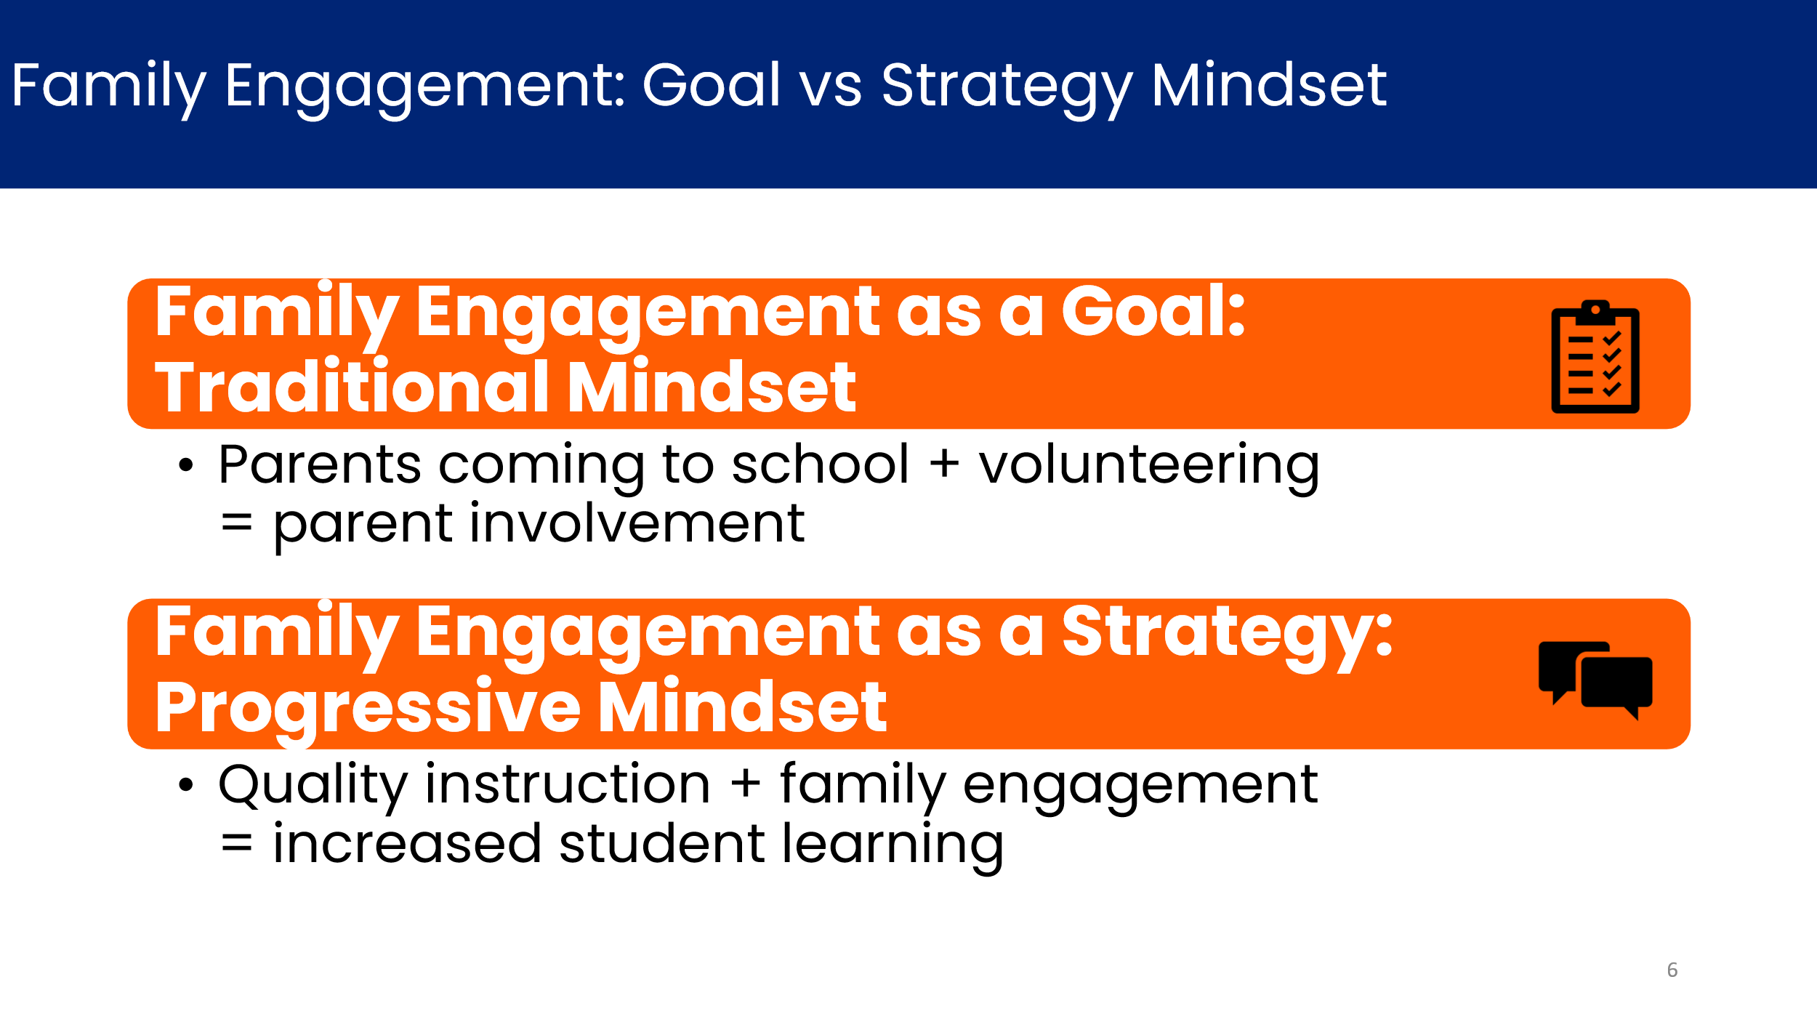 | Family engagement can sometimes be described as a goal we have to meet. We measure it by how many parents attend events and how frequently they participate. This traditional mindset can become transactional.  Seeing family engagement as a strategy for student achievement is a more progressive mindset. When instruction and family engagement are aligned, we see increased student learning. Families are seen as coming into the educational system with assets and knowledge. Tapping into these strengths is where transformational partnership can occur. | 2 minutes
7 | 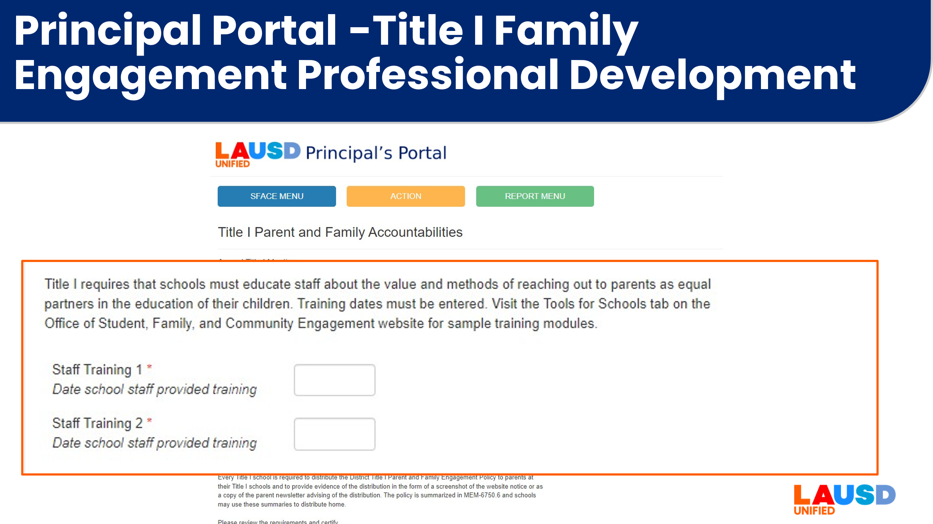 | Federal law under the Every Student Succeeds Act, Title I Section 1116 requires that districts and schools receiving federal funding regularly conduct professional development in support of family engagement. In LAUSD, this requirement is documented in the Principal Portal via two staff training opportunities each year. The purpose of these training sessions is to assist staff to partner with families to increase student achievement. | 1 minute
8 | 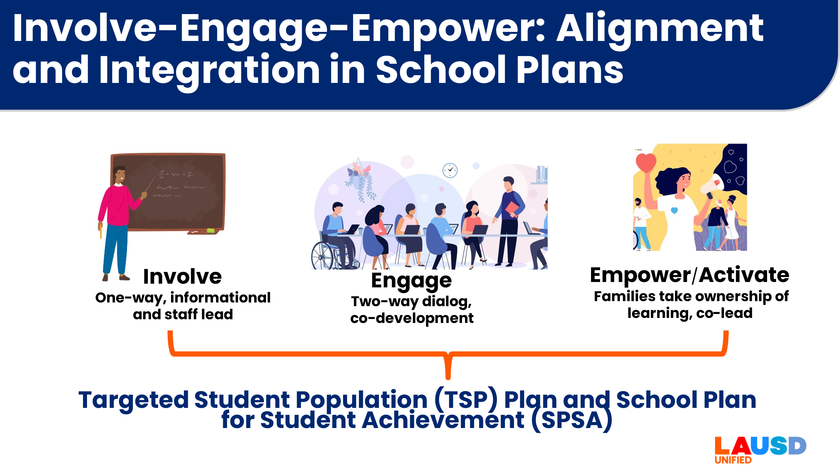 | Working with families happens along a continuum – From Involvement to Engagement to Empowerment.  Activities which INVOLVE families are one-way, led by staff, and are mostly informational. An example might be when we give parents an orientation on how to sign up for the Parent Portal.  Activities which ENGAGE families, are two-way, and include parent/family input in the development of a resource. An example might be a behavior goal that you and the parent co-develop during parent conferences.  Activities which EMPOWER families are those in which the parents take ownership and co-lead with school staff. An example might be a literacy circle hosted in the Parent and Family Center, or a parent-led orientation for new families.  The family involvement, engagement and empowerment strategies are captured in schools plans like the TSP and SPSA. | 2 minutes
9 | 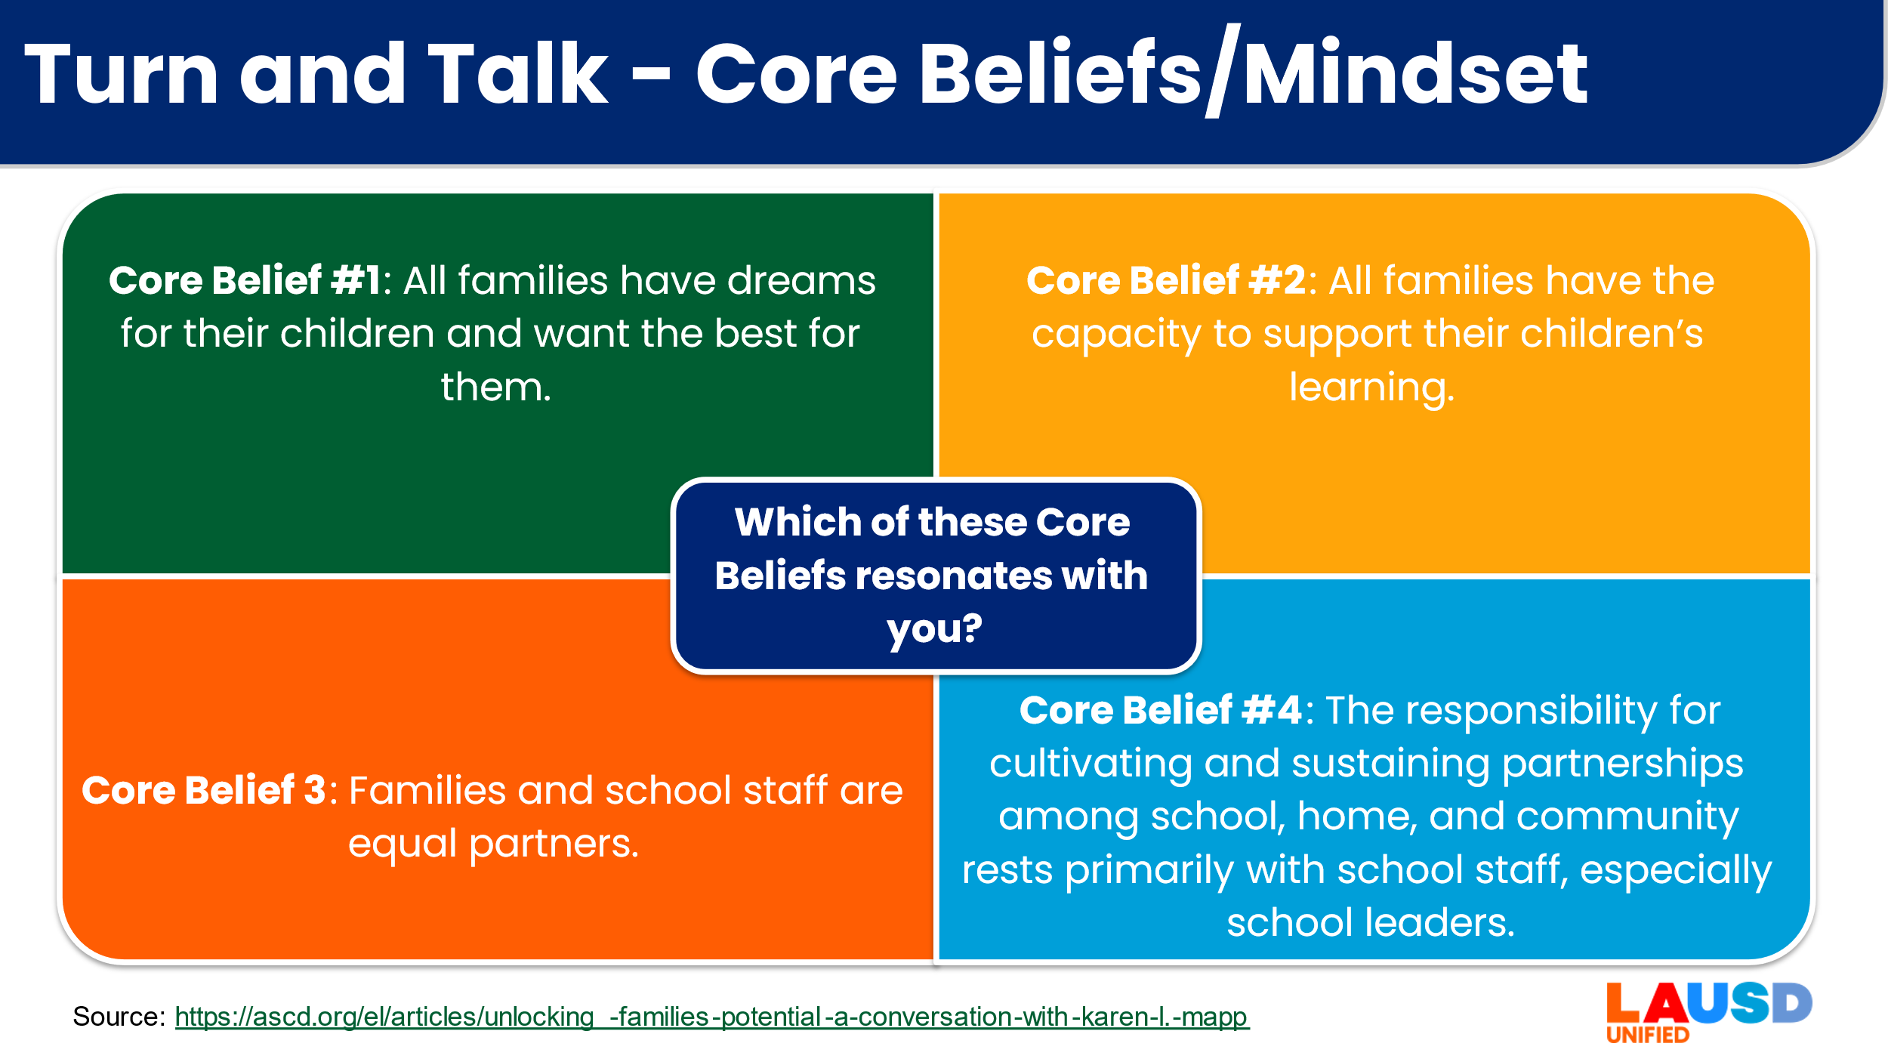 | To partner with families, it means we have to examine our beliefs about them. Dr. Karen Mapp, a family engagement author and research at Harvard shares these four CORE beliefs. Take one minute to read through them and partner with a neighbor to share which one resonates with you most?  [If time permits, share with a different partner: Which of these Beliefs is most challenging for you to hold?] | 10 minutes
10 | 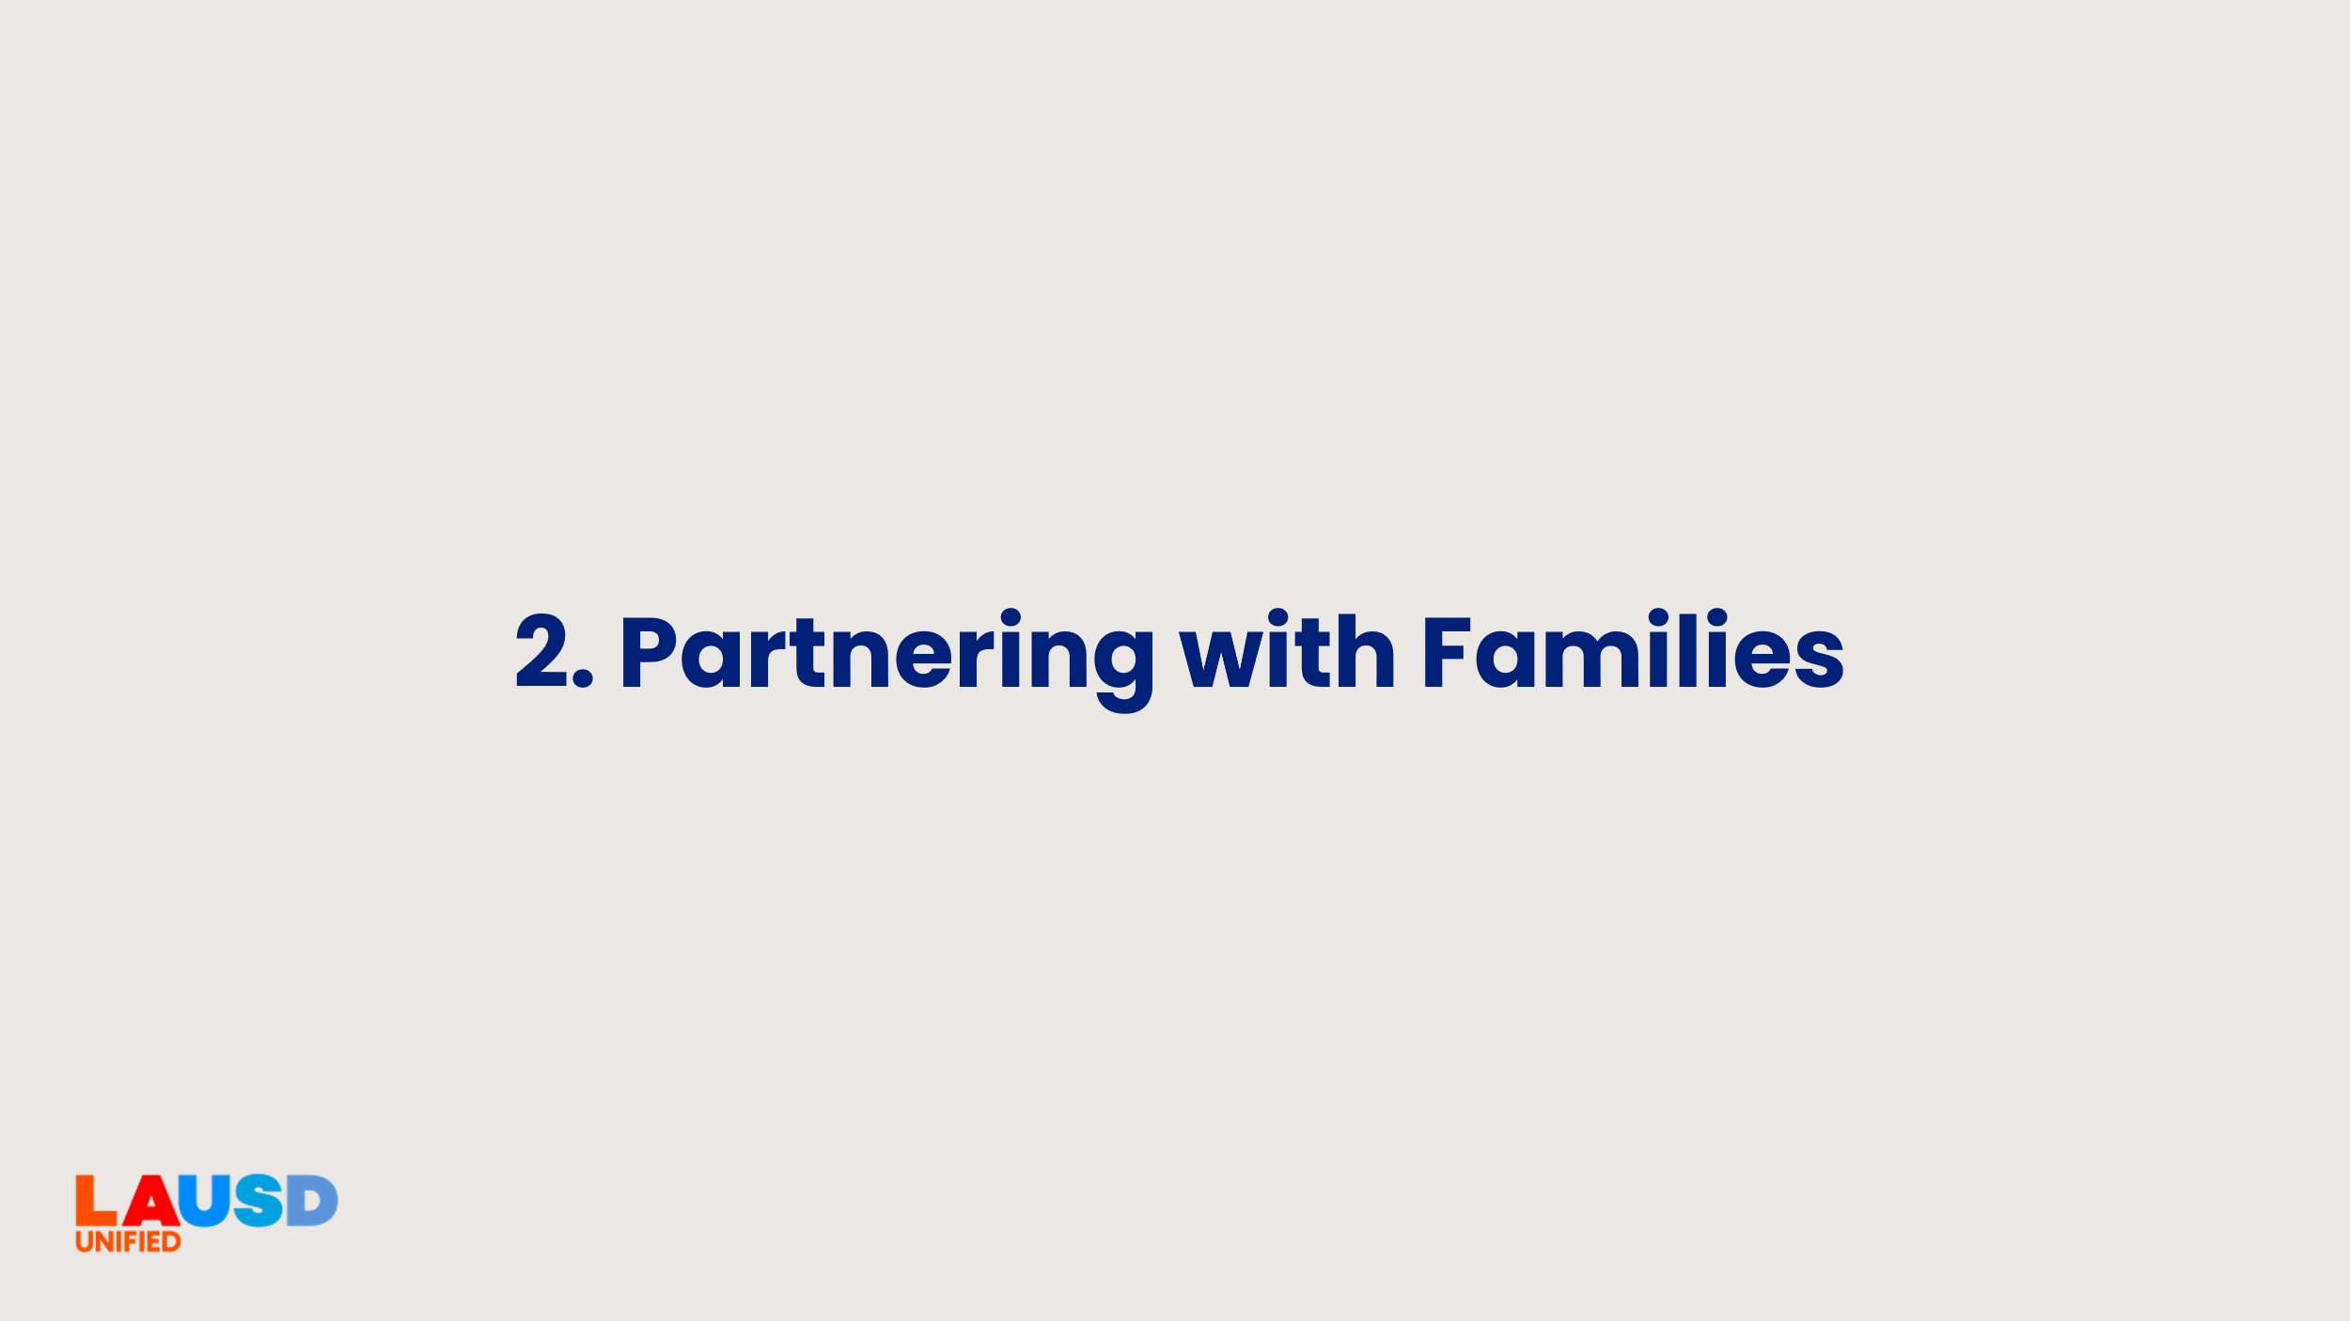 | [Transition slide to next activity]  Next, we’re going to move on to how partnership with families looks like in action. | <1 minute
11 |   [Hidden slide] | [Hidden slide – the slides that make up the next section are meant to be a choice between 4 activities. Choose ONE 30-minute activity that best suits your staff's needs.  - Explore the LA Unified’s Family Empowerment Rubric (Slide 12)  - Read and Reflect on Six Shifts to Better Family Engagement (Slide 13)  - School Experience Survey – Parent/Family Perceptions Using the What?, So What?, Now What? Protocol (Slide 14-15)  - Title I Parent and Family Engagement Policy and School-Parent compact Review (Slide 16)  - Bonus idea: Book study/Jigsaw (Slide 17)  Chose one activity for the Section 2 of this professional learning.] | 0 minutes
12 | 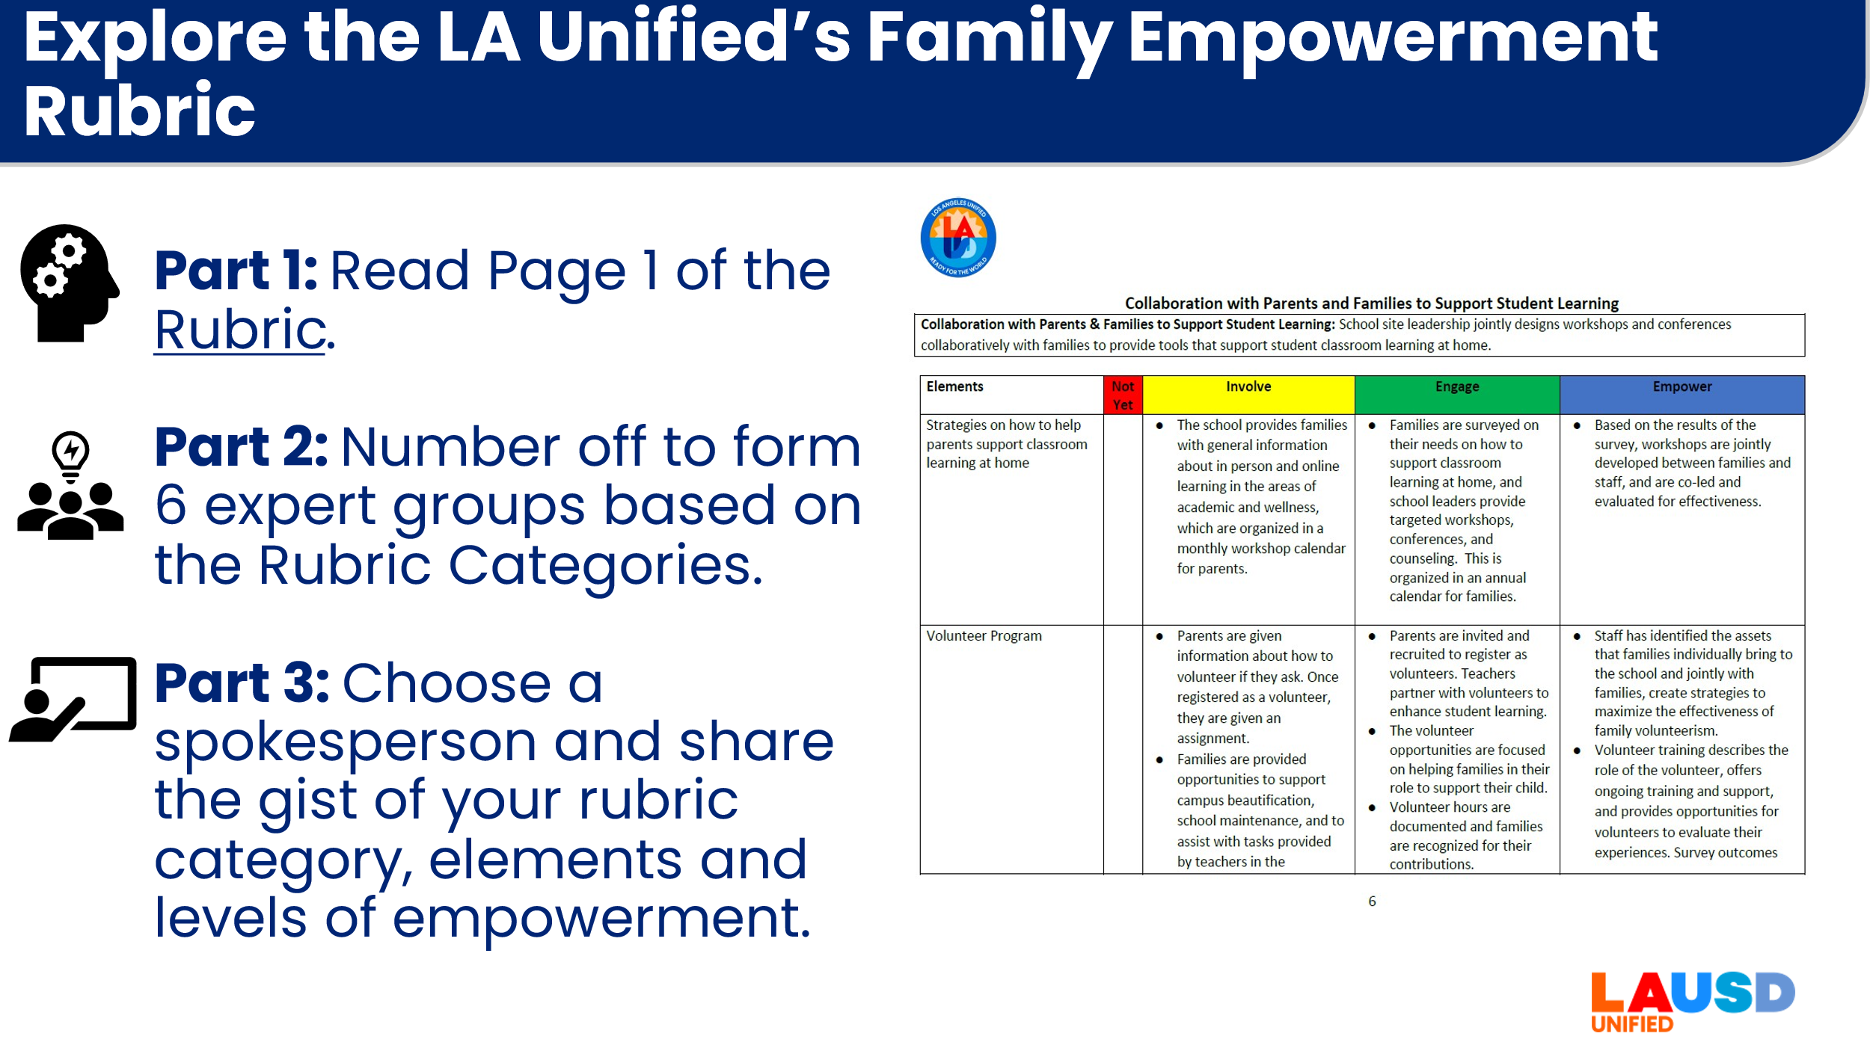 | Choice 1 - Explore the LA Unified’s Family Empowerment Rubric  We are going to Explore the LA Unified’s Family Empowerment Rubric. This document was created with parent, staff and community partner input. There are six categories and four levels.  First you will individually review the difference between Involve, Engage and Empower on Page 1 of the Rubric document. [5-7 minutes]  Next, we are going to count off to form six expert groups to each review ONE Rubric category and report on the gist of their section. [10 minutes - Use chart paper or a shared document to publish your summaries] Select one member of your group to share a 1-2 minute summary with the whole group. | 30 minutes  Print out copies or ask persons to open to Empowerment Rubric link: https://www.lausd.org/cms/lib/CA01000043/Centricity/Domain/577/LAUSD%20Empowerment%20Rubric.pdf
13 | 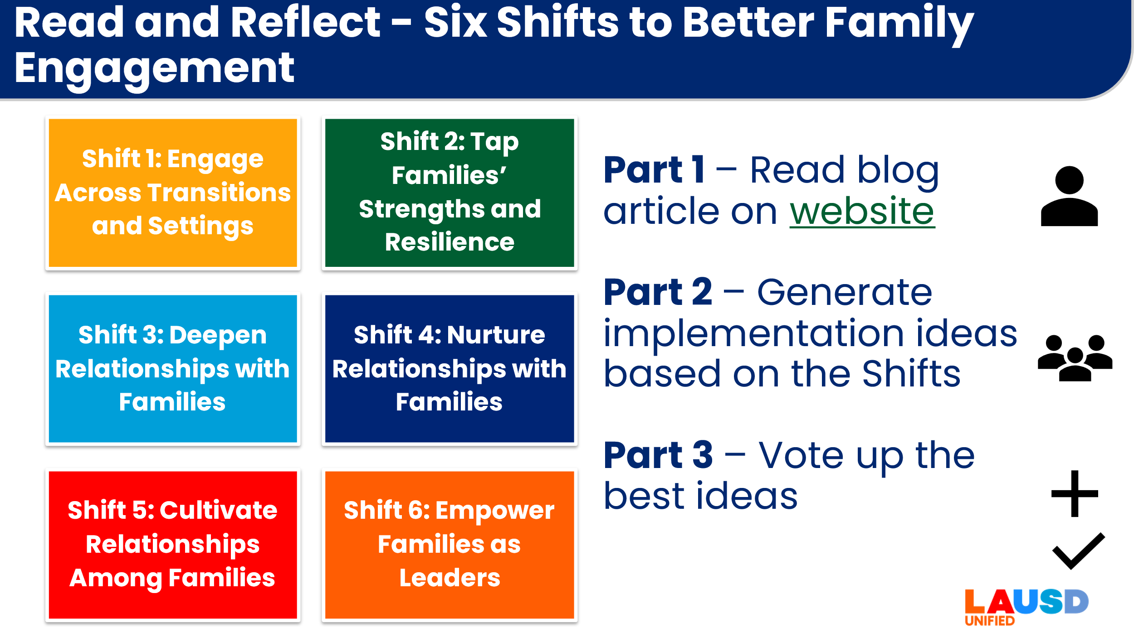 | Choice 2 - Read and Reflect on Six Shifts to Better Family Engagement  Individually, you will read about Six Shifts to Better Family Engagement. [3-4 minutes]  Next, with a partner or triad, you’ll generate actionable ideas for at least 3 Shifts that you would like to incorporate into our work with families. You’ll use chart paper [or a shared document] to write down your suggestions. [15 minutes]  Finally, we’ll take time to review the ideas generated and vote up ideas. [Use a + to vote up ideas on the shared document and use markers and a check mark P or a + to vote up on chart paper] [ 10 minutes] | 30 minutes  Print out copies or ask staff to read an article from the link.  Website article link: https://blog.searchinstitute.org/six-shifts-better-family-engagement  Optional resource – Self-reflection Tool using Six Shifts: https://searchinstitute.org/resources-hub/reframing-family-engagement
14 | 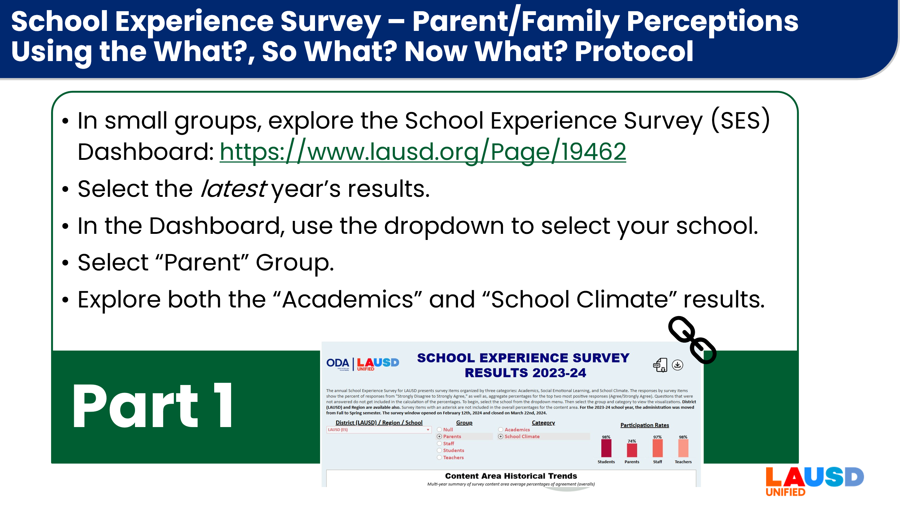 | Choice 3, Part 1 - School Experience Survey – Parent/Family Perceptions Using the What?, So What?, Now What? Protocol  For Part 1, you’re going to begin in small groups, exploring the School Experience Survey (SES) Dashboard for the latest School Experience Survey report. You will select the latest year’s results then, in the Dashboard, use the dropdown to select our location. Select “Parent” Group.  Explore both the “Academics” and “School Climate” results. [Tip – consider doing a walkthrough onscreen to support educators who may need support following these steps.] | 30 minutes total  Part 1 = 15 minutes  SES Dashboard website: https://www.lausd.org/Page/19462 [Choose the latest Dashboard available.]
15 | 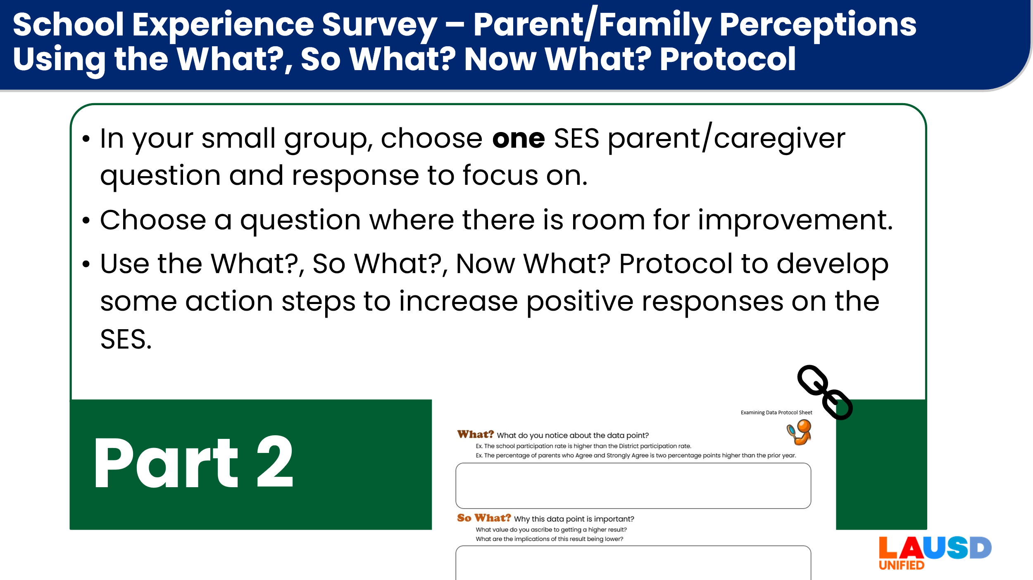 | Choice 3, Part 2 - School Experience Survey – Parent/Family Perceptions Using the What?, So What?, Now What? Protocol  Now that you have explored the Dashboard, your group will come up with one SES parent/caregiver question and response to focus on. Choose a response where we have room to grow. For example, don’t choose the response that 99% of respondents Agreed or Strongly Agreed.  You will use the What?, So What?, Now What? Protocol to develop some action steps to increase positive responses on the School Experience Survey. | 30 minutes total  Part 2 = 15 minutes  What? So What? Now What? Worksheet: https://docs.google.com/document/d/1MfFFDByls4wqefrX-InkjljUF-A8qfda/edit?usp=sharing&ouid=107149143496428911533&rtpof=true&sd=true
16 | 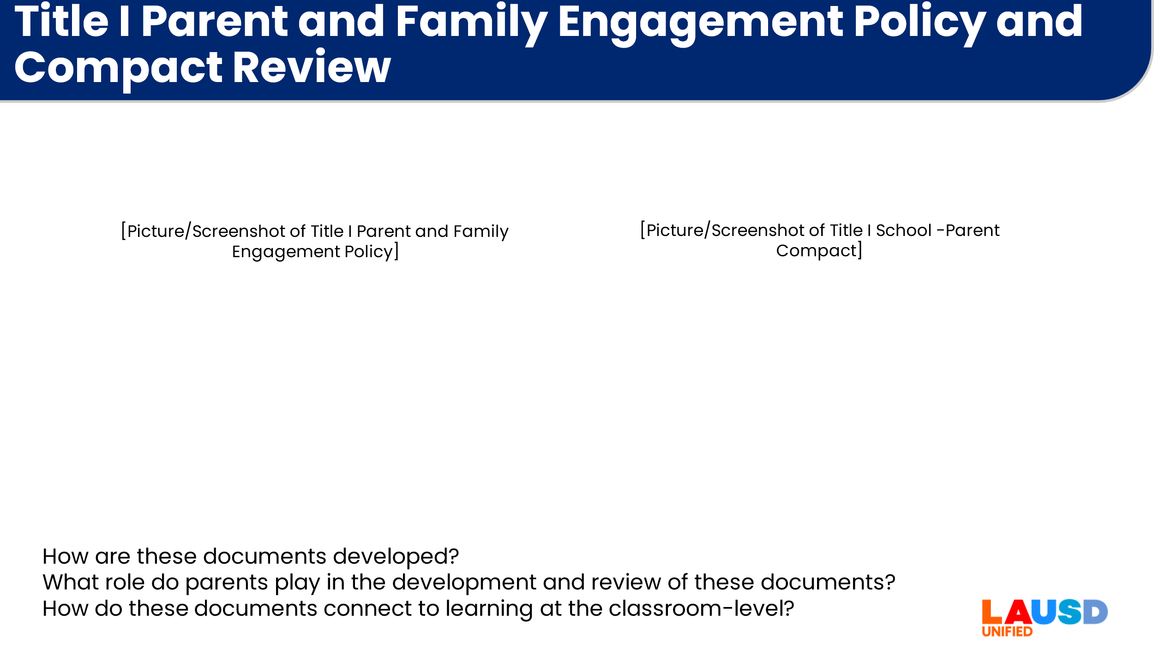  [Note: this slide requires personalization] | Choice 4 - Title I Parent and Family Engagement Policy and School-Parent compact Review  [This option is more of a “Show and Tell” to familiarize staff on the family engagement documents related to Title I, the School-Parent Compact (Compact) and the Parent and Family Engagement Policy (PFEP).  For this activity, you will need to prepare in advance copies of your schools’ PFEP and Compact or ensure that both documents are linked on your school’s website.  On the slide, insert a picture/screenshot of your school’s Title I Parent and Family Engagement Policy and School Parent Compact.  Invite your Title I Coordinator and/or Parent and Family Center Staff to speak to the development and approval of these documents. Describe the family engagement programming at your school.  There are three questions that can be used to guide the presentation by the coordinator/community rep or asked as a check for understanding:  How are these documents developed?  What role do parents play in the development and review of these documents?  How do these documents connect to learning at the classroom-level?]  [30 minutes] | 30 minutes  For this activity you will need copies of your school Parent and Family Engagement Policy (PFEP) and School-Parent Compact OR you can reference the documents on your school website.
17 | 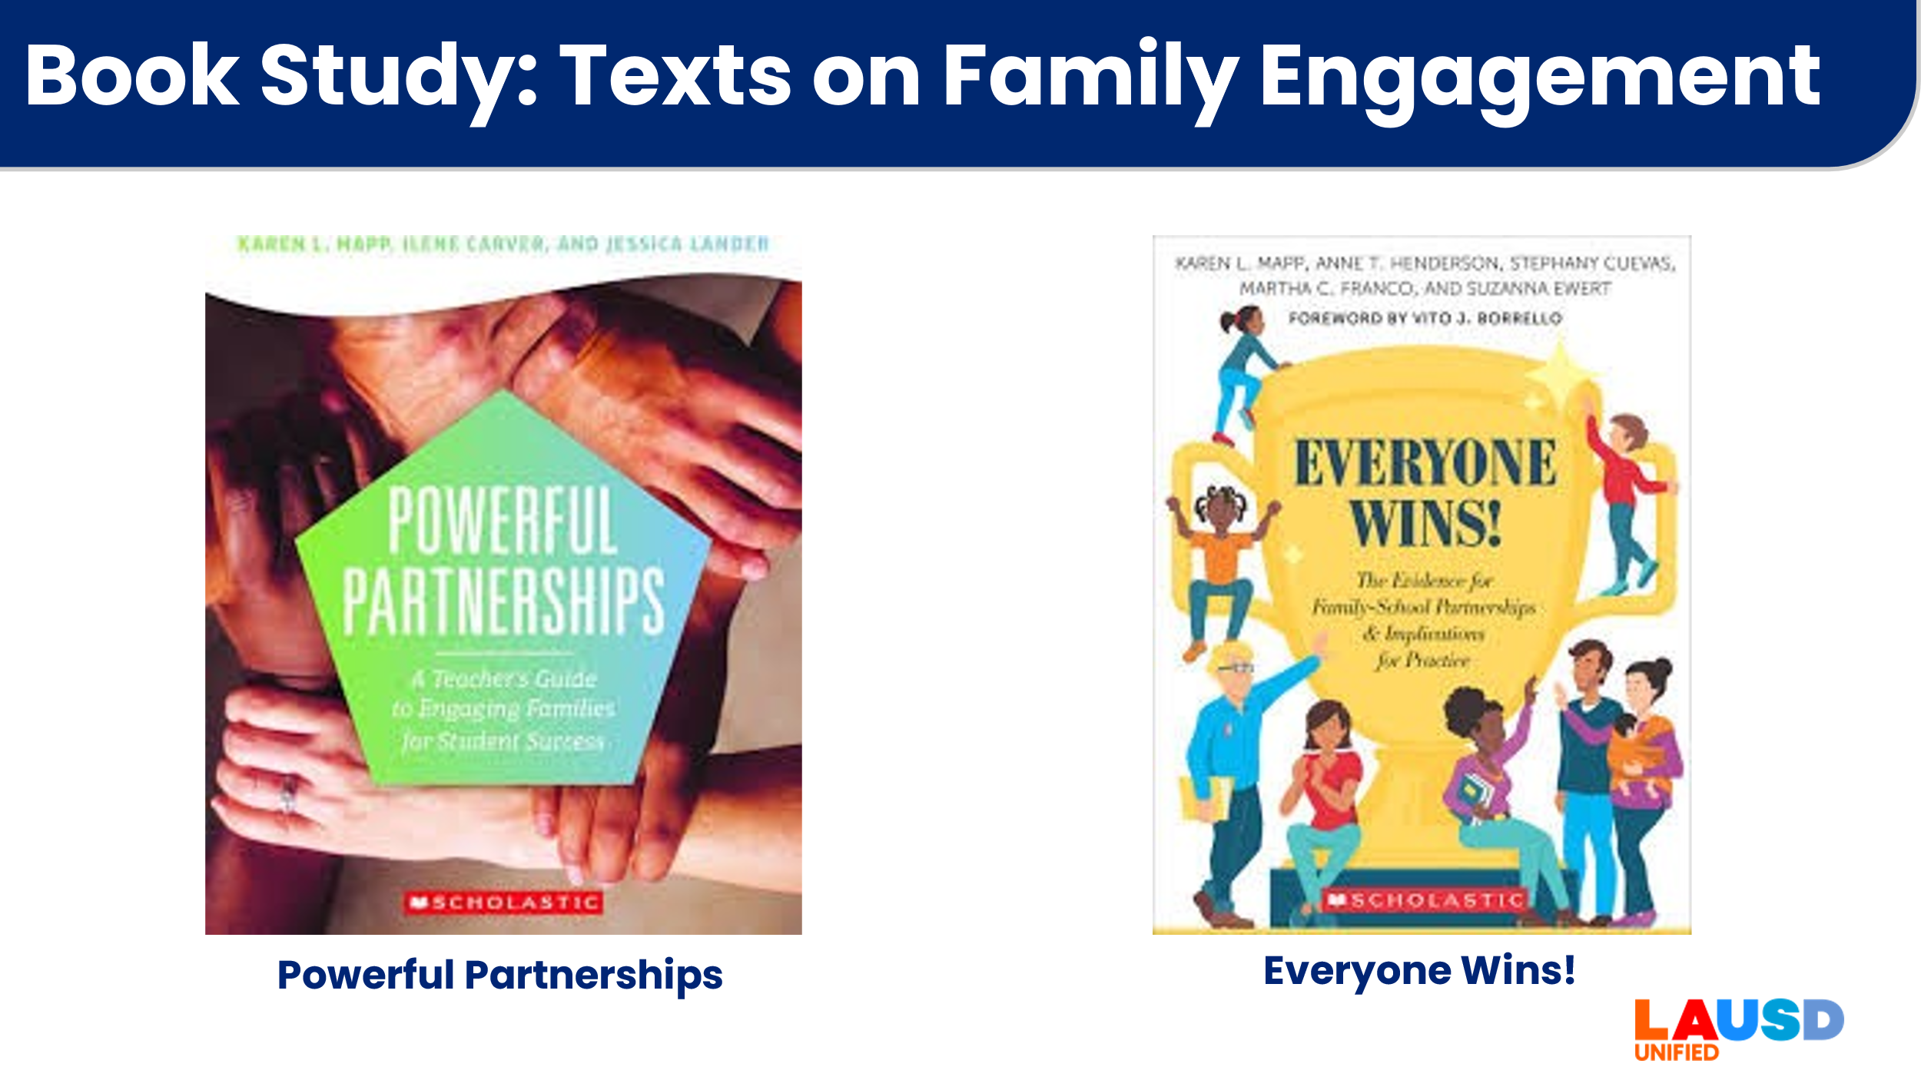  [Hidden slide] | [Hidden slide - Bonus Idea: Book study/Jigsaw  Recommended Texts to do a Book/Chapter Study -  Powerful Partnerships 1 2  Everyone Wins! 1 2 | 0 minutes
18 | 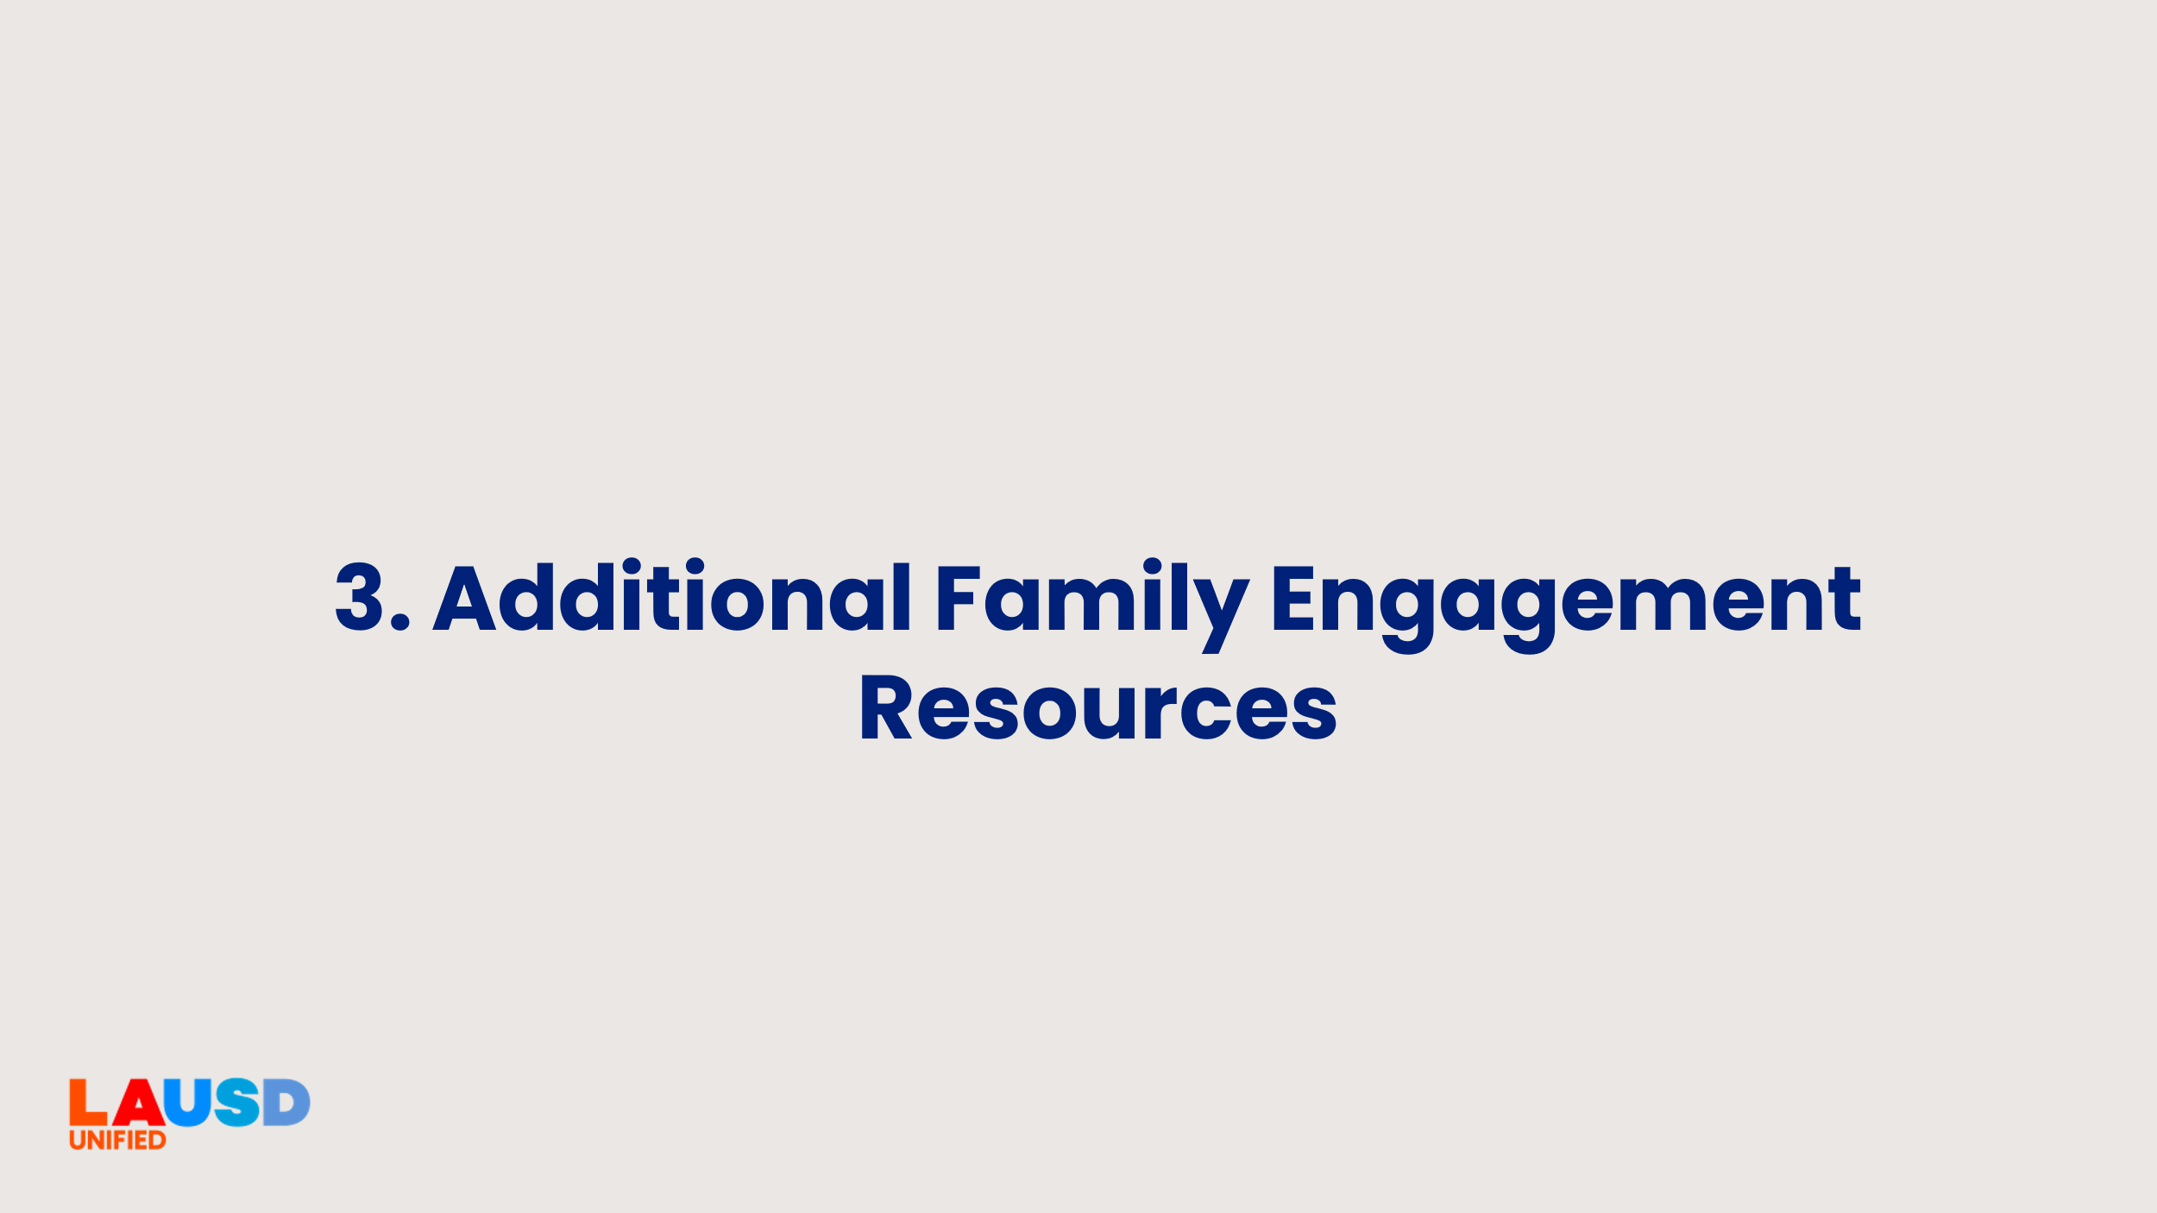 | [Transition slide to next activity]  For the final minutes of our learning this afternoon, I’m going to share some resources to support your interactions with parents and families. | <1 minute
19 | 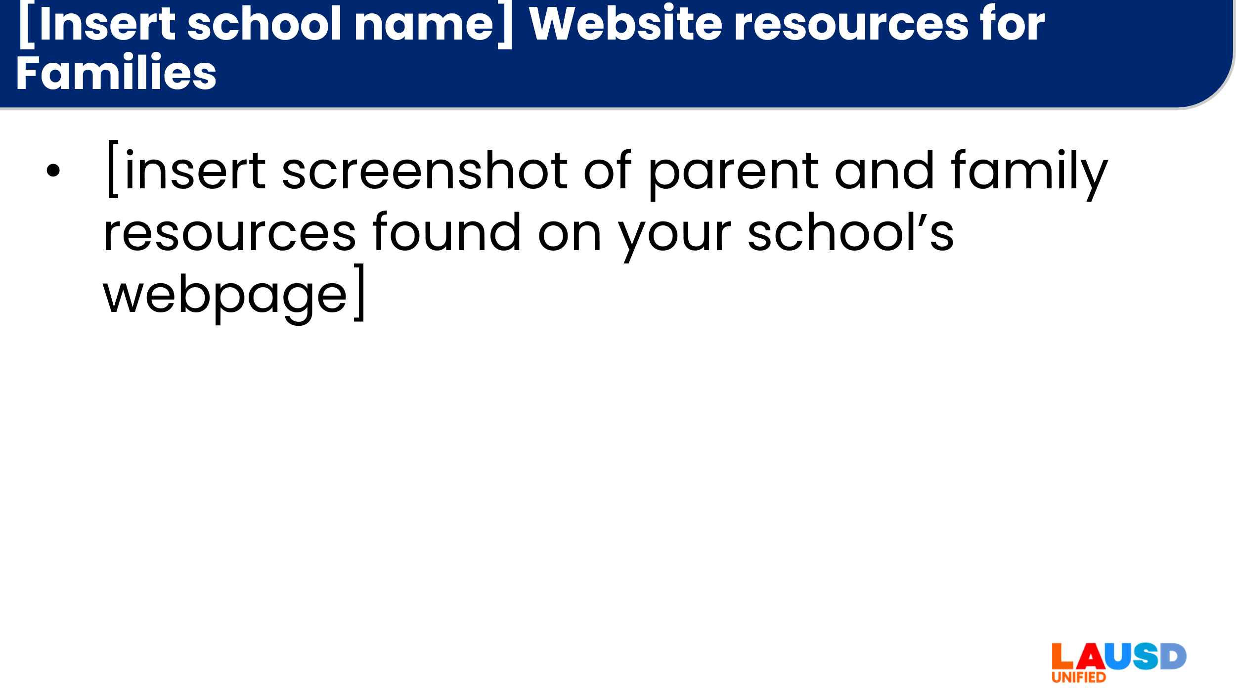  [Note: this slide requires personalization] | [Insert school name] Website resources for Families  This is our family page. Parents and caregivers can click on the links and get access to…  [Share a screenshot and/or a website walkthrough of your webpage(s) accessible to parents and caregivers so they can be partners in their student’s academic achievement. | 1 minute
20 | 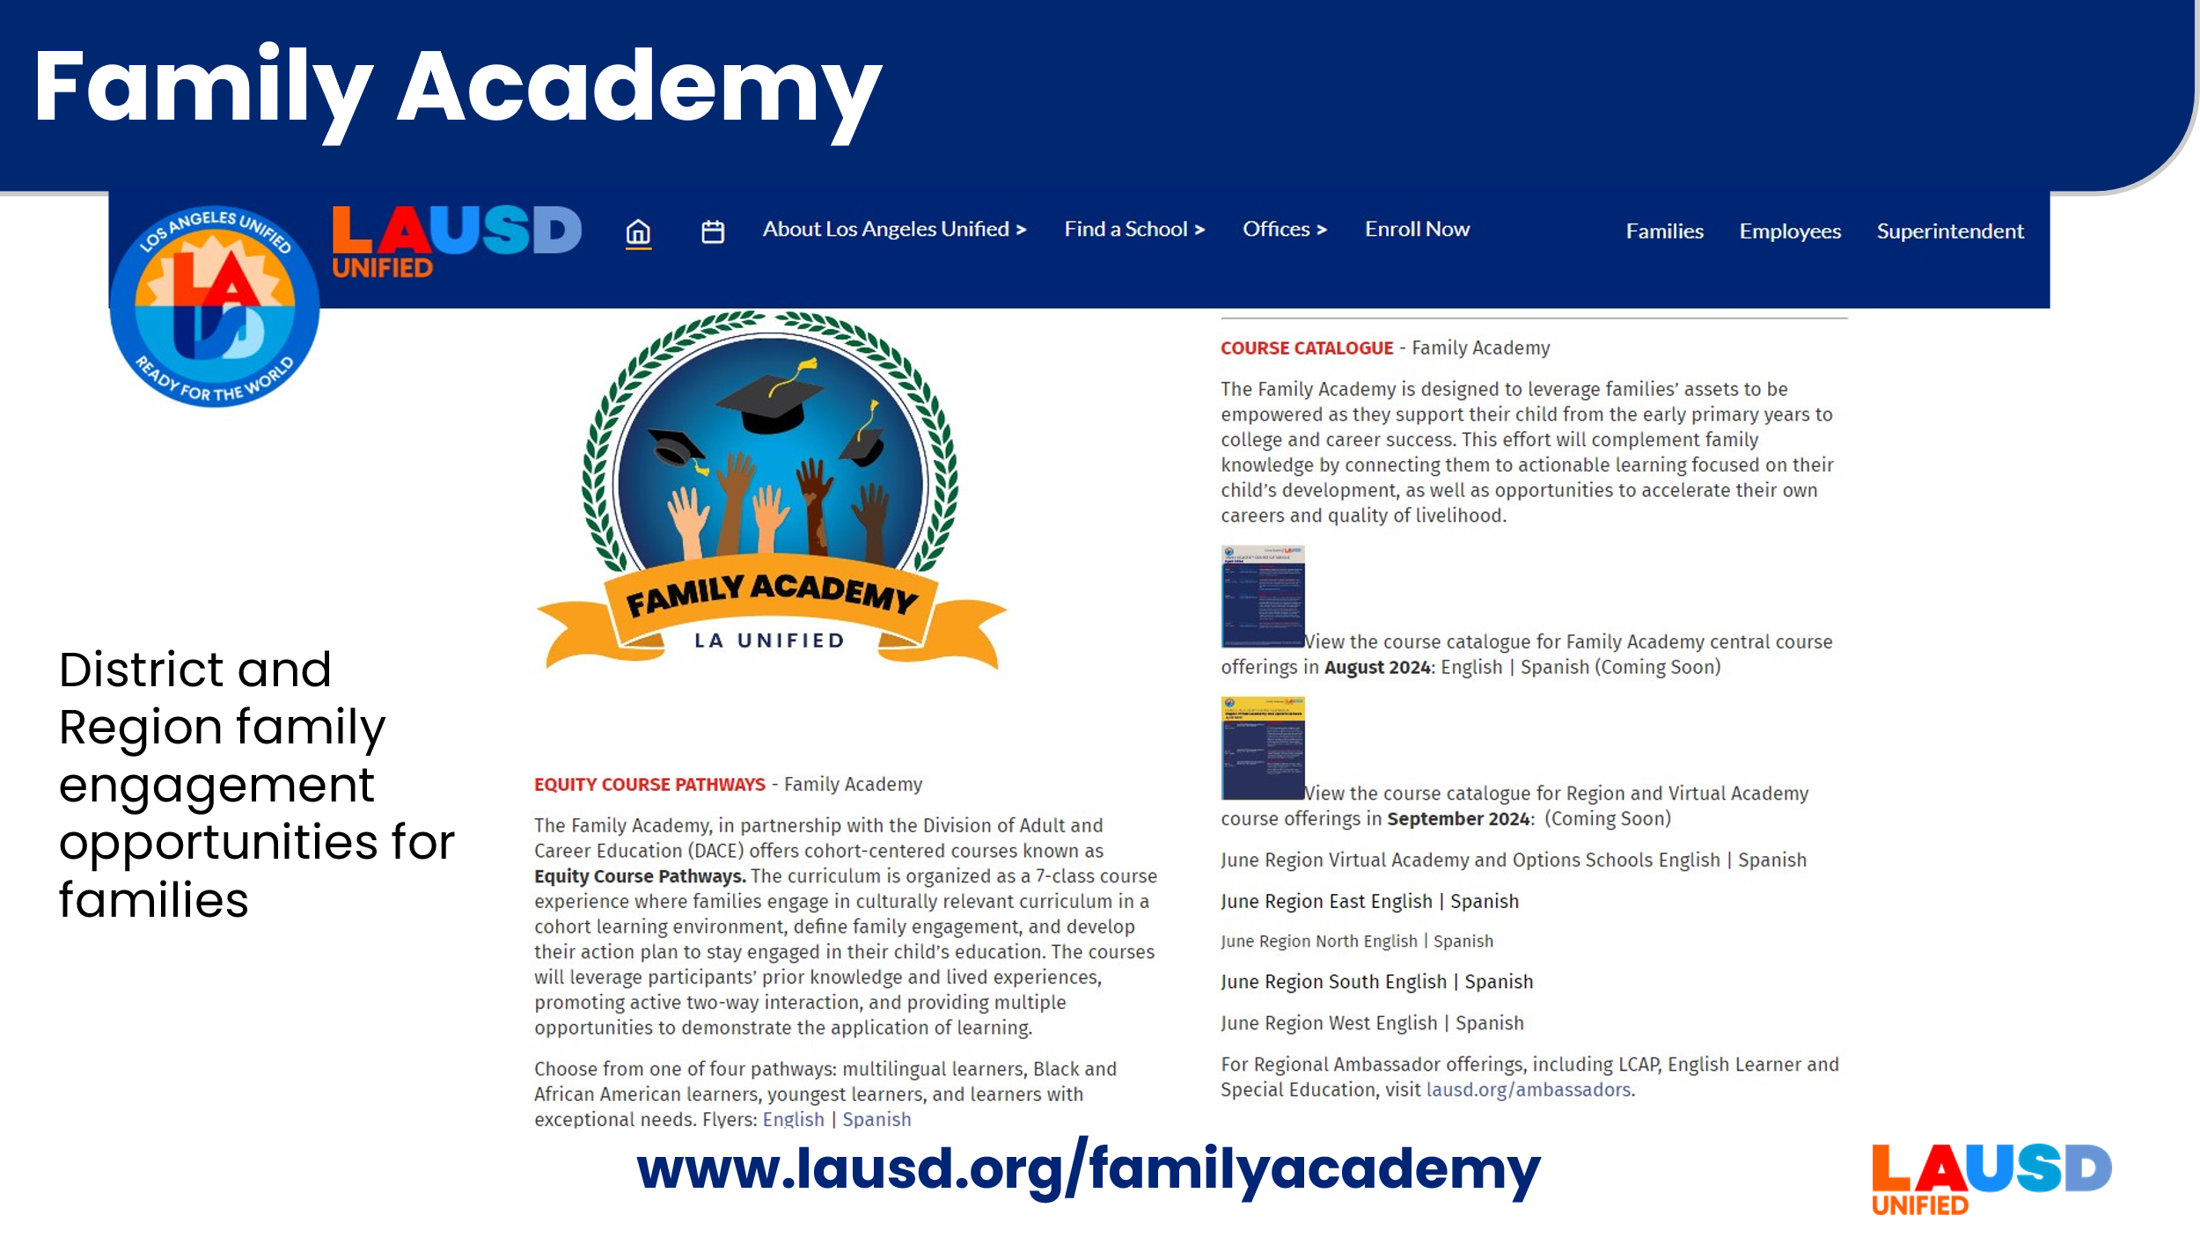 | The Family Academy is a series of district and Region webinars, in-person and hybrid engagement activities. You can download the course catalogue and flyers for parent classes on the Family Academy webpage here. | <1 minute
21 | 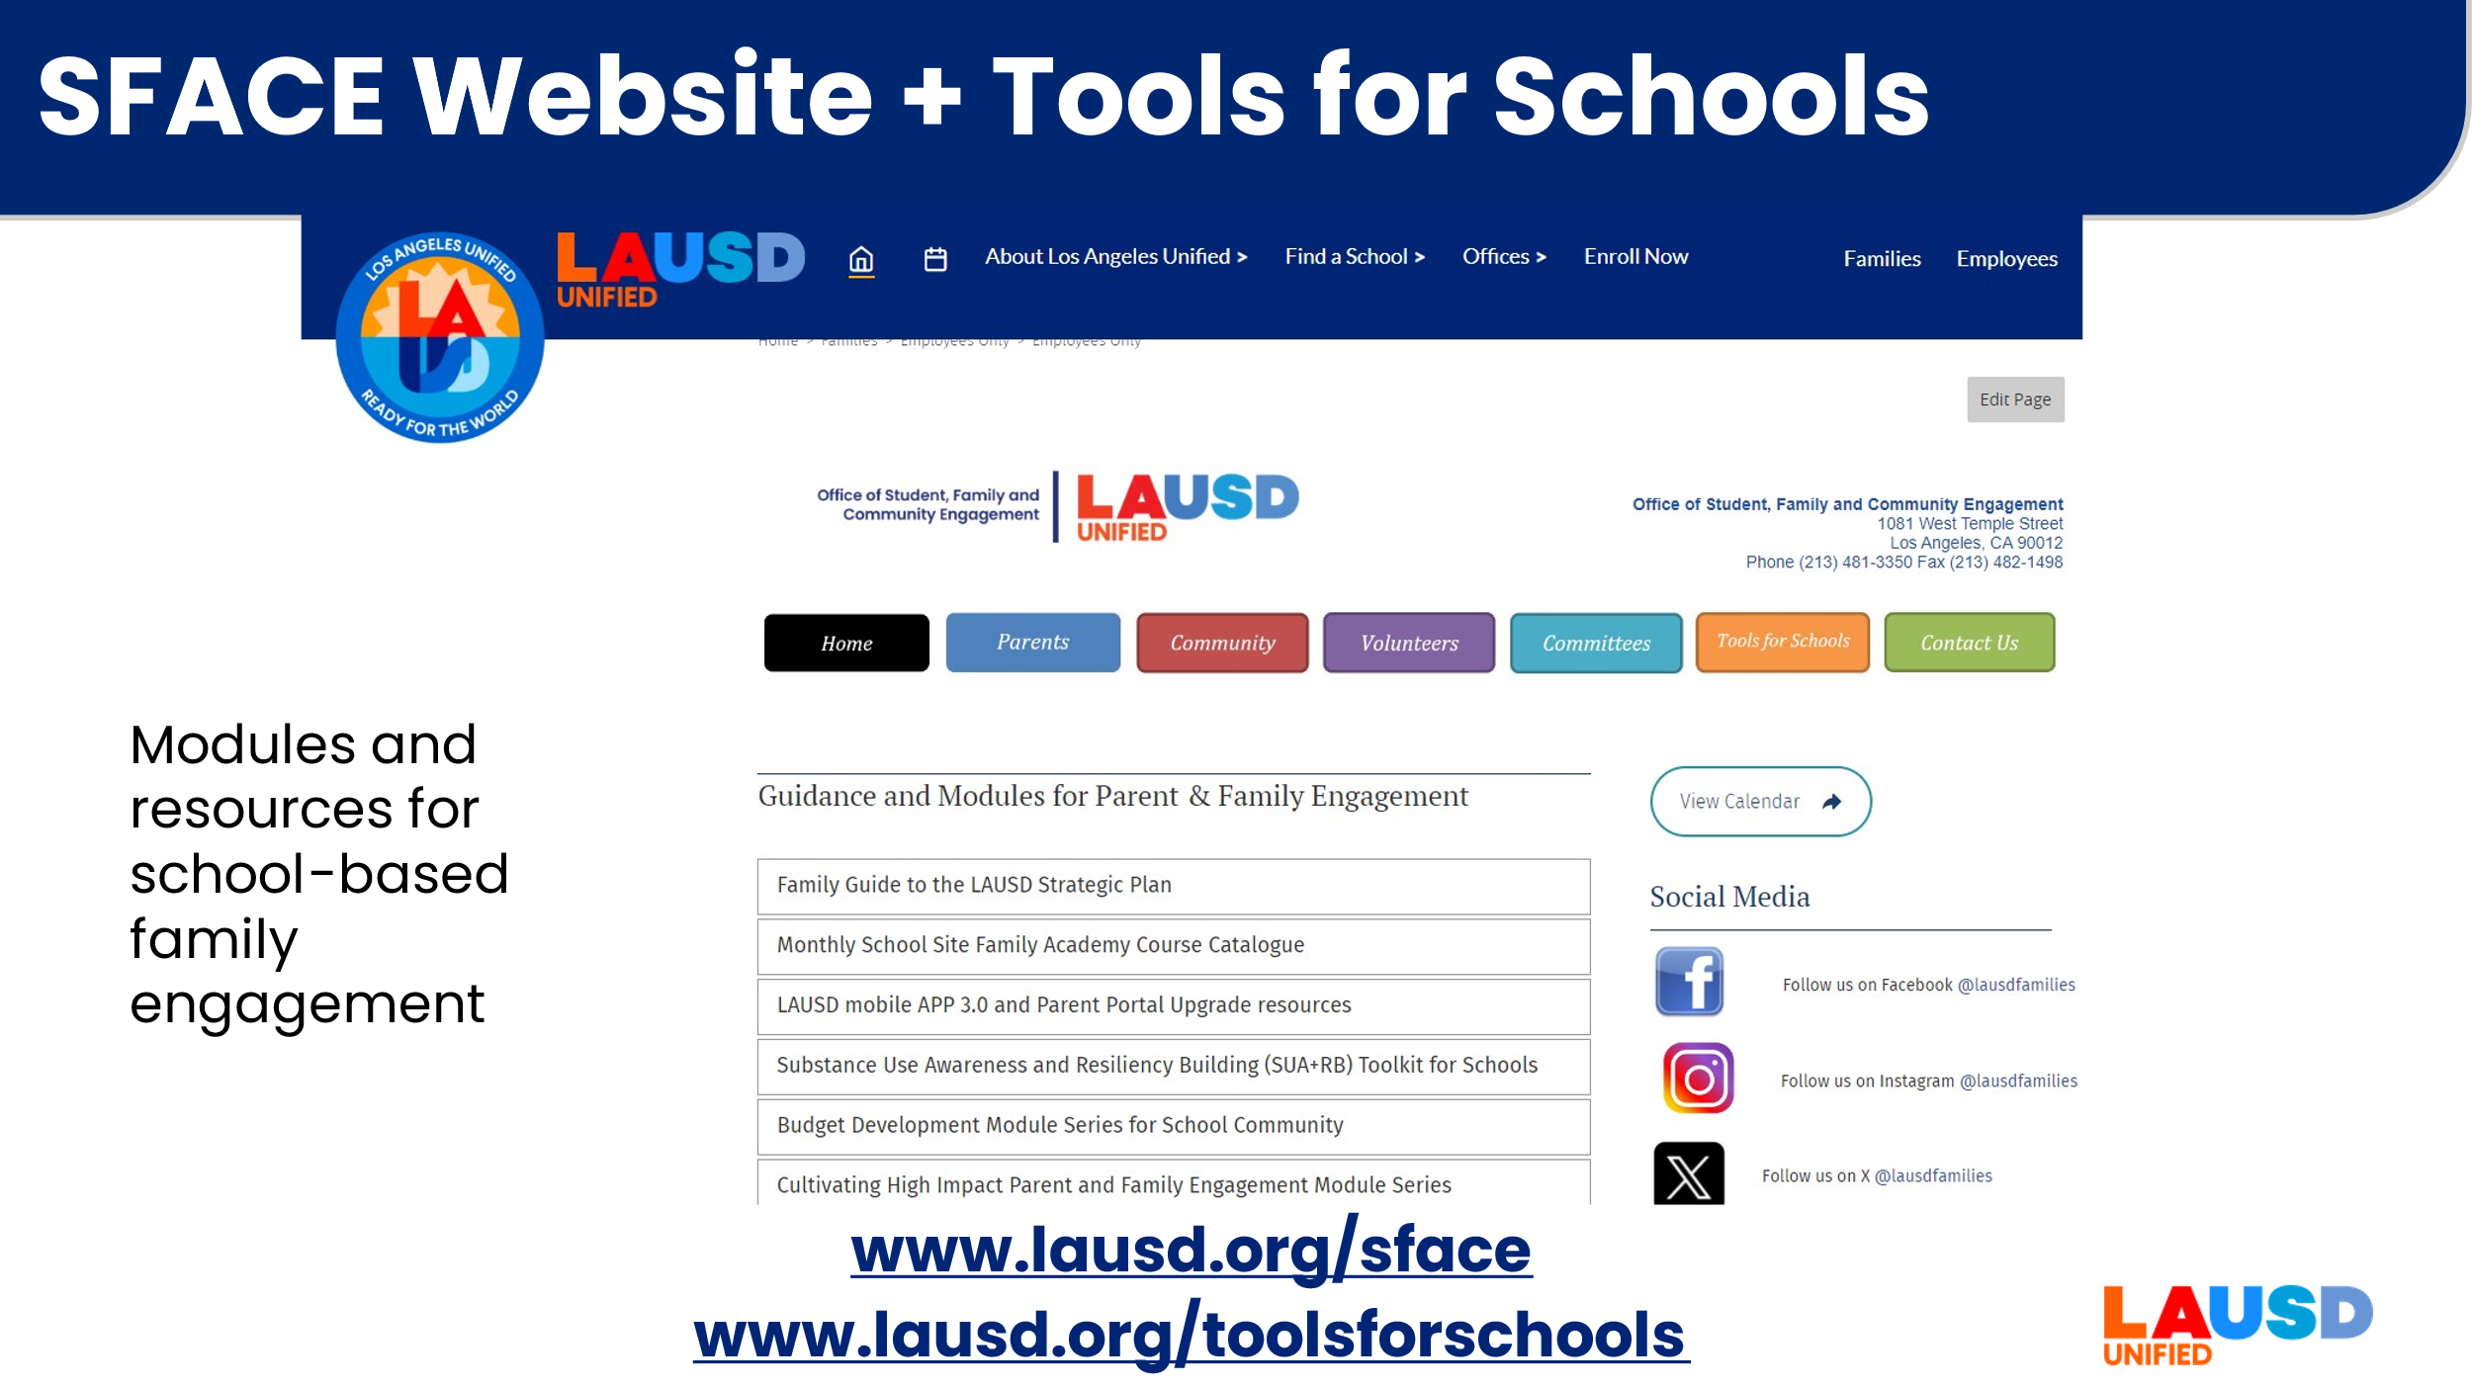 | The Office of Student, Family and Community Engagement (SFACE) has resources for families on their website. They also have the Tools for Schools page with resources for school staff. This is where you will find information on district wide programs and initiatives such as Parent Portal and the Volunteer Program. | <1 minute
22 | 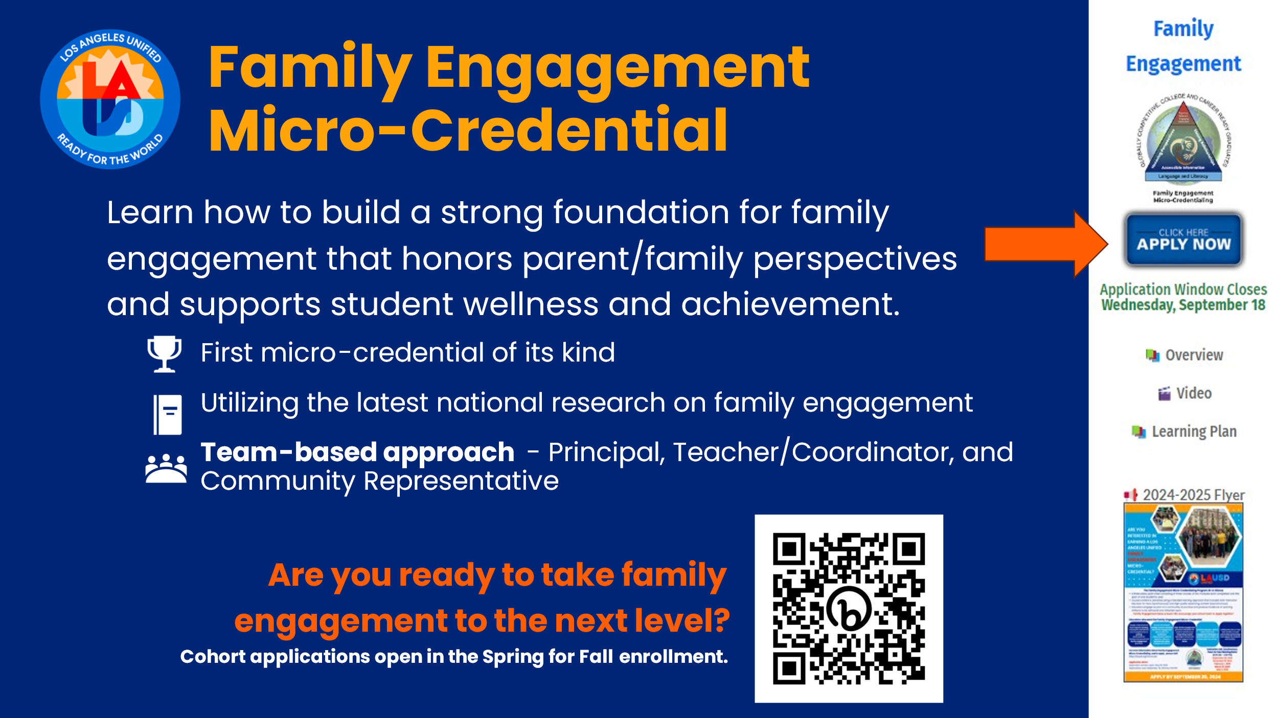 | And finally, if you are inspired and would like to really go deeper into how to engage families in a meaningful way, you might want to consider applying for the LAUSD Family Engagement Micro-credential. Learn more at https://www.lausd.org/microcred. Applications are open in May and due in September. | < 1 minute
23 | 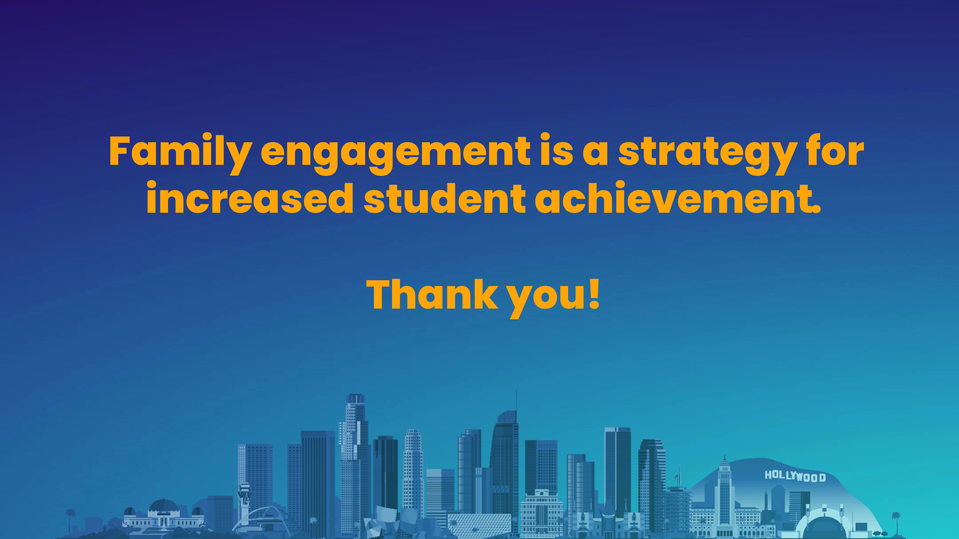 | Thank you for your thoughtful and engaged participation today. | <1 minute

