  Los Angeles Unified School District  Parent and Community Services  Parent Leadership development academy  Wednesday, march 22, 2017  Parent and community services office  10:00 am – 12:30 pm  DUAL LANGUAGE: SCHOOL PROGRAMS  This session will review the various LAUSD Dual Language Programs and the requirements for establishing a program. Participants will develop materials to assist other parents understand program elements.  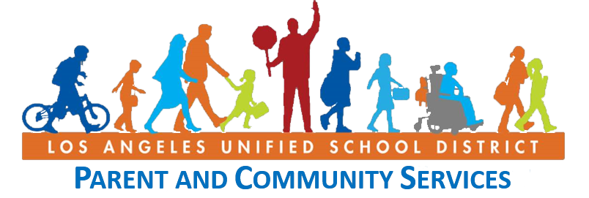  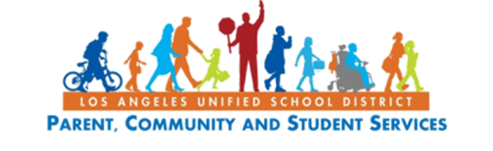  The last session will be held on Friday, May 5, 2017. | Parent Workshops on  Dual Language Programs  ────  Building  Parent Capacity  ────  Don’t miss this opportunity!  Parent and Community Services  1360 W. Temple Street  Los Angeles, CA 90026  (213) 481-3350  Families@lausd.net  For more information, please contact:  Angie Cardenas  (213) 481-3356

