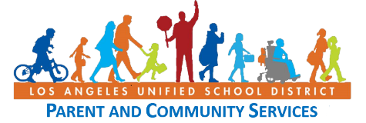

BYLAW REVIEW SESSIONS

You are cordially invited to attend two upcoming bylaws sessions. This will be a great opportunity to become more familiar with your committee’s bylaws and to review and provide recommendations. **Please note, this is not a mandatory training, however, you are strongly encouraged to attend**.

# WHEN: Tuesday, March 21, 2017

**D**

**A**

**Y**

**1**

# WHERE:

**Office of the Parent and Community Services**

1360 West Temple Street Los Angeles, CA 90026

# TIME: 4:00 p.m. – 6:00 p.m.

# WHEN: Saturday, April 1, 2017

**D**

**A**

**Y**

**2**

# WHERE:

**Office of the Parent and Community Services**

1360 West Temple Street Los Angeles, CA 90026

# TIME: 9:00 a.m. – 12:00 p.m.

Limited parking is available.

Spanish translation will be provided. Light refreshments will be served.

Please RSVP by calling the Office of Parent and Community Services at (213) 481-3350.