

Los Angeles Unified School District

Office of the Parent and Community Services

**Parent Advisory Committee**

**District English Learner Advisory Committee**

**TRAINING SESSION**



**SATURDAY, March 11, 2017**

**9: 00 A.M. – 12:00 P.M.**

PARENT and COMMUNITY SERVICES AUDITORIUM

1360 W. Temple Street, LOS ANGELES, CA 90026

# WORKSHOP: Local Control and Accountability Plan (LCAP)

In this workshop we will review the goals, data and district programs with a focus on early literacy program, Special Education, A-G data in preparation for recommendations during the two-day LCAP sessions in April.

For more information, please contact

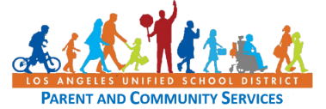Lisa Porter or Angie Cardenas at (213) 481-3350.