

Facilitator/Presenter’s Guide to Support ELA at Home with the Family PlayCards
Content: | Parents and staff will learn about the ELA PlayCards for Learning. Parents and staff will also learn about the Readiness Domains and how parents can be aware of these developmental skills in the home
Approximate Time Frame: | 60 min
Suggested Audience: | Parents/Families of K-8th grade students

Slide | Slide View | Presenter’s Text
1 | 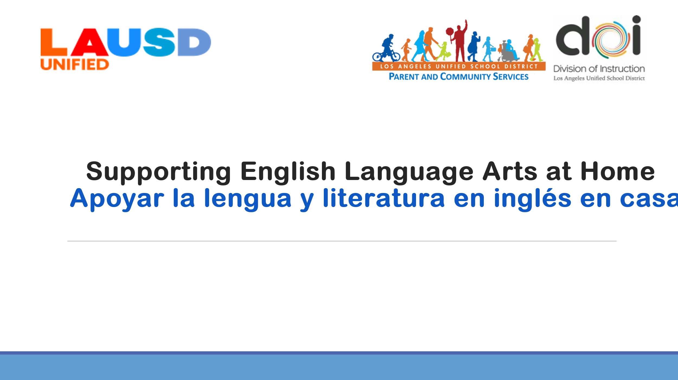 | Welcome and introductions
2 | 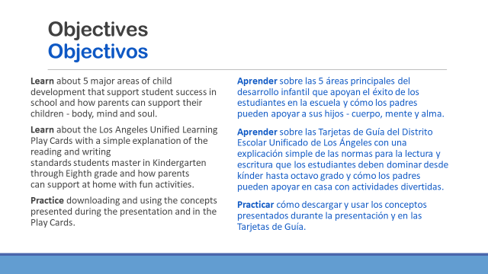 | Read objectives
3 | 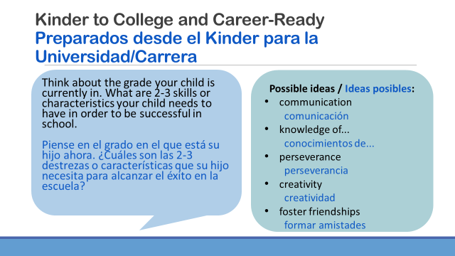 | Think about 2-3 skills or characteristics you child needs to be successful in school? (wait time)  Please type those skills in the chat box. ​  You may have thought of an idea similar to the ones on the screen, or not. Feel free to type in one skill/characteristic from the slide or type another skill. There is no wrong or right response here. ​  (take a moment to read out some of the skills)  ​
4 | 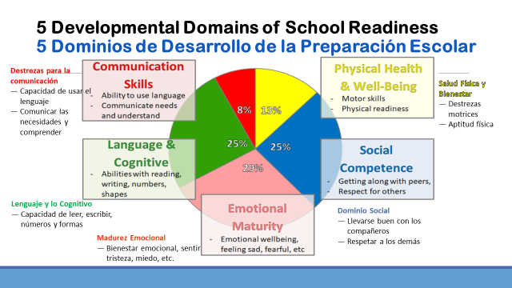 | In the previous slide, you shared the skills you feel are needed for success in school. ​  Here we have a slide that shows the 5 different areas of kindergarten readiness that researchers have found to be critical for school success. ​  Now you might be thinking to yourself, Kindergarten? but my child is no longer in kindergarten. ​  But let’s take a look at what these different skill areas are and how they actually relate to all our students-whether elementary, middle or high school.  I noticed in the chat some of you wrote skills related to the domain of Social Competence or the ability to get along with others and show respect. It also means the ability to express oneself appropriately according to social norms. ​  ​  I also noticed skills connected to the domain/area of Emotional Maturity which refers to a balance between a child’s curiosity about the world, an eagerness to try new experiences, and some ability to reflect before acting. ​  ​  Physical Health and Wellbeing is another one of our measures for school readiness. It means that a child is physically fit and eats a healthy diet which allows them to go to school and focus on learning. Physical fitness also supports the brain development. In little ones we look at their ability to be coordinated, kick balls, grip a pencil properly. Physical fitness, hand-eye coordination, balance are also important in our older children too. ​  ​  Others of you wrote skills that connect to Communication- use of language to communicate one’s experiences, ideas, wishes, and feelings so they are understood. How nice would it be if a teenager said, “Mom, I had a rough day at school and need to be left alone for a bit.” A young child able to communicate a story and be understood by others. ​  ​  And the fifth domain of school readiness that researchers have found predictive of school readiness and success is Language and Cognitive refers to vocabulary size and in kindergarten some key early literacy skills such as letter naming, ability to hear the sounds in words, and an interest in reading. We know the more interested all students are in reading the better they become at reading and developing a richer vocabulary that they can use when they communicate! ​  Cognitive skills involve the ways in which children perceive, organize, and analyze information. These are foundational math skills that only develop and get more complex throughout school. ​  ​  The studies have shown that children who enter kindergarten strong in these 5 areas will do well in 3rd grade standardized testing.​  And there is also research that shows children who do well in 3rd grade are more likely to do well in future grades and graduate high school. ​  So whether you are a parent of a pre-K student, elementary, middle or high school student, we know that these are skills that all children need to be strong in and continue to develop over their course in school.​
5 | 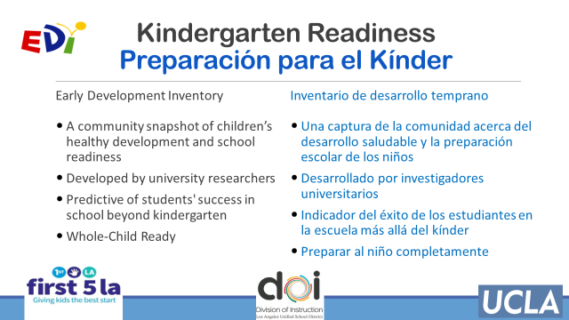 | LAUSD is working with First 5 LA and UCLA to administer an assessment called the Early Development Inventory (EDI) The EDI is a research-based assessment that measures the health/school readiness of our kindergarten students in these 5 domains. ​  ​The skills from these 5 EDI domains are assessed in our kindergarten students by their teachers through observation and interaction. ​  Currently this work is happening specific schools in LD West, Central, and East and plan to expand the implementation throughout the district to get a complete understanding of the strengths and needs of our children and their communities.  Kindergarten teachers at participating schools complete a survey about their students and Teachers complete a survey about their students and the data is shared with UCLA. UCLA then creates reports which give us with a snap shot of how children are doing across schools, neighborhoods and our city. ​
6 | 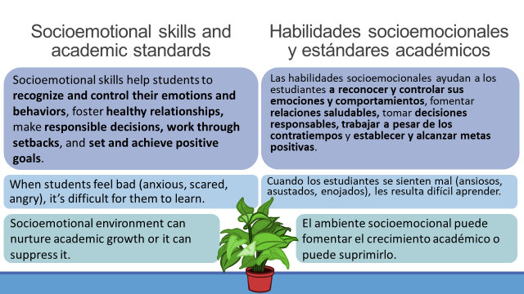. | Parents play an essential role in supporting all of the readiness domains—whether your child is entering kindergarten or leaving high school.  Some of those readiness skills, like Social Competence and Emotional Maturity, are non-academic in nature. While they may not seem like they have a direct connection to graduating from high school college, career and life-ready, these socioemotional skills help our children to be aware of their own emotions and the emotions of others around them.  A note here, students and adults develop socioemotional skills at different rates so it’s important not to compare one child to another.  Helping our children to be aware of themselves and how they interact with the world is one of the things parents do best! It’s also a strategy we can use to increase academic achievement because students do best when they are able to regulate their own emotions, feel safe and experience healthy levels of stress.  The socioemotional environment can nurture your child’s academic growth or it can stifle it.
7 | 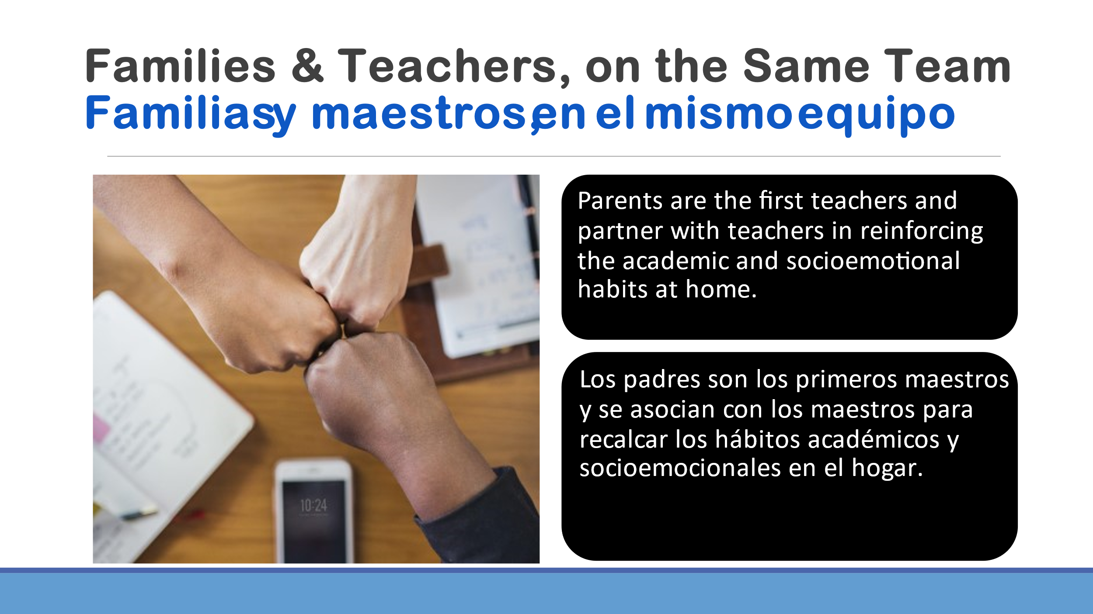 | Now, more than ever, families and schools must be on the same “team”—cheering and coaching students to get the best educational experience.
8 | 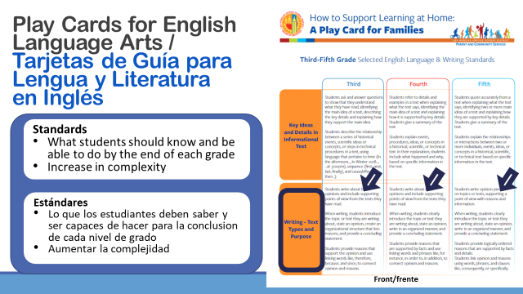 | LAUSD’s Office of Parent and Community Services is all about increasing partnership opportunities between families and schools.  Many families have expressed that they want to know more about how they can support their child’s learning at home, so the Family Play Cards were created in three grade spans:  - K-2nd grade  - 3-5th grade  - 6-8th grade  This formatting allows parents and family members to see how the grade level skills build from one grade to the next.  Note that the complete grade level standards in English Language Arts are not listed on the cards. Later in the presentation, I will be sharing a few websites where you can learn about ALL of the standards that describe what students should know and be able to do by the end of each grade.
9 | 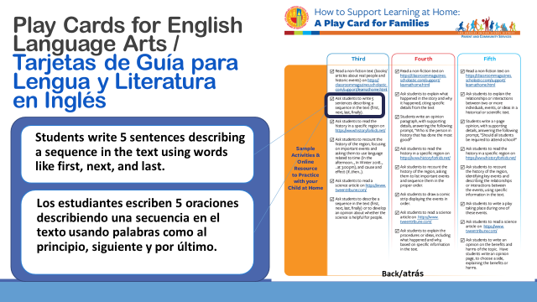 | On the back of the card there is an activity highlighted here.  It says “Write 5 sentences describing sequence in the text using words like first, next, and last.”  As a parent, feel free to use this as a guideline and modify it!  For example, ask your child to keep a journal. Give them a daily writing prompt, such as “Write 5 sentences that tell the family how to play the obstacle course you created using first, next, last...” or “Write 5 sentences that describe how the character FELT during the story (or movie) using words like first, next, and last.”
10 | 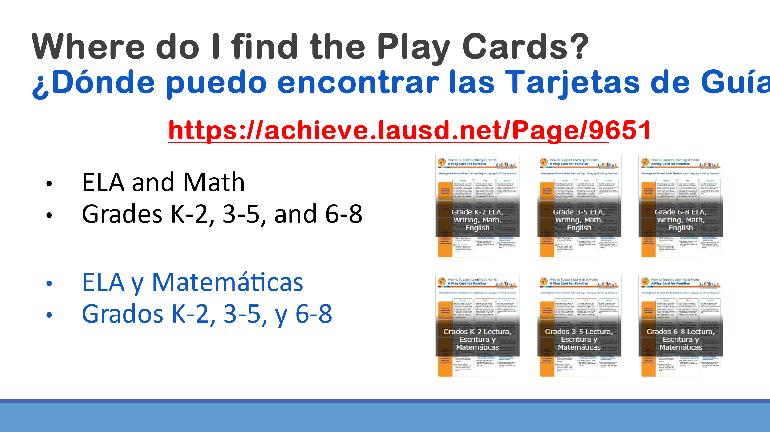 | Before I go on, I want to tell you how you can view and download these cards. Visit: achieve.lausd.net/Page/9651 and click on the title, “English Language Arts and Math PlayCards for Learning, Grade K-8”.
11 | 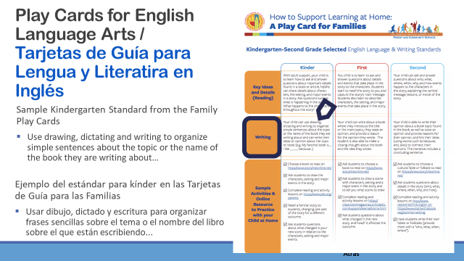 | Next, I’d like to show you three examples of the card activities being used with students.  The first is from the K-2nd grade cards. The grade we will look at is Kindergarten Writing: Use drawing, dictating and writing to organize simple sentences about the topic or name of the book they are writing about…”
12 | 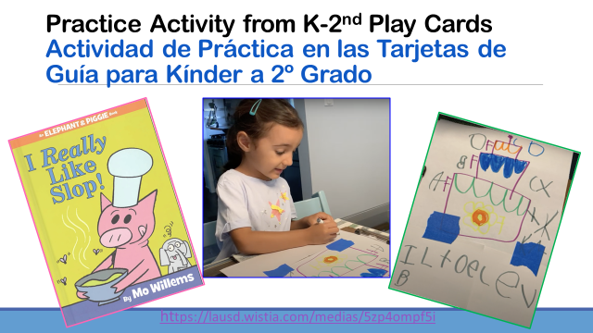 | Set background: “We are going to watch a video of a TK student working towards Kindergarten Standards with her mom as she writes after reading the book “I Really Like Slop,” from the Elephant and Piggie series. The main character’s favorite food is slop and he likes to eat it all the time.”​  ​  Make a connection to Family PLAY CARDS:​  Reading: With adult support, child learns to ask/answer questions about the story: “What is piggy’s favorite food to eat?” ​  Writing: Child can use drawing and writing to organize a simple sentence about the topic. “I like to eat cake every day.”​  *** Note that she is labeling her picture with the first sound that she hears in the word, which is age appropriate. Mom encourages her to write the sounds she hears. She wrote a “B” for the word day. You might wonder why she did not correct her…. the mom’s focus is to build an “I Can” belief in her daughter that she can write. ​  Also focused on building her daughter’s skills in writing a sentence.​  ​  What steps did mom take?​  Daughter repeated the sentence three times, mom repeated it. ​  Mom touched the paper for each word in the sentence. ​  ​  Sample Activities: ​  Have child draw a picture and write the sentence.​  Have child write an opinion about their favorite -- personal connection made to text.​  ​  Show Video: Before video ask parents to observe what the mother says and does, and what the daughter says and does in their interaction. ​  ​Debrief Video: ​  Reading: ​  Mother asks daughter about main character and what he likes to eat, and then mother makes a connection with her daughter and asks what her favorite food to eat.​  Writing: ​  Mother prompts her to draw a picture of the food she likes to eat most. (Drawing is a great way to engage students in developing oral language development which can lead to their desire to write to “tell” a story.)​  Asks daughter to remind her what the writing is about: “What you don’t like to eat, or what you don’t like to eat?”​  and daughter responds first in one word and then in a complete sentence.​  Pre-phonetic writing stage: Mother asks her to label things on her cake, and daughter sounds out the first sound and then​  Mother asks, “Is that what you hear?” Honors what her daughter already knows and encourages her. ​  Tracking: Mother touches paper as she repeats daughter’s sentence so she knows she will be writing words. ​  Final Product:​  Honor what your child was able to be successful at, and praise her. Then display her work.​  ​  Here is where you can see the connection with EDI social emotional area: daughter is willing to take risks and persevere, confidence in self.​
13 | 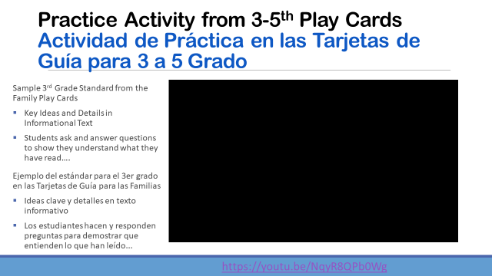 | Review ​  Demonstrate how a parent would look at the cards, read the standard, and show the activity-​  ​  Key Points:​  Aunt and nephew go to the website together, child selects article of interest​  Read together, and he reads independently​  She breaks up the reading and checks for understanding​  Gets his opinion, and helps him connect to the article/learning ​  Demonstrates features website has to offer, including the computer read aloud option, video for extended learning ​  ​  How might you engage with your child? What questions would you ask? ​  Provide frames for questions parents could ask?​  Key Ideas and Details in informational text?​  What is the main idea of this article/story?​  What are some details you remember from what you read?​  Can you tell me more about...?​  What makes you say that?​  ​
14 | 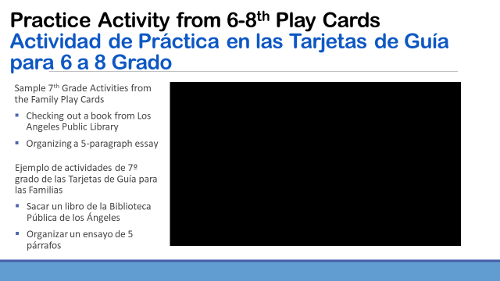 | Preview  This video shows a mother and daughter demonstrating how to access electronic books from the Los Angeles Public Library’s website using the Student Success Card.  An additional resource called Essay Pop is demonstrated to support writing.
15 | 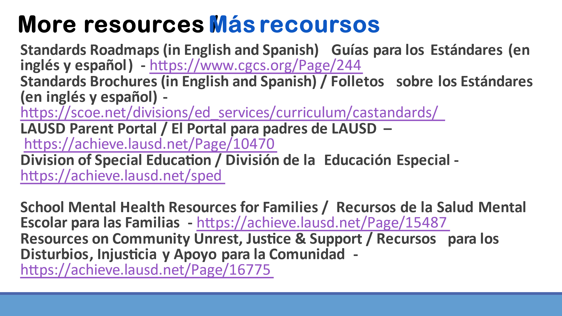 | These resources will help you go deeper into the learning from today.  (Highlight the links to find the complete text of the content standards for English Language Arts.)
16 | 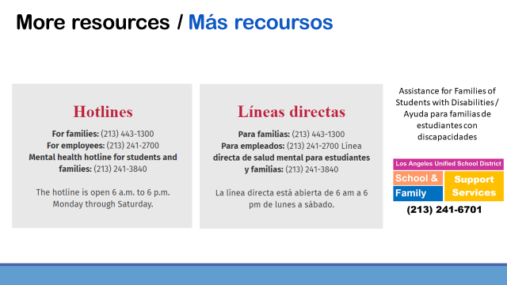 | Families may also benefit from the Hotlines that have been set up by LAUSD to support families’ needs. Please write these phone numbers down or use your phone to snap a picture.
17 | 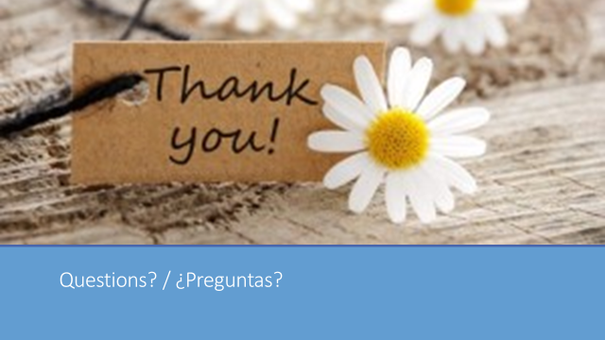 | Thank you!  Might there be any questions?

