Interim Behavior Response Plan (IBRP)

Student Name:  Click or tap here to enter text. | Date of Plan:  Click or tap here to enter text.
School Team Developing Plan:  Click or tap here to enter text. | School:  Click or tap here to enter text.

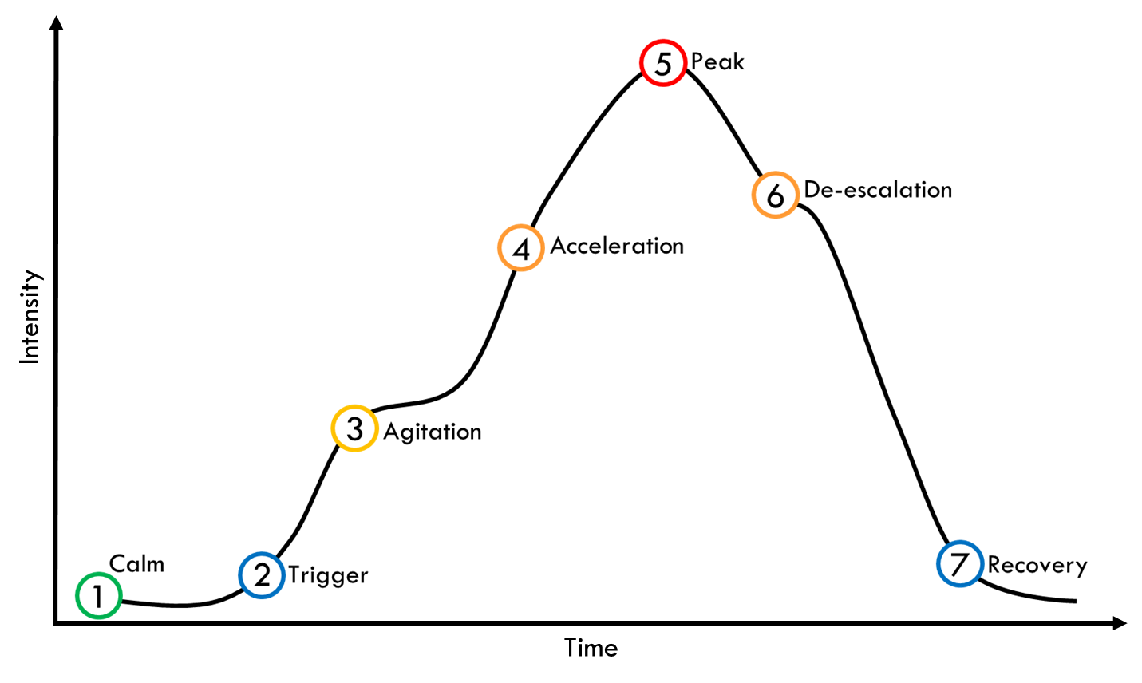

Calm | Student Behavior |  | Staff Responses
Calm | - Click or tap here to enter text. |  | - Click or tap here to enter text.
Triggers | Identify Known Triggers | Student Behavior | Staff Responses
Triggers | - Click or tap here to enter text. | - Click or tap here to enter text. | - Click or tap here to enter text.
Agitation | Student Behavior |  | Staff Responses
Agitation | - Click or tap here to enter text. |  | - Click or tap here to enter text.
Acceleration | Student Behavior |  | Staff Responses
Acceleration | - Click or tap here to enter text. |  | - Click or tap here to enter text.
Peak | Student Behavior |  | Staff Responses
Peak | - Click or tap here to enter text. |  | - Click or tap here to enter text.
De-escalation | Student Behavior |  | Staff Responses
De-escalation | - Click or tap here to enter text. |  | - Click or tap here to enter text.
Recovery | Student Behavior |  | Staff Responses
Recovery | - Click or tap here to enter text. |  | - Click or tap here to enter text.

After an incident staff should debrief to discuss what happened and determine any modifications/revisions needed.

