Visual Schedules
Use pictures to represent the routine that you have created. Visual schedules are useful for breaking down tasks and helping students follow routines. They are helpful tools in reminding your child of what they should be doing, and when they should start and finish.

For young children, you can use images to represent the activity they are currently engaging in and the image that they will engage in next.

For older students, the visual schedule can represent the all the activities are planned for the day.

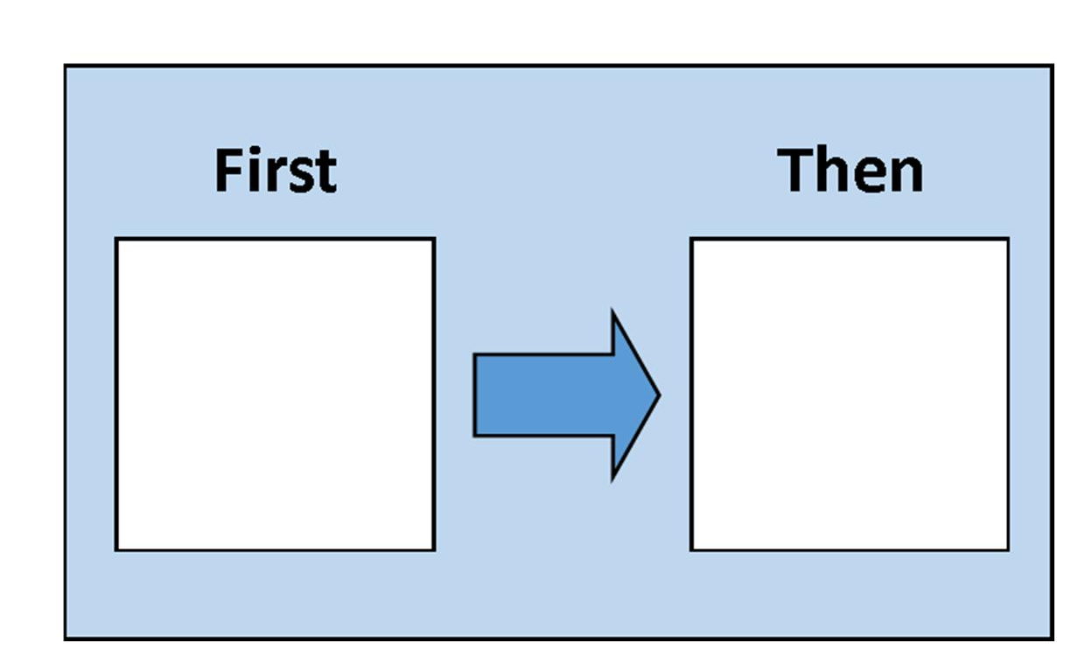
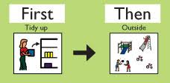

Resource:
https://www.schools.nyc.gov/learning/blended-learning/activities-and-supports/special-education-supports/speech-therapy-supports

