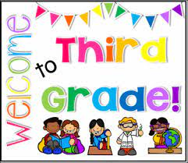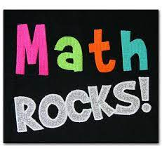

Dear Third Grade Families,
Welcome to the 2021-2022 School Year! The Math Department is so excited to begin the year. We have so many amazing things planned for your third graders this year.
As always, we like to keep the lines of communication open with our students and families. If you have any questions, please feel free to email your child's teacher or send a message via ClassDojo. We will be using the PS 68 Website (ps68bronx.org) for calendar events and much more, so please visit the website as often as possible. Also, we will be using google classroom for individual class communications, daily reminders, and homework. Your child's homeroom teacher will be sending information on how to join soon.
On the third grade math page you will find:
Teacher emails
Units of Study
Resources-Important Websites
And much more!!
We hope you find the math page useful. Please reach out to us if you have any questions.
Third Grade Math Teachers

