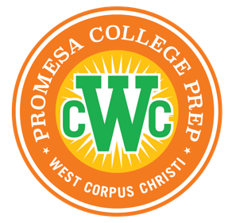

Promesa College Prep – West Corpus Christi

Bell Schedule

The school day for students is as follows on

Monday – Thursday
Pre-K3 – Kindergarten | 8:00 a.m – 3:30 p.m.
1st Grade – 3rd Grade | 8:00 a.m – 3:30 p.m.
4th Grade – 5th Grade | 8:00 a.m – 4:00 p.m.

The school day for students is as follows on

Friday
Pre-K3 – Kindergarten | 8:00 a.m – 3:30 p.m.

