Approvers - View & Approve Travel Requests/Expense Reports via ESS & Concur
This job aid is to provide step-by-step instructions for approvers on how to review travel request/expense report documents and approve/reject them.

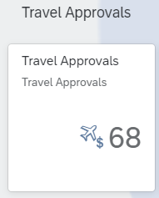
- Log into ESS with your LAUSD single-sign-on and click on the “Travel Approvals” tile to begin reviewing Travel Requests and/or Travel Expense Reports.

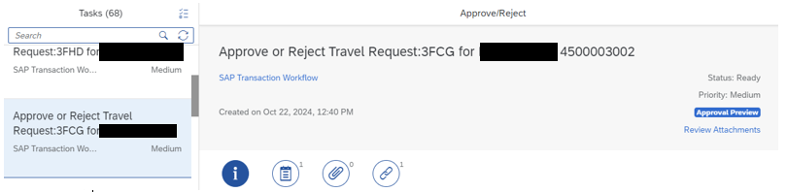
- After opening your Travel Approvals inbox, you can scroll through the queue or search for specific requests/reports using the search bar. You can search by the traveler’s name or by the four-digit Travel Request ID/six-digit Expense Report ID:

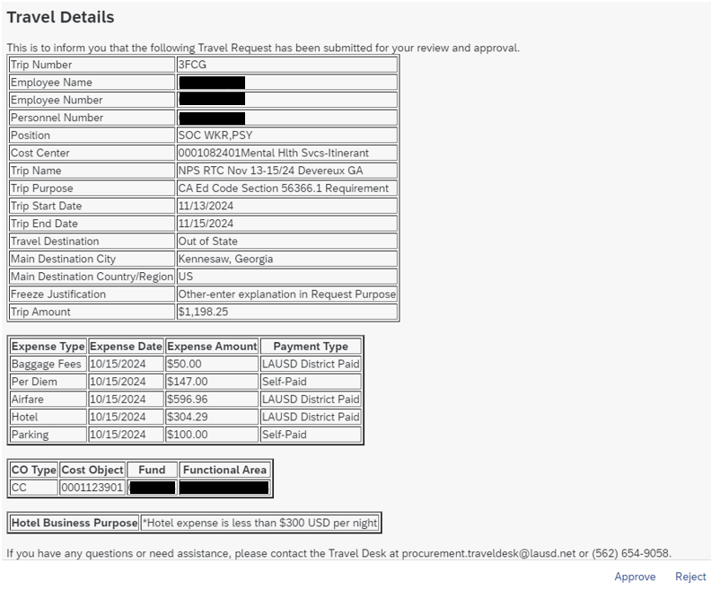
- Once you find the request you are looking for, review the details of the request:
- Ensure that the name of the conference is in the “Trip Name” field. The employee’s name should not be here.
- The “Trip Purpose” field should have a valid reason for the travel (i.e. Grant Requirement, Professional Development, Training, etc.) or the Freeze explanation.
- The “Trip Start” date should be the date of departure & the “Trip End Date” should be the date of the return from the trip.
- Make sure the “Travel Destination” field is correct. (Local = within 45 miles each way)
- If “Other” is selected for the “Freeze Justification” there MUST be a valid reason in the “Purpose” field.
- Ensure that the “Hotel Business Purpose” statement is correct. District policy currently states that hotel costs should not exceed $300 per night, including taxes & fees.
- All expenses must be listed as either “LAUSD District Paid” or “Self-Paid”. The only exception is when the Hotel or Airfare will be booked with the Concur Booking tools, in which case the expenses must be paid via the “Virtual Card”

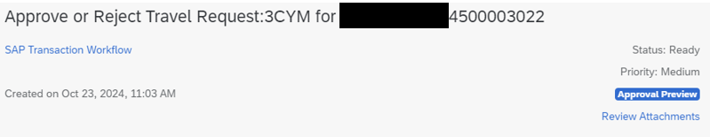
- After reviewing the travel details, you will need to review the attachments. A travel request should always have attachments. A request with no documentation should be rejected. Click on the “Review Attachments” link at the top of the request:

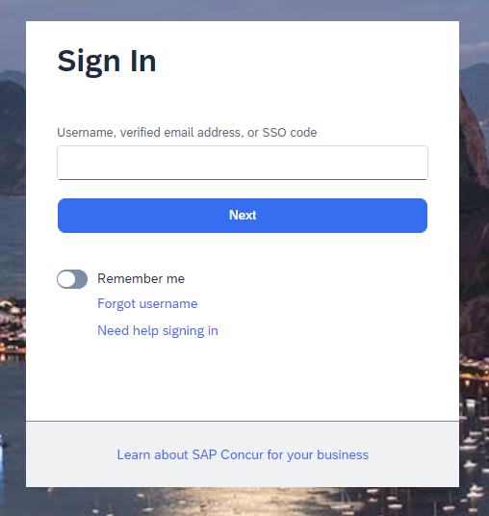
- You will be redirected to Concur. Use your LAUSD single-sign-on email to login:

- Click on “SAP_IAS_PRD”:
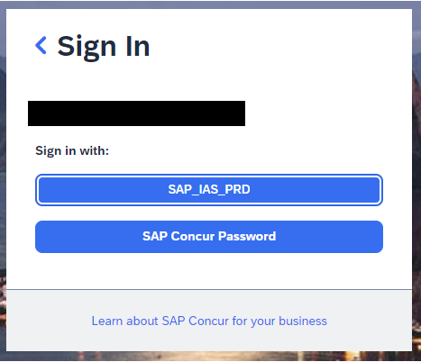
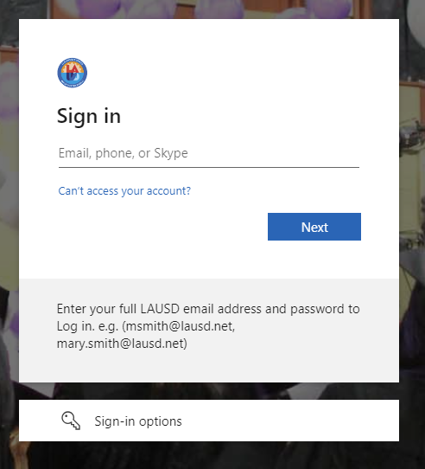
- Login again using your LAUSD single-sign-on email address & password:
- Once logged in you can use the “Home” drop-down to navigate to the “Requests” or “Expense” searches:
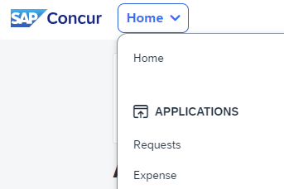

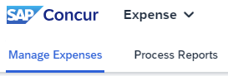
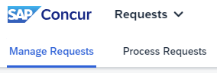
- Once you are redirected, click on “Process Requests” or “Process Expenses” depending on whether you are trying to approve a travel request or expense report:

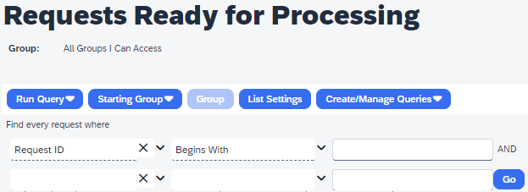
- When searching for travel requests, change the filters to “Request ID” and “Begins With”. Then enter the 4-digit travel request ID (Trip Number) in the search box (letters must be uppercase). Then click “Go”:

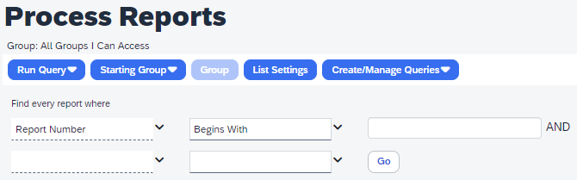
- When searching for expense reports, change the filters to “Report Number” and “Begins With”. Then enter the 6-digit expense report ID (Trip Number) in the search box (Ensure the letters are uppercase). Then click “Go”:

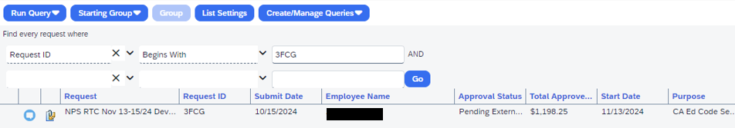
- After locating the desired request/expense report, you can click on the paperclip icon to open the attached document packet, which will open the attachments in a new window.

- Please see the lists below regarding supporting documentation requirements for travel requests & expense reports:

All TRAVEL REQUESTS should include:
- A copy of the Brochure/Flyer/Agenda and it must contain the name of the conference, dates, and location.
- A copy of the responses to the Deputy Superintendent of Instruction's Justification Questions if the traveler belongs to a school site or central office under the Deputy Superintendent of Instruction.
- Screenshot of 3 estimates for hotel (if applicable)
- Screenshot of 3 estimates for airfare (if applicable)
- Screenshot of 3 estimates for car rental (if applicable)
- Screenshot/printout of Google Maps showing the mileage from school/work to event location
All EXPENSE REPORTS should include:
- A copy of the Brochure/Flyer/Agenda and it must contain the name of the conference, dates, and location.
- Corresponding receipts for the expenses listed in the report. (Per Diem & Personal Car mileage expenses do not require receipts).

- Once all the documents have been reviewed you can go back to the original Travel Approvals queue in ESS. You can then select “Approve” or “Reject”.

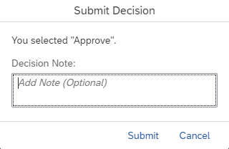
- You will be prompted to add a note. It is highly recommended you add notes if you are rejecting a request so that travelers can review them and make necessary changes.

- Once approved, the request will continue along the approval process. If rejected, the employee will receive an email alerting them that the request was returned for corrective action.

