

Educator Preparation Provider

Letter of Intent Application:

Add a Teaching Field
(Updated 03/23/26)

TABLE OF CONTENTS

Introduction 3
Directions 4
EPP Review Process: Add a Teaching Field 5
Key Terms 6
Abbreviations 7
Program Information 8
Program Intent 11
Program Justification 13
Clinical Experience 15
Program Startup 17
List of Appendices 19
Educator Preparation Provider Verification 20

Introduction
The Hawai'i Teacher Standards Board (HTSB) is the state-authorizing agency that approves and oversees educator preparation programs in Hawai'i (Hawaii Administrative Rules [HAR] §8-54-18).

The purpose of the Educator Preparation Program (EPP) Letter of Intent (LOI) Application is for institutions or organizations interested in implementing an Add a Teaching Field (ATF) teacher licensure program. Hawai'i-approved and non-Hawai'i-approved programs shall use the LOI application.

According to Hawaii Administrative Rules:

HAR §8-54-20:
(a) When applying for approval of a first-time provisional unit or program review, the following requirements shall be met:

(1). The letter of intent and preconditions must be submitted for consideration no less than one (1) year prior to the date of proposed program implementation; and
(2). Within two (2) years of acceptance of the letter of intent and preconditions, the unit must submit one (1) unit report and a program report for each program that will prepare educators for initial licensure.
(b) The board staff will convene a review team and conduct a virtual provisional review of the unit and programs within three (3) months of acceptance of the unit and program reports after staff review and board approval.
(c) The board will review the review team's recommendation and issue a decision upon recommendation of the board's Teacher Education Committee.
(d) A unit must receive board approval before advertising programs for initial licensure, implementing programs, and accepting candidates into any educator preparation program.

HAR §8-54-2.4:
(e) the EPP will be charged a $500 Review fee for each license field.

The review fee must be paid 30 days after receipt of the LOI application.

Please direct any inquiries about the process to the following HTSB staff:

Executive Director: Felicia Villalobos
Email: felicia.villalobos@hawaii.gov

Licensing Specialist: Dr. Jennifer Padua
Email: jennifer.padua@hawaii.gov

Directions

- Please read the entire application and complete all prompts. All questions must be answered. Incomplete applications and/or missing appendices will be returned.
- This application is designed for the ATF licensure program. If you have an existing ATF Hawai'i-approved program and are making changes, please contact the HTSB Executive Director to determine if you should submit a Program Modification application.
- HTSB may accept limited embedded URLs or can set up a file-sharing folder for documents to be uploaded directly. Please describe any information within the prompt. The prompt requesting the public website page may be a live URL.
- Save the file as InstitutionName_LOI_ATF_LicenseFieldName_date.
- Please submit a copy of the LOI in Microsoft Word and PDF to the email below. Submit all appendices as a PDF file.

Executive Director: Felicia Villalobos
Email: felicia.villalobos@hawaii.gov

Licensing Specialist: Jennifer Padua, Ph.D.
Email: jennifer.padua@hawaii.gov

EPP Review Process: Add a Teaching Field
(Hawaii Revised Statute §302A-803(a)(13-14); Hawaii Administrative Rules §8-54-20-25)

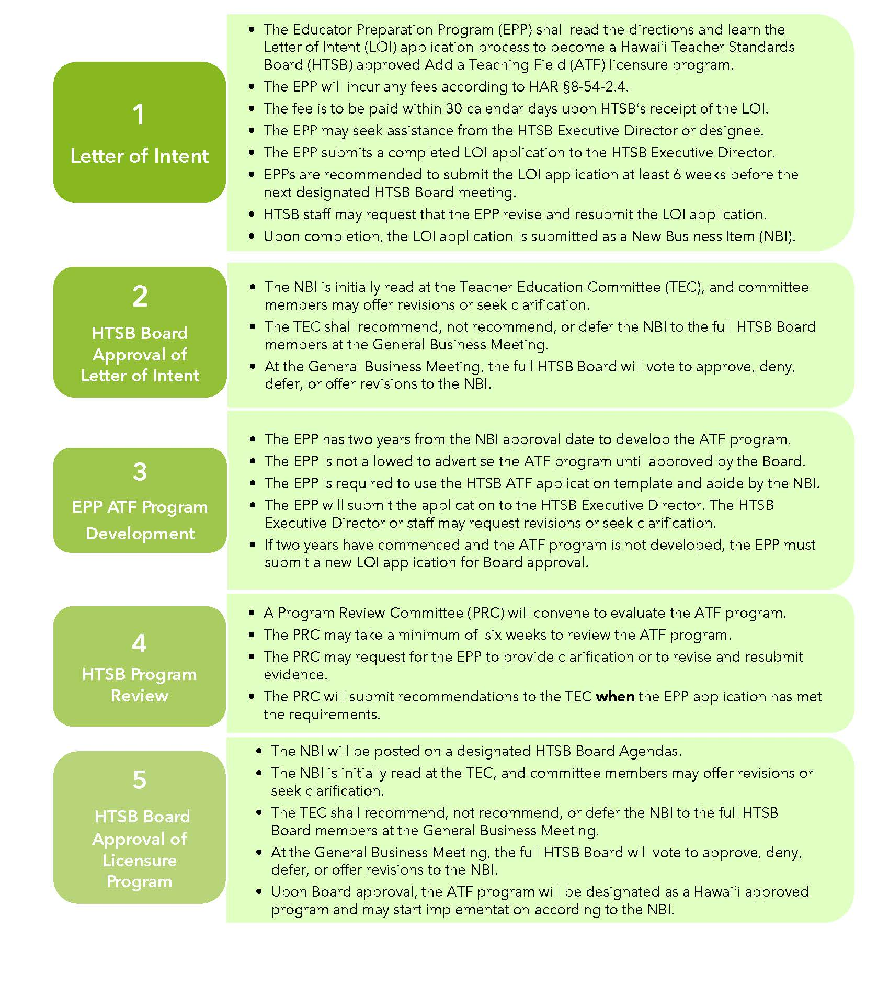

Key Terms

Term | Definition
Add a Teaching Field Program | An Add a Teaching Field program prepares existing licensed educators to add another teaching field and possibly grade level span to their valid license (§8-54-24).
Add a Teaching Field Candidate | An HTSB licensed teacher accepted into the add teaching field program.
Alternative Certification Program | An alternative certification program is offered by a for-profit or non-profit organization and provides teacher licensure for individuals who have earned a baccalaureate degree.
Alternative Route | A teacher preparation program at an institution of higher education that offers a pathway to initial teacher licensure for individuals who have earned a baccalaureate degree.
Clinical Experience | The culminating activity of extended teaching practice for teacher candidates or inservice teachers to obtain a licensure recommendation. Clinical experience may be referred to as student teaching, internship, or residency.
Educator preparation program | An organization, college, or university that provides a teacher licensure program for future or current teachers.
Emergency Hire Teacher | An individual who does not meet teacher licensure requirements but is employed as a teacher of record.
Grade level span | A cluster of student progression levels in the preschool through twelfth-grade school system. Examples of grade level bands are preschool–Kindergarten, grades K-6, grades 6-12
Licensed teacher | An individual who has completed a state-approved teacher education program and has a valid HTSB license.
Institute of Higher Education | An institution of higher education is a college or university that offers post-secondary courses for individuals interested in earning an academic degree.
National Accreditor | An agency that accredits schools or programs offering certification or degrees in the United States.
Program Accreditor | An agency that evaluates the quality of professional preparation programs.
Regional Accreditor | An agency that focuses on the quality of academic programs in state-owned or non-profit colleges or universities in a specific region of the US.
Teacher candidate | A college student or an Emergency Hire Teacher enrolled in a teacher education program and pursuing a teacher license. A teacher candidate does not have a license. Teacher candidates may be called pre-service teachers.
Teaching field | A subject area or content knowledge for which individuals are preparing to become a professional licensed educator. Examples include Early Childhood Education, Elementary Education, School Counseling, Special Education, or School Librarian.

Abbreviations

Abbreviation | Meaning
ACP | Alternative Certification Program
ATF | Add a Teaching Field
ATF candidate | Add a Teaching Field candidate
B.A. | Bachelor of Arts
B.S. | Bachelor of Science
B.Ed | Bachelor of Education
EPP | Educator Preparation Provider
HTSB | Hawaiʻi Teacher Standards Board
HIDOE | Hawaiʻi Department of Education
HIPCS | Hawaiʻi Public Charter School
IHE | Institution of Higher Education
LOI | Letter of Intent
M.A. | Master of Arts
M.Ed. | Master of Education
M.Ed.T | Master of Education in Teaching
M.S. | Master of Science
PB-Cert | Post-baccalaureate Certificate
PRC | Program Review Committee
SATEP | State Approved Teacher Education Program
TECC | Teacher Education Coordinating Committee
US | United States

Program Information

Institution Name
Mailing Address*
Public URL/Website
*If your institution does not have a physical presence in Hawai'i, explain how HTSB licensed teachers will receive prompt in-person support (§16-255-2).

Institution Administrator
Title
Email Address
Phone Number

EPP Administrator Name (if different from Institution Administrator)
Position
Phone
Email

EPP Liaison for HTSB Communication
Name
Position
Phone
Email

Mark an X next to the option that best describes your institution.
Institution of Higher Education, Public College, or University
Institution of Higher Education, Private/Independent
Alternative Certification Pathway, For-profit
Alternative Certification Pathway, Non-profit (501/503c)

Provide your institution's vision, mission, and goals.

Describe the history and development of your EPP to help the reviewers understand the context of your institution. Include information about the age, history, and distinguishing features (1000 words).

Are you an approved EPP in other U.S. states or jurisdictions? If yes, please list the states, all approved teacher licensure fields and grade span.

Provide a summary of students and faculty demographics (e.g., enrollment, diversity, full-time, part-time) in your EPP (300 words).

Please read the following prompts and mark an X in the Yes or No column. | YES | NO
Is your institution approved by the Council for Higher Education Association?
Is your institution registered with the Hawaiʻi Post-secondary Education Authorized Program?

Is your institution currently approved by the HTSB?

Does a United States regional accreditor approve your institution?
If yes, attach a copy of the institution's current accreditation letter, including status and expiration date.
Does a US teacher educator program accreditor approve your educator preparation program? If yes, attach a copy of the institution's current accreditation letter, including status and expiration date.
Are any of your programs accredited by the Distance Education Accrediting Commission? If yes, attach a copy of the institution's current accreditation letter, including status and expiration date.
Are any of your programs accredited by other US accreditors not listed above? If yes, attach a copy of the institution's current accreditation letter, including status and expiration date.
Has your program received approval as a Hawai'i Department of Education (HIDOE) Affiliate Program to place teacher candidates or HTSB licensed teachers in its school? If yes, please attach a copy of your HIDOE Educator Affiliation Agreement.

Program Intent
Mark X next to the proposed ATF licensure program.

Licensure Program | Select One
Add A Field Program - IHE
Enrolled students hold a valid teaching license from the HTSB. Upon successfully completing the program, they will receive a recommendation for a specific licensure field. Enrolled students earn college credits.
Add A Field Program - ACP
Enrolled students hold a valid teaching license from the HTSB. Upon successfully completing the ACP, they will receive a recommendation for a specific licensure field. Enrolled students do not earn college credits.

List the ATF teacher license field requested for approval.  List of HTSB-approved licensure fields | List the grade level span for the licensure field. | If IHE, list the academic degree or certificate the completers will earn. Write N/A if needed.

Read the following prompts and mark an X in the Yes or No column if you anticipate implementing your program using the instructional delivery modes. | YES | NO
Face-to-face: in-person at a physical location
Blended: face-to-face and online learning
Online: synchronous learning
Online: asynchronous learning
Online Hybrid: synchronous and asynchronous
Other (please describe):

Program Justification

Briefly describe your proposed ATF licensure program and why the targeting teaching field and grade level is selected (300 words maximum).

Describe how the proposed ATF licensure program will address the HIDOE and HIPCS educational needs and strategic plans. Cite quantitative and qualitative data and academic research to support your response (500 words maximum).

Explain how the proposed ATF licensure program will complement and address any challenges with existing Hawaiʻi approved programs. Cite quantitative and qualitative data and academic research to support your response (500 words maximum).

If you are an EPP, explain how this ATF licensure program will enhance your existing licensure programs and not compete with similar licensure programs being implemented. Cite quantitative and qualitative data and academic research to support your response (500 words maximum).

Please summarize your institutional/organization data designed and collected to identify this needed ATF licensure program. Provide a copy of the data method/s, year implemented, number of responses, and participant demographics (e.g., faculty, staff, students, educators) that your institution used (500 words maximum).

Who are the targeted educators you anticipate enrolling in the ATF licensure program? (300 words maximum)

Clinical Experience

Explain if you anticipate having a field experience/clinical experience in this ATF licensure program (300 words maximum).

If the proposed ATF program will have a clinical experience, please answer the following prompts.

Describe how you plan to select, prepare, evaluate, support, and retain partnership schools (300 words maximum).

If you do not have existing partnerships with the HIDOE or HIPCS, what is your plan to establish these partnerships? (300 words maximum).

If you are a Hawaii-approved program, please provide quantitative data on the number of program completers who have received a teacher license from the HTSB within the past six years and are currently teachers in the HIDOE or HIPCS. All approved license fields and grade level spans must be reported. If your EPP has different degree pathways, such as an undergraduate, post-baccalaureate, or master’s degree program, these teaching fields and grade level spans are required. Add more rows if needed.
Completer Year | Number of program completers | Number of teachers currently employed in the HIDOE | Number of teachers currently employed in the HIPCS

Program Startup

How many months do you anticipate an enrolled student will need to complete your licensure program?

What are the anticipated costs an enrolled student will pay annually and the total cost upon program completion?

Will this licensure program provide tuition assistance for enrolled students?
If yes, please explain the funding source, requirements to receive funding, and any payback obligations (e.g., teaching for specified years or exiting the program without successful completion).

Will enrolled students be required to obtain professional liability insurance in this program?

What anticipated recruitment strategies do you anticipate using to enroll potential students in the program?

What time of the year do you anticipate potential students can apply to the program? What time of the year will the program start (e.g., fall, spring, specific month)?

How many enrolled students does the EPP anticipate in the ATF licensure program in its first year of operation?

Explain the current employment outlook and how the proposed ATF licensure program will support completers in the job market upon exiting your program and sustaining itself for the next 3-5 years. Cite data and academic research to support your response (300 words maximum).

List of Appendices
Please support the LOI with the following appendices as separate PDF attachments. You may add additional appendices if needed.

Save the file name as InstitutionName_LicenseFieldName_AppendixLetter_date.pdf

Appendix A: A copy of the institution organization chart and the educator preparation program organization chart.

Appendix B: A copy of current accreditation letters from the United States regional institution accreditor, teacher education program accreditor, and other accreditors such as the Distance Education Accrediting Commission.

Appendix C: A copy of the HIDOE Affiliate Program Agreement

Appendix D: List of data sources and dates collected.

Appendix E: Institutional data method/s used to collect program need information.

Appendix F: Reference of academic literature or academic research formatted in APA 7th edition.

Educator Preparation Provider Verification

Preparer's Information
Name
Position
Telephone Number
Email

Contact Person should there be any questions about the application.
Name
Position
Telephone Number
Email

I verify that the contents of this adding a teaching field program application are complete, accurate, and approved by the institution/organization administrator.

I verify that all documents needed to support this application will be provided by my institution/organization.

I verify that acceptance of this application does not guarantee HTSB EPP Approval.

Please use ink or digitally stamped signature.
Name
Date

